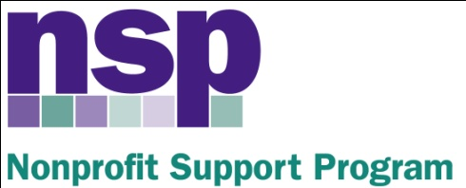

Hartford Foundation for Public Giving
Nonprofit Support Program
Building Evaluation Capacity (BEC) Program
Class of 2017, Session 5

March 23, 2016

AGENDA

USING OBSERVATIONS AND INTERVIEWS, ANALYZING QUALITATIVE DATA
8:30 – 8:40 | Review
8:40 – 9:45 | Observations: Presentations and Activities
9:45 – 10:10 | Introduction to Interviews, Interview Activity I
10:10 – 10:20 | Break
10:20 – 10:30 | Interviews: Additional Details
10:30 – 11:00 | Interview Analysis Activity 2
11:00 – 11:50 | Using Qualitative Data – Activities and Planning
11:50 – 12:00 | Wrap Up - Homework
HW | Finalize your Initial Thoughts  Work on Instruments  Next Session: May 11, 2016
Anita Baker
Evaluation Services
www.evaluationservices.co

