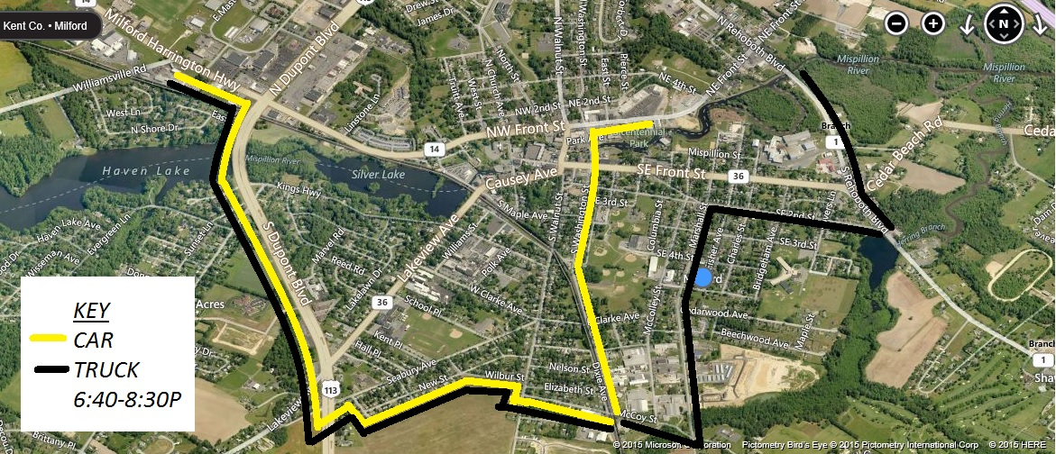

West Bound

Follow Detour signage-

CAR- S. Washington St to McCoy St –right turn

TRUCK- Alt 1 Rehoboth Blvd to SE 2nd St –right turn

TRUCK- SE 2nd St to Marshall St –left turn

TRUCK- S. Marshall St to McCoy St –right turn

ALL- McCoy St to S Walnut St –right turn

S Walnut St to Wilbur St –immediate left turn

Wilbur St to New St –left turn

New St to Cherry St –right turn

Cherry St to Seabury Avenue –left turn

Seabury Avenue to N. Rt 113 –right turn

N. Rt 113 to Westbound Rt 14 –left turn

To all points West and North and South

East Bound

Follow detour signage-

Southbound Rt 113 to Seabury Avenue –left turn

Seabury to Cherry St, --right turn

Cherry to New St, --left turn

New St to Wilbur St –right turn

Wilbur St to S Walnut St –right turn

S Walnut St to McCoy St –left turn

McCoy St to S Washington St –left turn follow to all points North and East

TRUCKS continue on McCoy St to Marshall St –left turn

Marshall St to South East Second St –right turn

S.E. 2nd St to Alt 1-Rehoboth Blvd to all points North, East and South

2016 Milford Parade DETOUR Map!