REGULAR MEETING
AUGUST 21, 2013

A Regular Meeting of the Town Board of the Town of Hampton, County of Washington and the State of New York was held at the Town Hall, 2629 State Route 22A, Hampton, New York on the 21st day of August 2013.

PRESENT: David K. O’Brien----------Supervisor
Herbert Sady, Jr.-----------Councilman
David Jensen---------------Councilman
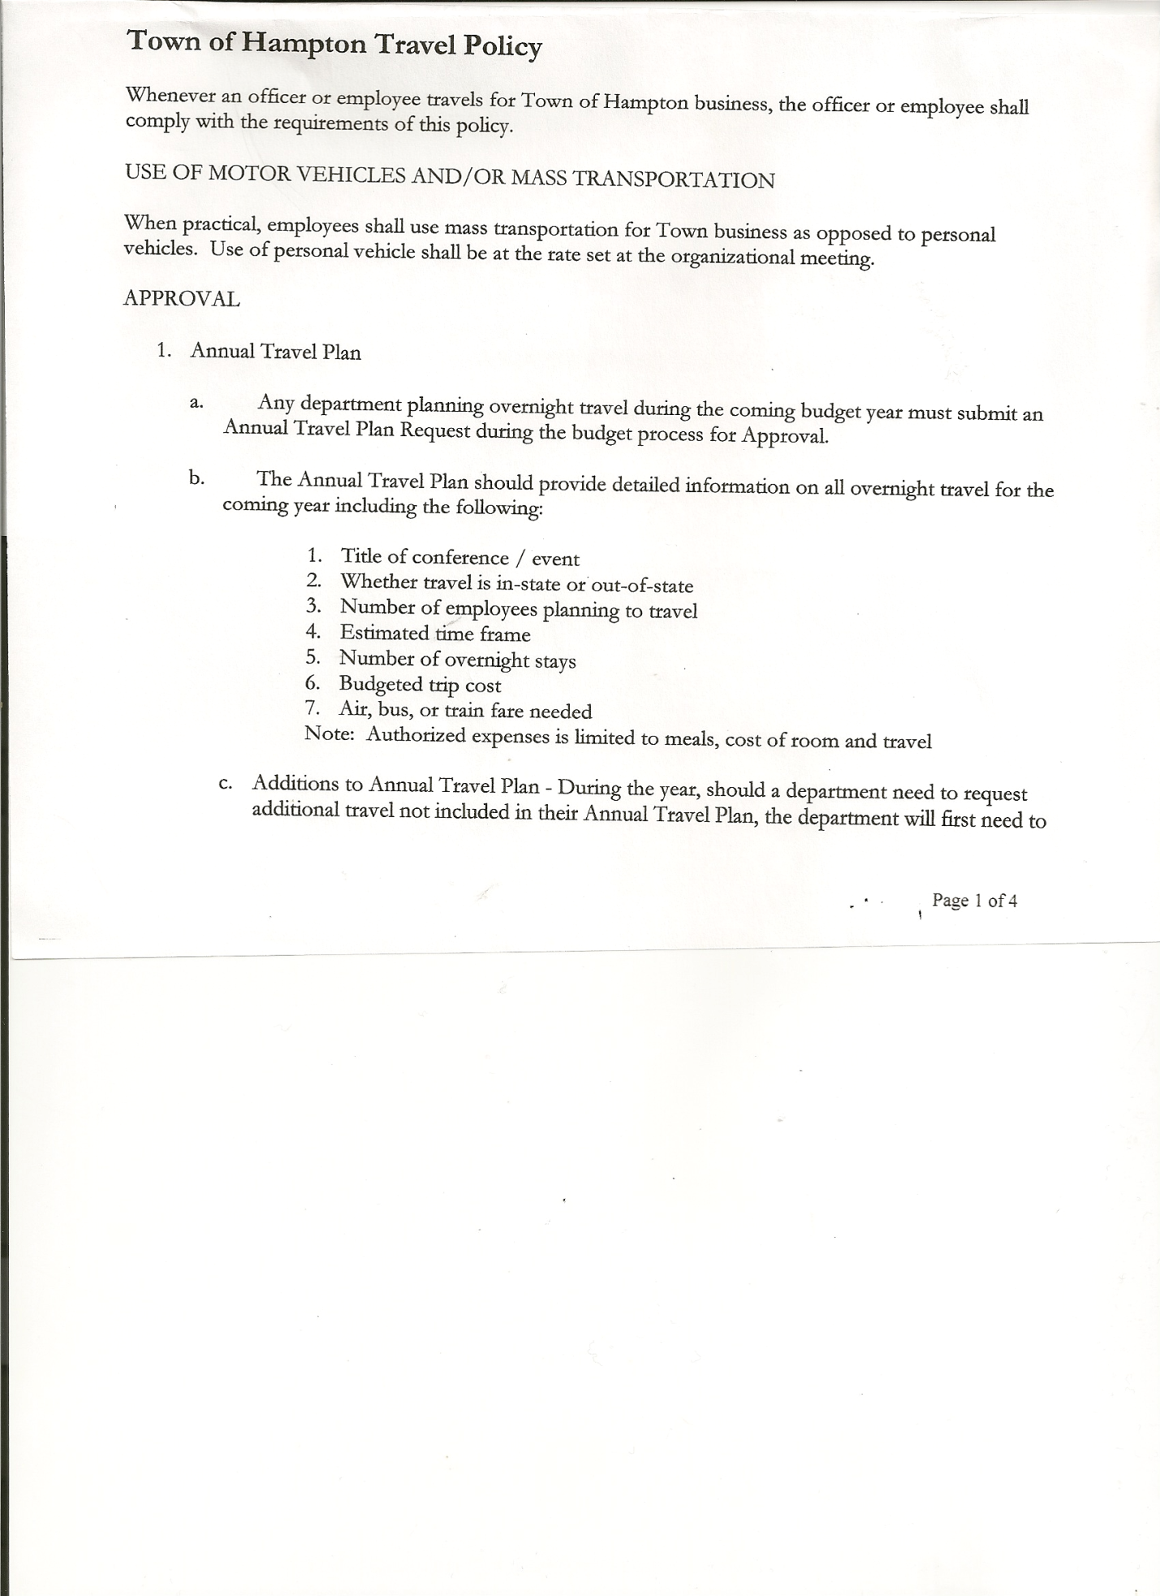
Rebecca Jones--------------Town Clerk
Camilla Shaw---------------Deputy Town Clerk/Tax Collector
Francis Baker---------------Highway Superintendent

ABSENT: David Perry------------------Councilman
Tamme Taran---------------Councilwoman

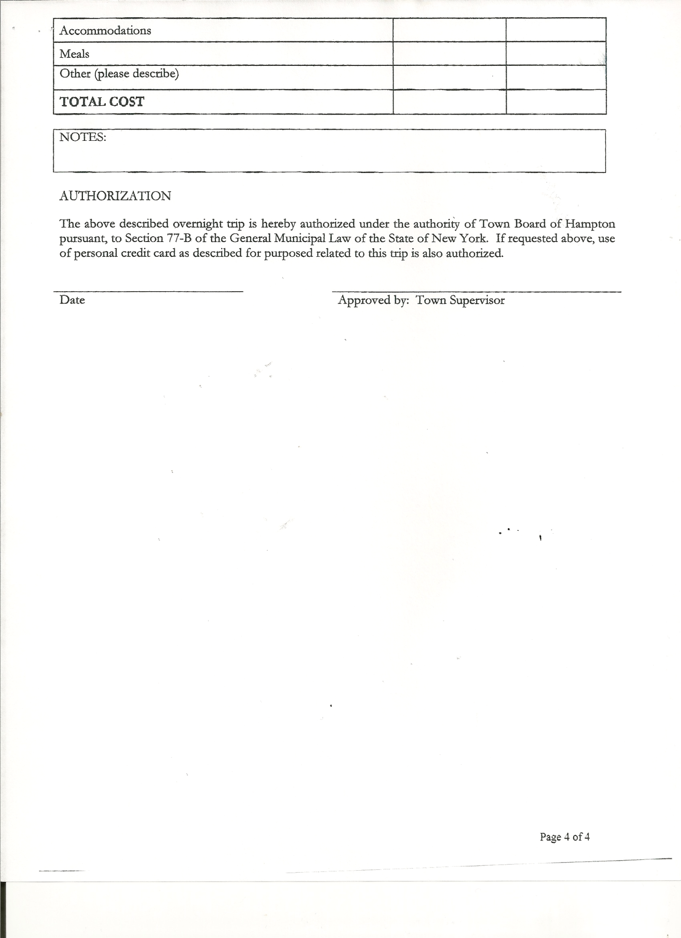
Planning Board Member(s): Bonnie Hawley, Chair

Also present: Whitehall Times Reporter, Derek Liebig, Rebecca Beayon, John Mashak, Patti Panebianco, Leonard Reed, Matthew Sears and Andrea Sweeney.

The meeting was called to order by David O’Brien, Supervisor at 7:30pm followed by the Pledge of Allegiance. Locations of Fire Exits were given.

RESOLUTION NO. 69-2013
APPROVAL OF THE MINUTES
On a motion of Councilman Jensen, seconded by Councilman Sady, the following resolution was
ADOPTED: Ayes 3 O’Brien, Sady, Jensen
Nays 0
RESOLVED that the Regular Town Board Minutes for July 17th, 2013 be accepted.

Permits/Subdivisions
Naomi Holmes of Hickey Road submitted a Subdivision Application. The SEQRA short form was completed.

RESOLUTION NO. 70-2013
SUBDIVISION-NEGATIVE DECLARATION
On a motion of Councilman Sady, seconded by Councilman Jensen, the following resolution was
ADOPTED: Ayes 3 O’Brien, Sady, Jensen
Nays 0
RESOLVED to adopt a negative declaration and finding that there will be no adverse environmental impacts and to consider it a minor subdivision, therefore waving the public hearing.

RESOLUTION NO 71-2013
APPROVAL OF SUBDIVISION
On a motion of Councilman Jensen, seconded by Councilman Sady, the following resolution was
ADOPTED: Ayes 3 O’Brien, Sady, Jensen
Nays 0
RESOLVED to approve Naomi Holmes’ subdivision.

TOWN BOARD MEETING
AUGUST 21, 2013 PAGE 2

Larry Carman, Dog Control Officer submitted his report, which was read by Supervisor O’Brien…a copy is attached.

RESOLUTION NO 72-2013
DOG SHELTER AGREEMENT
On a motion of Councilman Jensen, seconded by Councilman Sady the following agreement/resolution was
ADOPTED: Ayes 3 O’Brien, Sady, Jensen
Nays 0

AGREEMENT FOR SHELTER SERVICES

THIS AGREEMENT made as of the 21st day of August, 2013, pursuant to the provisions of section 114 of the Agricultural and Markets Law, by and between the Town of Hampton, a municipal corporation organized under the laws of the State of New York, with a mailing address of 2629 State Route 22A, PO Box 125, Hampton, New York 12837 (hereinafter referred to as “Town”) and Nancy Quell, Safe Haven Boarding & Grooming, with a principal place of business 167 Route 29, Greenwich, NY 12834 (hereinafter referred to as “Shelter”).

WITNESSETH:

WHEREAS, the Town desires to obtain the services and use the facilities of Shelter as provided in Section 114 of the New York State Agriculture and Markets Law and to obtain other services in relation to stray, sick, injured or unwanted dogs ordered confined pursuant to Section 2.14 of Part 2 of the State Sanitary Code as contained in Chapter 1 of Title 10 (Health) NYCRR, and deceased dogs; and

WHEREAS, Shelter has represented that Shelter is qualified, willing and able to provide such services and has presented a proposal to the Town for the same; and

WHEREAS, Shelter owns and operates a shelter for the care of dogs and the Town requires a facility suitable for such shelter and care; and

WHEREAS, the Town desires to utilize the services of Shelter and to utilize said shelter.

NOW, THEREFORE, in consideration of the mutual covenants, promises and agreements contained herein, the Town and Shelter agree as follows:

1. DUTIES OF SHELTER: Shelter shall maintain a shelter for dogs seized within the Town in accordance Article 7 of the Agriculture and Markets Law and any Local Law or Ordinance. Shelter’s duties with respect to the same are as follows and shall be performed at the cost and expense of the Town:

a. To properly shelter, care, feed and water such dogs for the minimum redemption period required by the Agriculture and Markets Law.

TOWN BOARD MEETING
AUGUST 21, 2013 PAGE 3

b. To make such dogs available for redemption by their owners for a period of time equal to or greater than the minimum redemption period (5 days for an unidentified dog, whether or not licensed and 10 days for a licensed dog whose owner is notified personally or by certified mail that the dog is in the shelter).

c. To make such dogs available for adoption if at the end of the appropriate redemption period, if said dog has not been redeemed by its owner.

d. To ensure that the Town has collected the appropriate fees, charges, fines, or penalties owed to the Town prior to releasing a dog to its owner, adopting out a dog or euthanizing a dog. If any additional fees are due to the Shelter they shall be paid to the Shelter prior to releasing the dog to the owner.

e. To arrange for veterinary services for said dogs, if necessary.

f. To arrange for a veterinarian to euthanize any dog for which euthanization is necessary and legally authorized, and to arrange for the burial of any dogs so euthanized.

g. To prepare, retain, and make available to the Town complete and accurate records concerning the care and disposition of all dogs cared for by the shelter hereunder as well as any expenses incurred and any fees collected, as required by Article 7 of the Agriculture and Markets Law and any regulations promulgated thereunder.

h. To respond to a request for service within twenty four (24) hours of notification.

i. To be present for court cases, seizures, appearance ticket, or similar appearances before a court.

j. To comply with the provisions of Article 7 of Agriculture and Markets Law and any rules and regulations promulgated pursuant thereto in relation to the seizure, holding, care, redemption and disposition of seized dogs.

k. To comply with the provisions of Article 7 of Agriculture and Markets Law and any rules and regulations promulgated pursuant thereto in relation to dangerous dogs.

l. To properly operate and maintain said shelter at all times during the term of this Agreement.

2. PAYMENT: Payment under this Agreement for shelter services shall be made pursuant to Schedule A, attached hereto and incorporated herein.

3. TOWN’S RIGHT TO CIVIL ACTION: Nothing contained herein shall limit the Town’s rights under applicable provisions of the law, or by means of any civil action or proceeding, to recover from the owner of any dog delivered by the Town to Shelter’s shelter any fees, charges or outstanding fines or penalties owned by such owner to the Town.

TOWN BOARD MEETING
AUGUST 21, 2013 PAGE 4

Nothing herein shall obligate the Town to deliver to Shelter any minimum number of dogs or all of the dogs seized in the Town.

4. TERM: The term of this Agreement is from July 17, 2013 through December 31, 2013, unless earlier terminated pursuant to the provisions herein. This Agreement shall be renewable for additional one year terms, upon the affirmative vote of the Town Board.

5. LIABILITY INSURANCE: For all of the services set forth herein and as hereinafter amended, Shelter shall maintain or cause to be maintained, in full force and effect during the term of this Agreement, at its expense a Worker's Compensation insurance (if it has employees) and a liability insurance policy with property damage coverage. Such policies are to be in the broadest form available on usual commercial terms and shall be written by insurers of recognized financial standing satisfactory to the Town who has been fully informed as to the nature of the services to be performed. Notwithstanding anything to the contrary in this Agreement, Shelter irrevocably waives all claims against the Town for all losses, damages, claims or expenses resulting from risks commercially insurable under this insurance described in this section. The provisions of insurance by Shelter shall not in any way limit Shelter's liability under this Agreement.

If the insurance is terminated for any reason, Shelter agrees to purchase an unlimited extended reporting provision to report claims arising from the services performed for the Town.

Immediate written notice shall be given to the Town of circumstances or incidents that might give rise to future claims with respect to the services performed under this Agreement.

This Agreement shall not become effective until the Town is in receipt of said insurance discussed herein.

7. TOWN’S RIGHT TO TERMINATE: The Town shall have the right to terminate this Agreement if:

a. Shelter fails or refuses to comply with all applicable laws or ordinances; or

b. Shelter violates any of the terms and conditions of this Agreement; or

c. In any event, the Town, without prejudice to any other rights or remedy it may have, may by fourteen (14) days written notice to Shelter, terminate this Agreement.

8. SHELTER’S RIGHT TO TERMINATE: Upon fourteen (14) days written notice, Shelter shall have the right to cease performing or terminate the Agreement if the Town violates any of the terms and conditions set forth herein.

9. INDEPENDENT CONTRACTOR: It is hereby mutually covenanted and agreed that the relation of Shelter to the services to be performed by him under this Agreement shall be that of an independent contractor. As an independent contractor, he will be responsible for all damage, loss, or injury to persons or property that may arise in or be incurred during the conduct

TOWN BOARD MEETING
AUGUST 21, 2013 PAGE 5

and progress of said services, whether or not Shelter, his agents, or employees have been negligent. Shelter shall hold and keep the Town free and discharged of and from any and all responsibility and liability of any sort or kind. Shelter shall assume all responsibility for risks or casualties of every description, for loss or injury to persons or property arising out of the nature of the services, from the action of the elements, or from any unforeseen or unusual difficulty. Shelter shall assume all blame, loss and responsibility of any nature by reason of neglect or violation of any federal, state, county, or local laws, regulations, or ordinances.

10. INDEMNIFICATION: To the fullest extent permitted by law Shelter shall indemnify, defend and hold harmless the Town and its agents and employees from and against all claims, damages, losses and expenses including, but not limited to, attorney’s fees arising out of or resulting from the performance of the services hereunder or the maintenance of the shelter, as discussed herein.

11. ASSIGNMENT: In accordance with the provisions Section 109 of the General Municipal Law, Shelter is hereby prohibited from assigning, transferring, conveying, subletting or otherwise disposing of this Agreement, or its right, title or interest in this Agreement, or its power to execute this Agreement, to any other person or corporation without the previous consent in writing of the Town.

12. ALL INCLUSIVE: Each and every provision of law and clause required by law to be inserted in this Agreement shall be deemed to have been inserted herein. If any such provision is not inserted through mistake or otherwise, then upon the application of either party, this Agreement shall be physically amended forthwith to make such insertion. In particular, Shelter shall, among other things, fully comply with:

a. Labor Law Section 220-e and Executive Law Sections 291-299 and the Civil Rights Laws relating to prohibition against discrimination and equal opportunity.
b. Affirmative action, as required by the laws of the State of New York and the laws of the United States of America.

13. AUTHORIZATIONS: The Supervisor has executed this Agreement pursuant to a Resolution adopted by the Town Board of the Town of Hampton, at a meeting thereof held on August 21st, 2013. The Supervisor of the Town, whose signature appears hereafter, is duly authorized and empowered to execute this instrument and enter into such an agreement on behalf of the Town. Shelter represents that it is his signature which appears hereafter and that he is duly authorized and empowered to execute this instrument and enter into such an agreement. This instrument shall be executed in duplicate. At least one copy shall be permanently filed, after execution thereof, in the Office of the Town Clerk.

14. NOTICES: Any and all notices and payments required hereunder shall be addressed to the parties at the address listed above, or to such other address as may hereafter be designated, or to such other address as may hereafter be designated in writing by either party hereto.

15. SEVERABILITY. Any term or provision of this Agreement which is invalid or unenforceable in any jurisdiction shall, as to such jurisdiction, be ineffective to the extent of such invalidity or unenforceability without rendering invalid or unenforceable the remaining terms and provisions of this Agreement in that or any other jurisdiction.

TOWN BOARD MEETING
AUGUST 21, 2013 PAGE 6

16. NON WAIVER. A waiver of any provision of this Agreement by any party shall not prevent any party from enforcing that provision or any other provision hereof.

17. AMENDMENTS: This Agreement constitutes the complete understanding of the parties. No amendment of any provisions thereof shall be valid unless in writing signed by both parties.

18. GOVERNING LAW: This Agreement is governed by the laws of the State of New York.

IN WITNESS WHEREOF, the parties hereto have caused this Agreement to be executed by their duly authorized officers or representative on the day and year first above written.

TOWN OF HAMPTON

By: By:________________________
David K. O’Brien, Supervisor Nancy Quell

Attest
By:
Rebecca Jones, Town Clerk

(Seal of the Town of Hampton)

TOWN BOARD MEETING
AUGUST 21, 2013 PAGE 7

SCHEDULE A

Fees charged:

To Municipality

A. Housing $10.00 per day or any part thereof or in accordance with Section 118 of the Agriculture and Markets Law as may be applicable. If dog is redeemed the Town will receive $18.00 per day.
B. Pick-up Fee $30.00 plus mileage at .40 per mile
C. Euthanasia $20.00 handling fee, plus veterinary costs
D. Disposal (0-100lbs.) $35.00 small
$45.00 medium
$60.00 large
E. Rabies Shot prior to release or adoption $35.00

To Public

A. Impoundment Seized dogs may be redeemed by producing proof of licensing
and identification pursuant to the provisions of Article 7 of the Agriculture and Markets Law and by paying the impoundment fees as set forth herein:
- For the first impoundment: $20.00, plus the prevailing charge to
the Town of Hampton for each day of impoundment.
- For the second impoundment: $40.00, plus a fee of $3.00 for
each additional twenty-four (24) hour period, plus the prevailing
charge to the Town of Hampton for each day of impoundment.
- For the third and any subsequent impoundment: $60.00, plus a
fee of $3.00 for each additional twenty-four (24) hour period, plus the prevailing charge to the Town of Hampton for each day
of impoundment.
F. Court Appearance $30.00
G. Hourly Charge ($25.00 each additional person)
H. Mileage $ 0.50
I. Space/Shelter Rental $ 18.00
J. Saturday, Sunday, $25.00 surcharge
Legal Holiday, After
7:00pm
K. Physical Calls Same as fees for A, F, G, H, J
L. Notices, Summons, N/A
Tickets

DATED: August 21, 2013 Supervisor O’Brien AYE
Councilman Sady AYE
Councilman Jensen AYE

Camilla Shaw, Tax Collector….no activity..zero balance

Bonnie Hawley, Planning Board Chair gave Planning Board report:
-continuing to work on Mobile Home Ordinance…they have another section completed
-next meeting will be August 27th, 2013 at 7:00pm at the Town Hall

TOWN BOARD MEETING
AUGUST 21, 2013 PAGE 8

Francis Baker, Highway Superintendent gave his report:
- second town roadside mowing done
- mowing cemeteries
- Backhoe repairs to heater blower fan
- fellas have been taking some vacation days
- Holcomb’s delivering winter sand
- Cutting brush on Carver Falls Road
- Dirt roads being graded where needed

Supervisor O’Brien stated that the Auditor from the State Comptroller’s Office suggests the following for Highway Department:
1)writing down mileage of vehicle when filling up…Frank stated that there was a meter on gas tank, but not on diesel tank
2)maintenance logs….Frank stated one is kept in each vehicle
3)Inventory of Highway Garage needs to be updated

RESOLUTION NO. 73-2013
BUDGET AMENDMENT
On a motion of Councilman Sady, seconded by Councilman Jensen the following resolution
was
ADOPTED by Roll Vote Supervisor O’Brien AYE
Councilman Sady AYE
Councilman Jensen AYE
Resolved the following Budget Amendment to the General Fund is approved:
Increase Supervisors Contractual Expense A1220.4 in the amount of $527.00 and
Decrease Supervisors Personal Service A1220.1 in the amount of $527.00

RESOLUTION NO. 74-2013
APPROVAL OF SUPERVISOR’S MONTHLY REPORT
On a motion of Councilman Sady, seconded by Councilman Jensen, the following resolution was ADOPTED Ayes 3 O’Brien, Sady, Jensen
Nays 0
Resolved the Supervisor’s Monthly report be accepted as submitted for JULY 2013
06/30/13 07/31/13
ACCOUNT BALANCE RECEIPTS DISBURSEMENTS BALANCE
General Fund $ 73943.54 $ 5845.23 $ 7779.90 $ 72008.87
Highway Fund $ 98839.92 $ 16.77 $ 8097.57 $ 90759.12
Equipment Reserve $ 64123.67 $ 10.72 $ 0.00 $ 64134.39
Building Fund $ 3407.00 $ 301.04 $ 764.29 $ 2943.75
Fire #1 $ 27813.00 $ 0.00 $ 12658.00 $ 15155.00
Fire #2 $ 4541.00 $ 0.00 $ 2270.50 $ 2270.50
Totals $272668.13 $ 6173.76 $ 31570.26 $ 247271.63

TOWN BOARD MEETING
AUGUST 21, 2013 PAGE 9

Town Hall news:
---Open House on Saturday October 12th instead of the 13th (that 13th is a fund raiser for Haynes House of Hope) from 2 – 5 pm/ Supervisor O’Brien asked if Hampton Firemen would be interested in selling hot dogs & hamburgers…Matt Sears will check and let him know/Invites and newsletter to be done.

Audit Update-finishing up here at the Town Hall…Friday (8/23) maybe last day, then in 2 to 6 months will send final report.

Computer Security Policy handed out for review and will discuss at future meeting
Retirement Statements…. completed by individuals regarding Retirement System
Budget Worksheets handed out…due back by September 4th
Community Billboard Sign has been built…need to decide where it should be put also need to put something up by drainage basin so no one backs into there.

Camilla Shaw presented coasters made by Megan Zeimet (Rose Zeimet’s granddaughter) for use on the bench at the Town Hall.

The Town Clerk’s report for July 2013 was submitted to the Board. The Town Clerk had Board Members review and sign bank reconciliation statements for Town Clerk Account and Special Town Clerk Account dated July 30, 2013.

RESOLUTION 75-2013
AUDIT OF CLAIMS
On a motion of Councilman Sady, seconded by Councilman Jensen, the following resolution was ADOPTED Ayes 3 O’Brien, Sady, Jensen
Nays 0
Resolved that the bills have been reviewed by the Town Board and are authorized for payment in the following amounts.
General Fund No. 111 through No. 126 $ 2391.70
Highway Fund No. 73 through No. 86 $ 7313.84
Building Fund No. 14 through No. 21 $ 1766.92
Total all funds $ 11472.46

On a motion of Councilman Sady, seconded by Councilman Jensen, the meeting adjourned at
8:50 pm. All in favor Aye.

Respectfully submitted,

Rebecca S. Jones, RMC
Town Clerk

SPECIAL MEETING
AUGUST 28, 2013

A Special Meeting of the Town Board of the Town of Hampton, County of Washington and the State of New York was held at the Town Hall, 2629 State Route 22A, Hampton, New York on the 28th day of August 2013.

PRESENT: David K. O’Brien----------Supervisor
Herbert Sady, Jr.-----------Councilman
David Perry-----------------Councilman
Tamme Taran---------------Councilwoman
David Jensen----------------Councilman
Rebecca Jones--------------Town Clerk
Camilla Shaw---------------Deputy Town Clerk/Tax Collector
Francis Baker---------------Highway Superintendent

Also present: David & Nancy Bridges, Gary Heimerle, Kim Perry, Artie Pratt, Leonard Reed, Donald Sady and Andrea Sweeney.

The Special Meeting was called to order by David O’Brien, Supervisor at 8:00 pm followed by the Pledge of Allegiance. Locations of Fire Exits were given.

COMMUNITY/BILLBOARD SIGN
Possible locations discussed were:
- By the drainage basin (located to the right side of the Town Hall)
- Gravel area on the side of the Town Hall
- By Town Highway Garage…on the side under the “Town of Hampton” sign
Several concerns were discussed….in the way of snow removal; trucks backing out; safety issues near the drain; and visibility of sign. Following the discussion…it was decided to have the sign put up by the Highway Garage. Board Members still would like something put up the drainage basin. Supervisor O’Brien will check with the State and see if they would install anything, since it is their drain.

OPEN HOUSE/DEDICATION
Saturday, October 12th, 2013 is the day for the Open House/Dedication for the new Town Hall. The time has been changed, originally set for 2 to 5pm, will now be from 1 to 4pm.
Items discussed and decided on are as follows:
- Cider & Coffee, Cake and Donuts-------Tamme Taran
- Check on cups/napkins--------------------Andrea Sweeney
- Chairs and tables for outside--------------Herb Sady
- Chairs from Hampton Fire Dept.---------Leonard Reed
- Signs and water-----------------------------Donald Sady
- Newspaper notice/radio
and newsletter to residents-------------David O’Brien
- Computer slide show of pictures---------David Jensen
- Clean upstairs/downstairs and
Power washing building-------------------Alternative Sentencing
It was decided to not have hot dogs and hamburgers…changing to donuts, cake, etc.

TOWN BOARD MEETING
AUGUST 28, 2013 PAGE 2

Shelter Agreement has been sent for signature. Dogs will be kept in Hampton area for 1 to 2 days, after that they will go to the shelter in Greenwich.

Supervisor O’Brien discussed the overview from the Auditor regarding Fiscal Oversight/Policies and Procedures. When full report is received from the State Comptroller’s Office it will be discussed and noted.

COMPUTER POLICY
Town Board Members still reviewing….will further discuss at next meeting.

RESOLUTION 76-2013
EXECUTIVE SESSION
On a motion of Councilwoman Taran, seconded by Councilman Jensen the following resolution was
ADOPTED Ayes 5 O’Brien, Perry, Sady, Taran, Jensen
Nays 0
Resolved the Town Board enter into an Executive Session at 9:02pm to discuss matters of the Audit.

RESOLUTION 77-2013
RETURN TO REGULAR SESSION
On a motion of Councilman Sady, seconded by Councilman Jensen the following resolution was
ADOPTED Ayes 5 O’Brien, Perry, Sady, Taran, Jensen
Nays 0
Resolved the Town Board return to regular session at 9:39pm.

On a motion of Councilman Perry, seconded by Councilwoman Taran the meeting adjourned at 9:39 pm. All in favor Aye.

Respectfully submitted,
Rebecca S. Jones, RMC/Town Clerk

