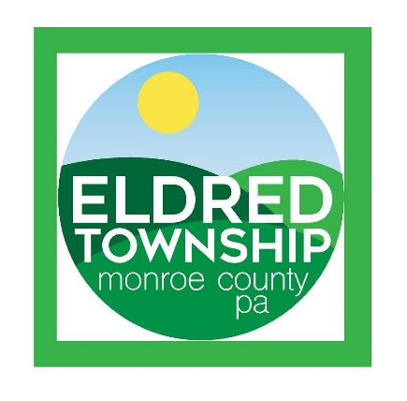

***Eldred Township***

***2021 Budget Presentation Overview***

**Board of Supervisors:**

*JoAnn Bush*

*Gary Hoffman*

*Donna Mikol*

Eldred Township has a rich history of being a quiet community with varying levels of terrain and vistas. The residents who live here were either born or raised here or they came from other areas because of the peace and tranquility that our township has to offer.

There is however one consequence of being a rural residential area; it is that is our tax base is very limited. We do not have any sort of “industry” to generate revenue. Our primary form of is derived from residential taxes earned income taxes.

**Income/Revenue Sources:**

**All Taxes Paid:**

When one looks at the amount of “taxes” we pay, it is easy to conclude that our township taxes are outrageous. That is clearly *not* the case. The most expensive taxes we pay are “school taxes” and second to that “County” taxes. The Township taxes are what Eldred residents pay to fund the costs required to provide Eldred Township residents with Township services.

First service is public’s safety. The Township is responsible to have assurances of efficient emergency response for protection of Police, Fire and EMS services.

Second is road maintenance. We are responsible to maintain twenty-four and one half (24.5) miles of township roads. Recently, it was said that our residents have a high expectation the roads will be cleared from a snowstorm in hours, and not days, as it was many years ago. It is not about a lack of patience. We have more residents currently who travel outside the Township to work and shop.

Prior to the recent County reassessment, our millage rate exceeded nine (9) mills. The recent Monroe County reassessment caused our millage to drop to 1.38 mils. After the lengthy budget meetings, it is necessary to plan to the future for sustainability of these services. With that in mind, we are recommending proposing an increase of the millage by 0.57 mills, for a total to 1.95mills.

When looking for an answer to “what an Eldred Township resident pays and what the Township needs to cover all expenses”, one only needs to look at the following pie chart as shown. 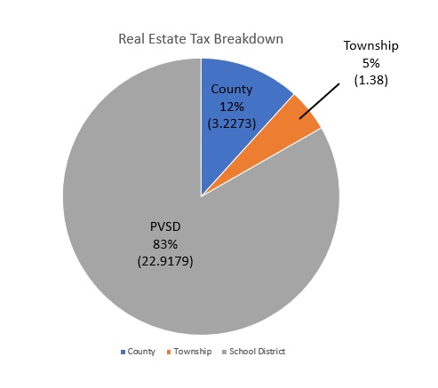

***‘What Services do I get in return from Eldred Township in return for the taxes I pay?”***

1. **Public Safety:**Included under the “public safety” definition is to ensure that we take the appropriate steps necessary to make sure our residents receive the best Police, Fire and Emergency Medical response that is possible.
   * Life Safety Services: *Police, Fire/Rescue and Emergency Medical Service, 9-1-1 Public Safety Dispatching and Emergency Management Planning and Response Services*
2. **Highway Maintenance:** the township “Public Works” department maintain twenty four (24+) plus miles of Township roads which include: Snow and ice removal, general road maintenance, repairs to road beds, mowing, culvert and drainage pipe maintenance, street signage, traffic studies etc. Some may not think that maintaining our network of roads may not be such a high priority. However, all it would take is one incident where a State Trooper, Fire Truck or Ambulance could not be able to get to an emergency because a Township road was not maintained, and you will think differently.
3. **Other Services:** 
   * *Ongoing and Comprehensive Municipal planning by our local Eldred Planning Commission.*
   * *Zoning/Building Codes Enforcement.*
   * *Parks and Recreation: Community Center and Mock Park maintenance.*

**Public Works and Service Projects in 2020:**

Our own in-house Public Works Team completed the following projects this year.

* *Flood mitigation for the cleanup and road repair of the storm that occurred on August 4, 2020.*
* *We replaced road pipes and drainage areas that should have been completed in the past but were put aside.*
* *Added enhanced security measures at the municipal building, for security of our staff.*
* *Upgraded and organized the municipal garage area.*
* *Updated the lighting in the municipal garages.*
* *Repainted the interior of the municipal building, long overdue.*
* *Started to update the lighting in the Eldred Township Community Center to LED fixtures.*
* *Fuel tank replacement for fueling service vehicles*
* *Purchased a used “tar buggy” so that our Public Works employees (PW) can facilitate their own seal coating and overlay rather than purchasing these services.*
* *Purchased a new “tailgate spreader” to do our own seal coating/overlay paving of damaged areas.*
* *Purchased a used street broom from “Municibid”, thus eliminating the need to rent a sweeper.*
* *Our Public Works Team became the “go to” folks* *for normal maintenance issues and troubleshooting any reported problems at the Community Center and all municipal properties.*
* *Finished the “Fiddletown Entrance” to “Mock Park”, including concrete pads with tables, landscaping and installed the gravel parking lot.*
* *Completed the “parking area” at the Mock Park-Wes Flo Access Point.*

**Taxes and Tax Revenues for 2021**

**New Budget Categories and Special Tax for each of the following;**

1. **“Road Department Equipment Replacement Program”**

Our Public Works Department is responsible to maintain our roads 24 hours per day, 365 days a year. Past Supervisors did the best with what they could with what they had to work. We that said however, as we move on, we are dealing with additional costs and mandates.

Historically, capital equipment replacements were handled by either continuing to “patch” things together or acquiring other townships’ used equipment. A few years back there were budget line items created to set aside for such procurements; however, when we evaluated that line item and compared that to the actual replacement costs of the heavy equipment to do the job correctly the funds did not accumulate quickly enough to replace old equipment.

This year we had to deal with several simultaneous catastrophic equipment failures that resulted in the “red line” of several primary trucks because they were no longer safe to drive on public roads.

**“Where are we today?”**

Today the Board is trying to determine where to acquire funding to replace trucks that cost an excess of $150,000.00 outfitted with a snowplow and salt spreader.

The average age of our fleet of “first out” trucks and heavy equipment is about 15 years. It is unanimous that we need to be more proactive with planning and try to “catch up” with what we need to continue a high level of safety and service for the employees and township residents.

**Our Plan:**

1. A 0.25 mil increase to generate approximately $50,000.00 per year (combined with the annual *line item* in the general fund of $25,000), for a total of $75,000.00. Strictly used for road equipment procurements. Known as “*special levy/tax”* to start in 2021. This increase shall be specifically earmarked, in accordance with the *Second class township code; 2305 (10),* allowing the Township to start a fund to be used *only* for the replacement of road equipment.

By taking this plan, future Supervisors should not be faced with a lack of “seed money” if they stick to this plan. Additionally, the Board will continue to seek out grants to help offset the cost of future purchases.

**What has changed?**

Some of our fleet of heavy-duty trucks exceed twenty years old. These vehicles are used at some of the worst weather possible. The cost of a new *heavy-duty* plow truck, including the plow and salt spreader, top off around $170,000.00. That is purchasing the units off the “PA COSTARS” contract; the Commonwealth of PA essentially has negotiated with vendors on discount levels that they agreed to. It is legal and expedites the procurement process for local governments.  
  
In 2020 we replaced one truck, with a larger tandem axle vehicle. This truck allows for hauling larger loads which results in less trips to the quarry’s for materials, saving fuel cost and time for the budget.

In September of this year, we found catastrophic frame failures on one of the much older plow trucks. We had a certified welder provide us with a budgetary estimate to repair the truck and that cost was approximately $50,000.00. Even if we made the initial repairs, we would still have had a 20 plus year old vehicle.

We did not have the funds in the reserves to purchase a new truck. We started with our first “Lease/purchase” procurement. This allowed us to get what we needed sooner than waiting

eight plus years to save for it.  
  
It is no longer feasible to put aside $20,000 per year to replace trucks. This is simply not sustainable moving forward. In the future, trucks will cost significantly more than what we would have ever saved.

**2.“Volunteer Fire Department Capital Equipment Replacement Costs”**

The Board of Supervisors, through an annual appointment, has designated the first due Volunteer Fire Company “the Kunkletown Volunteer Fire Company”. They are the “first due”, or the first Fire/Rescue dispatched when someone calls 9-1-1, reporting any emergency incidents in our Township.

This is 100% volunteer department. Other than the twenty-five thousand dollars ($25,000.00) the township began allocate a few years ago, they need to add additional funding in order to operate from either grants, or low interest loans issued by the Commonwealth of Pennsylvania.

This year the global pandemic crisis has removed their ability and every Volunteer Fire Company across the Commonwealth, to sustain a budget without their addition of fundraisers.

Their primary fundraisers were Breakfasts, the annual Carnival (in the Church Grove), and the West End Fair. This year because of the pandemic, they had to cease all of their fund raising activities. They lost over $40,000.00 because of the restrictions imposed upon them.

***Apparatus Costs:*** one needs to consider this; a first line fire engine/pumper, in the circa 1960, cost somewhere around $50,000.00 as a high. Today however, there are Federal National Standard “minimums,” if you will, as to how a piece of apparatus shall be built, a first line fire engine/pumper can exceed five hundred thousand dollars ($500,000.00), and that just meets the Federal guidelines.

The township had been budgeting $2,000.00 per year towards the replacement of a new fire truck. Based on what has been presented it would take about 62.5 years to save up enough money for a 25% down payment. This does not deserve further explanation.

The Board intends to delete the current “contribution” to the fire company of $25,000.00 and create a “special levy” of 0.25 mils that will generate approximately $50,000.00 a year. The Board’s intent is to make the first $25,000.00 available for annual operating expenses. The remaining $25,000.00 shall (in a separate account) be used for future capital equipment procurements by the designated fire company by the Board of Supervisors.

There is a much larger problem than lack of funding, which is a lack of available workers to respond to calls. We are fortunate that Eldred Township has volunteers who commit their time and their lives to helping others. This is a very volatile situation across the County and across the Commonwealth.

The job is not for the faint of heart and requires volunteers who have the time for the commitment involved as well as the time for training and response. Eventually, projected, fire companies will need to consolidate their organizations, combining manpower and eliminate the duplication of equipment and overhead.

By virtue of design, the future townships Supervisors may be required to contribute to another fire company because of the lack of available personnel. Should there be a total or partial consolidation it will provide the latitude for future Boards participate. Therefore, when an event such as this occurs the township retains the discretion to divide the newly established fund and send it to as many participating volunteer fire companies as necessary insuring adequate fire protection for the Township.

**3. General Operating Budget Millage Increase of 0.07mils:**

To keep the township operations level and be in a position to cover normal operating costs and costs that continue to rise, we must increase the general millage by 0.07 mills which will provide the needed revenue to cover our overall operating expenses.

We are all trying to live through 2020 with the global pandemic along with all of the stressors that have come with this situation. Our township is very lucky in that recently we received notification that we would be receiving a grant from the “CARES” fund for approximately $15,000.00. This reimbursement is for some of our extraneous expenditures which were the result of actions needed in response to COVID 19. The additional emergency costs do not reflect normal operating expenses.  
  
The pandemic is what it is. However, current funding levels cannot remain the same and still sustain the township operations. We can no longer hope that our costs will go down. That is a dream not reality.

Our expenses, with a very few exceptions, are “Fixed” just like with our own personal budgets. Those include the costs for utilities, insurances etc.

We also have costs that we can do little about as far as “cost control”. An example of this are utilities; the cost of electric; we do shop for the costs of both the electric generation and the delivery, but the impact is not significant.

**Breakdown of Expenses**

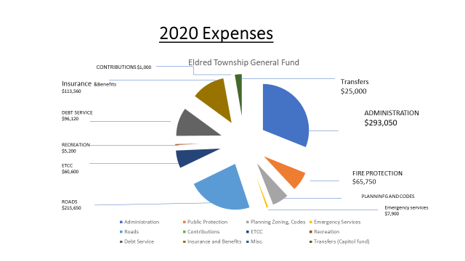

We have the cost of fuel for vehicles and heating oil, which are purchased through COG

The joint agreement with the Monroe County Council of Governments or “COG”.

COG is a consortium of Monroe County municipalities who jointly bid various services and supplies to reduce procurement costs. Procurements in General:

One needs to understand the constraints on a PA municipality when it comes to “purchasing options”.

* Costs for goods and services under certain bid thresholds may not require public advertising but may require the municipality to obtain three (3) written quotes, email quotes are perfectly acceptable. Depending on what those goods or services are needed one could certainly advertise any purchase if the municipality should desire however the costs of legal advertising has skyrocketed but if its mandated by legislation, we have no choice.
* A municipality can purchase “professional services” such as “insurances, computer software or programming services” or expenses for some public safety or normal utility services.
* A municipality can purchase from the “Commonwealth of Pennsylvania’s Joint Purchasing Program, also call “CoStars”. Purchases from this program are not required to be publicly bid since the Commonwealth has already bid the products and services on these contracts. Municipalities must however refer to a vendor’s specific and valid PA State Contract number if they decide to purchase “off” the Contract.

One misnomer: a municipality could not negotiate with a vendor who is NOT on the CoStars program (in an attempt) to reduce their price below a current PA State Contract price and ultimately not publicly advertise the procurement.

There are other mitigating factors that drive the costs up for municipalities to purchases goods and services:

* “Prevailing Wage” is the single most expensive factor that a municipality has to pay for. This is where a typical local electrician might get paid $30.00/hour, but under the Prevailing Wage schedule the township might have to pay a first class electrician $90.00/hour. These fees are non-negotiable but all drive up the costs for any “bricks and mortar” construction projects.
* There are costs for engineering fees and architectural fees; these are not options.
* A municipality, when they are required to bid something must require the successful vendor to provide a “bid bond”, this in case a bidder withdraws their bid and fails to deliver a performance bond, the municipality keeps that bond in default.
* Once a bid is awarded the successful vendor must provide a “performance bond” within ten (10) business days. This bond is required so that if a vendor fails to complete the contract or their workmanship doesn’t meet the specifications the municipality can “pull” their performance bond and the money’s derived from that to hire another vendor to complete the job.

We have a total of three (3) full-time employees and approximately three (3) part-time employees who facilitate keeping the roads in shape. This past year, instead of hiring independent contractors we have applied some of the skills our current in-house employees such as painting and minor construction projects They also help residents during our “clean up days”, which has proven successful.

At this time, there are no additional funds earmarked for any special park or recreation projects in next year’s budget. Whatever funds currently budgeted for park improvements will remain as is. There are residents that appreciate the park improvement plans and residents who are not prefer no change. Future improvements are planned for Grant assistance.

This budget is reflecting our goal to be realistic, being responsible fiduciary stewards, and to set future plans. The townships around us are looking to the future generation returning to “outdoor” activities. We need to be diligent in opportunities to keep our township rural, aesthetic, but a nice place to visit and perhaps retire or raise a family. That requires careful planning and sustainability and additional tax revenue.

Any questions please submit in writing to:

**Eldred Township Board of Supervisors**