Funding and Flexibility for At-Risk Students:
A 2018 Legislative Priority
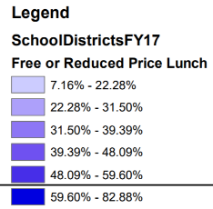
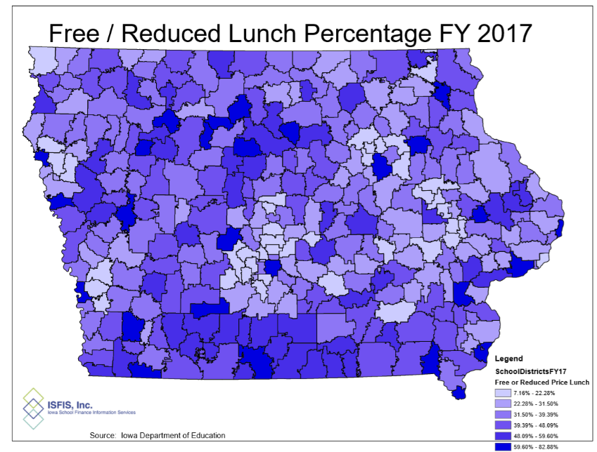
Background: Iowa has traditionally been a homogenous state with relatively low rates of poverty. As such, Iowa’s funding formula does not sufficiently recognize low income as a driver of at-risk student programing. In 2001, about 28% of students were eligible for Free and Reduced Lunch, with the lowest district percentage of eligibility at 4.2%. Dropout Prevention funding is based on total enrollment count, not the percentage of students at-risk. Although flexibility for use of DoP funds was expanded in the 2015 and 2017 Sessions, DoP funding is still limited to 2.5% of the total regular program district cost or up to 5% of regular program district cost based on historical practice.
Current Reality: In FY 2017, 41.3% of students were eligible for Free and Reduced Price Lunch.
- Once concentrated in Iowa’s urban centers, poverty is now found throughout the state. The map’s darkest color shows those districts with 59% or more of enrolled students eligible for Free and Reduced Price Lunch. Of the 62 school districts in FY 2017 with more than half of their students eligible, 51 are rural school districts. In Iowa’s smallest enrollment category (below 300 enrolled), 50.3% of enrolled students are eligible.
- Iowa’s funding for at-risk students and dropout prevention resources, translates into less than 10% additional funding commitment for these students. This falls short of the national average investment, which is 29% funding beyond the base for low-income students. (American Institute for Research, Study of a new Method of Funding for Public Schools in Nevada, Sept. 2012)
- Students from low income families are more likely to begin school behind their peers academically, exhibit non-proficient literacy skills, especially in early elementary grades, and to fall further behind over summer breaks, unless schools have the resources, staff and programs to meet their needs.
- Different funding caps are arbitrary, based on history of school districts access of dropout prevention funds, rather than on the number of students at-risk in the district today.
- Current requirements for dropout prevention and at-risk expenditures have been loosened recently, but are still regulated by the state, requiring DE approval of planned expenditures, which may preclude districts from investing in the practices they believe will best meet the needs of students.
RSAI calls on the Iowa Legislature to address the issue of Funding and Flexibility for At-risk Students: Resources for serving at-risk students should be based on need, such as the number/percentage of students eligible for Free and Reduced Price Lunch, in addition to enrollment of the district. The current disparity in dropout prevention capacity ceiling (some districts held to 2.5% and others up to 5% of regular program district cost) is unfair, arbitrary, and based on old history no longer relevant to supporting student needs. Districts should be given flexibility in determining the expenditure of at-risk resources to support students to graduate college/career ready for success.

