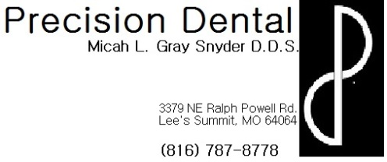
Permanent crown recommendations
- If anesthetic was used during your procedure today:
  - Not only is the tooth numb, but the surrounding soft tissue structures are as well, including lip, tongue, gums, cheeks, etc. Be very careful not to bite or suck on these soft tissues while profoundly numb. Since you are so numb you will not be able to feel how hard you are biting or sucking which can result in serious soft tissue damage.
  - Your numbness can last for several hours following your procedure, on average about 3-4, however everyone reacts to local anesthetic differently. If you wake up tomorrow morning and still feel numb please contact the office for further evaluation.
  - As the numbness wears away, your soft tissues may begin to itch or tingle. This is a normal reaction and does not indicate an allergic reaction. It is very important to be careful not to scratch or itch the area because the tissues are still numb and it is possible to do soft tissue damage by scratching or itching too hard without realizing it.
  - You may want to take a pain reliever (ex: Ibuprofen, Acetaminophen, etc.) prior to the numbness wearing away because the site of the injection may be sore like a bruise. The injection site may actually bruise and some swelling is also a normal occurrence. If you are concerned about any bruising or swelling please contact the office for further evaluation.
- To protect your crown, avoid chewing ice or other hard objects.
- Brush and floss normally around your permanent crown. Remember there is still natural tooth structure that exists under and at the base of your crown that is still prone to decay if not properly maintained with good oral hygiene habits.
- Some sensitivity to hot , cold and pressure is normal for a few days following permanent crown placement. HOWEVER, if sensitivity persists beyond a few days or gets progressively worse with time, please contact the office for further evaluation.
- If crowned tooth feels “high” or other teeth do not feel like they are hitting normally please contact the office for further evaluation. This is a condition that is normally very easy to fix and but will not resolve on its own. If it is not resolved, it can lead to further complications including toothache or infection.
- Your dentist may recommend use of a night guard to further help protect your crown.
- Please contact the office with any other questions or concerns.

