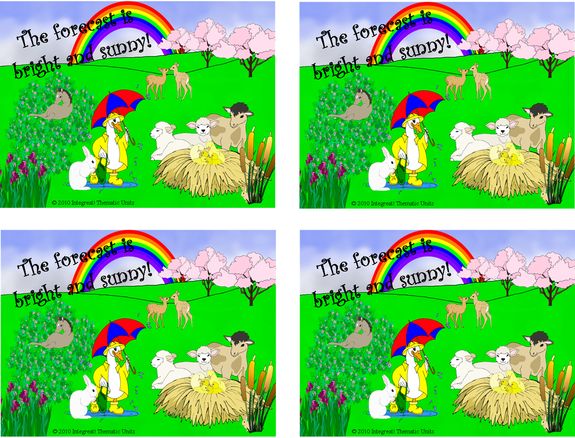
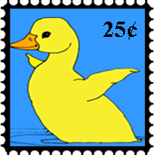
The forecast calls for bright and sunny!
REPLACE this text with your own message, OR

ERASE it and write your own in by hand.
The forecast calls for bright and sunny!
REPLACE this text with your own message, OR

ERASE it and write your own in by hand.

The forecast calls for bright and sunny!
REPLACE this text with your own message, OR

ERASE it and write your own in by hand.

The forecast calls for bright and sunny!
REPLACE this text with your own message, OR

ERASE it and write your own in by hand.

