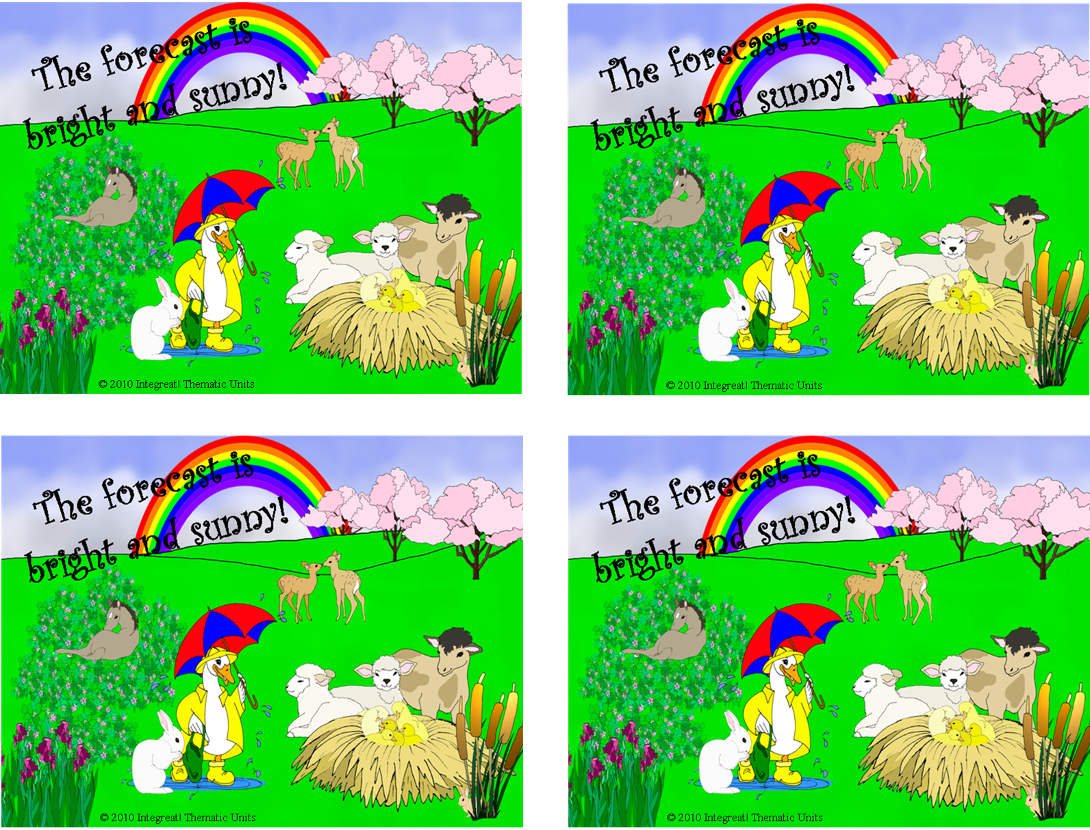

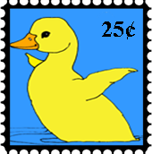

*The forecast calls for bright and sunny!*

REPLACE this text with your own message, OR

ERASE it and write your own in by hand.

*The forecast calls for bright and sunny!*

REPLACE this text with your own message, OR

ERASE it and write your own in by hand.

*The forecast calls for bright and sunny!*

REPLACE this text with your own message, OR

ERASE it and write your own in by hand.

*The forecast calls for bright and sunny!*

REPLACE this text with your own message, OR

ERASE it and write your own in by hand.