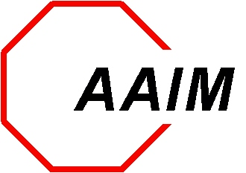

Alliance Against Intoxicated Motorists
Woodfield Grove, Suite 131 870 East Higgins Road Schaumburg, IL 60173
(847) 240-0027 Toll free (888) 240-0027
Fax (847) 240-0028 www.aaim1.org

Summer 2017

Dear Friend of AAIM,

The Alliance Against Intoxicated Motorists is hosting its 27th Annual Benefit Evening Gala on Saturday, October 21, 2017 at Medinah Banquets, 550 Shriners Drive, Addison, IL 60101. Proceeds from the benefit help support AAIM’s Victim Assistance Fund.

Every year AAIM invites one person from every family to write a tribute in memory of their loved-one, or a story if you are a victim that was injured. We encourage you write your story in 500 words or less and include a picture of your loved-one by Monday, September 25, 2017 If your tribute/story has been published in our benefit book in the past, we understand the story has not changed; however, please take the time to update the story and your journey through this difficult time. Please return your story to your advocate by the deadline date.

If you have access to a computer you may e-mail your story and picture directly to your Advocate. If you do not have access to a computer or need assistance with the enclosed instructions please contact your Advocate.

twyla.blakely@comcast.net Twyla Blakely - 630-941-8704
jzinck28@gmail.com Jessica Zinck – 815-274-1084
artigosia@hotmail.com Margaret Skrzypkowski – 847-494-5133
kellykrenzer@gmail.com Kelly Krenzer – 815-975-7847
aaim.cindy@gmail.com Cindy Huerta – 630-440-4013

Or you may request their home mailing address. If you are not working with your Advocate at this time please contact the AAIM office at 847-240-0027.

Warm Regards,
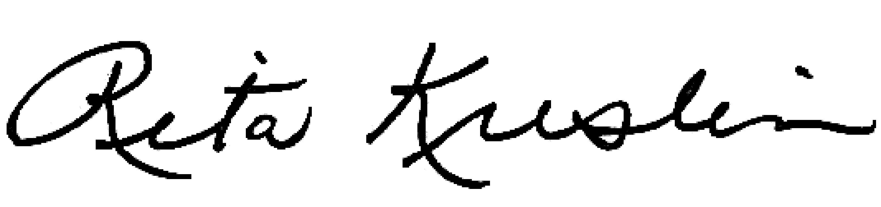

Rita Kreslin
Executive Director

