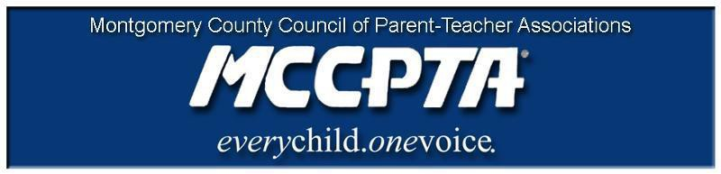

DELEGATES’ ASSEMBLY MEETING AGENDA
Tuesday, September 24, 2019
Carver Center Auditorium

7:00 pm Call to Order

7:00 pm Welcome and Introduction of Officers; Approval of Agenda & April 2019 Minutes

7:15 pm Introduction to MCCPTA

7:35 pm 2019 Family Survey Results

7:45 pm New Business

Calendar for 2019-2020
Approve Budget
Advocacy Priorities
Highlights from Approved Work Plan

8:20 pm Officer Reports

8:40 pm Committee Updates & Announcements

9:00 pm Adjourn

Dates:

10/10/19 MCCPTA Board of Directors Meeting (7 pm, Carver Room 134)
10/22/19 MCCPTA Presents (6 pm, Carver Auditorium)
10/22/19 MCCPTA Delegates Assembly (7 pm, Carver Auditorium)
10/23/19 MCCPTA/MCPS/BOE Annual Meeting (7 pm, Carver Auditorium)
10/30/19 MCPS/MCCPTA CIP Workshop (MCPS provides MCCPTA with information about the Superintendent’s recommended Capital Improvement Program (CIP) Budget. The workshop helps cluster coordinators gather information for their CIP testimony. There is a separate CIP testimony prep session for MCCPTA.)
11/14/19 MCCPTA Board of Directors Meeting (7 pm, Carver Room 134)

