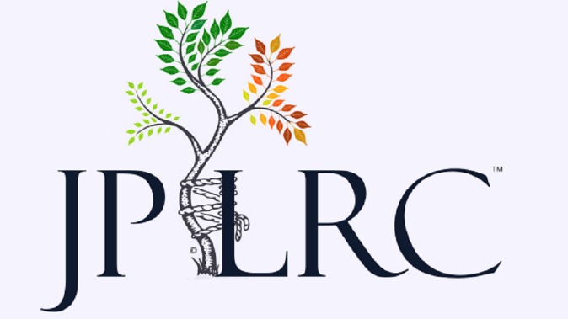

Terms of Use
By using the JPLRC.com® website you agree to be bound by these terms of use ("Terms of Use"). JPLRC.com is owned and controlled by JPLRC, LLC. These Terms of Use affect your legal rights and obligations. If you do not agree to be bound by all of these Terms of Use, please do not access or use the service.
Your use of JPLRC.com is subject to My Knee Guide’s Privacy Policy. Please review our Privacy Policy, which also governs the website and informs users of our data collection and practices.
It is your responsibility to ensure your computer or mobile device meets all the necessary technical specifications to enable you to access and use JPLRC.com. Apple Applications are only licensed for use on a device owned or controlled by you and using the Apple iPhone OS.
We may, from time to time, restrict access to certain features, parts or content of the Website, or the entire Website.
We cannot guarantee the continuous, uninterrupted or error-free operability of JPLRC.com. There may be times when all of, or certain features, parts or content of JPLRC.com, becomes unavailable (whether on a scheduled or unscheduled basis) or are modified, suspended or withdrawn by us, in our sole discretion, without notice to you. You agree that we will not be liable to you or to any third party for any unavailability, modification, suspension or withdrawal of JPLRC.com, or any features, parts or content of JPLRC.com.
You may only use JPLRC.com for your own non-commercial personal use and only in accordance with these terms.
Subject to the following sections, you may retrieve and display content from JPLRC.com on a computer or mobile device, print pages from our website and store the Application in electronic form.
Additional terms may also apply to certain features, parts or content of JPLRC.com and, where they apply, are set out in these terms or will be displayed before you access the relevant features, parts or content.
Except to the extent expressly set out in these terms, you are not allowed to:
- Create (whether for yourself or someone else) any financial product or service which seeks to match the performance of, or the capital or income value of which is related to JPLRC.com.
- Republish, redistribute or re-transmit any of the JPLRC.com media.
- Copy or store JPLRC.com and its content other than for your own personal non-commercial use and as may occur incidentally in the normal course of use of your browser or mobile device.

- Store JPLRC.com (including pages of our website) on a server or other storage device connected to a network or create a database by systematically downloading and storing any data from JPLRC.com.
- Remove or change any content of JPLRC.com or attempt to circumvent security or interfere with the proper working of JPLRC.com or any servers on which it is hosted.
- Create links to JPLRC.com from any other website, without our prior written consent, although you may link from a website that is operated by you provided the link is not misleading or deceptive and fairly indicates its destination, you do not imply that we endorse you, your website, or any products or services you offer, you link to (and do not frame or replicate) the home page of JPLRC.com, and the linked website does not contain any content that is unlawful, threatening, abusive, libelous, pornographic, obscene, vulgar, indecent, offensive or which infringes on the intellectual property rights or other rights of any third party.
You must only use JPLRC.com and anything available via JPLRC.com for lawful purposes (complying with all applicable laws and regulations), in a responsible manner, and not in a way that might damage our name or reputation or that of any of our affiliates.
All rights granted to you under these terms will terminate immediately in the event that you are in breach of any of them.
Intellectual property rights
All intellectual property rights in JPLRC.com and any content of JPLRC.com (including text, graphics, software, photographs and other images, videos, sound, trademarks and logos) are owned or leased by JPLRC, LLC, unless otherwise stated. Except as expressly set out here, nothing in these terms gives you any rights in respect to any intellectual property owned by us and you acknowledge that you do not acquire any ownership rights by downloading or using JPLRC.com. In the event you print off, copy or store any JPLRC.com owned media (only as permitted by these terms), you must ensure that any copyright, trade mark or other intellectual property right notices contained in the original content are reproduced.
Content and its intended use
We may change the format and content of JPLRC.com from time to time. You agree that your use of JPLRC.com is on an 'as is' and 'as available' basis and at your sole risk.
While we try to make sure that all information contained in JPLRC.com (other than any user-generated content) is correct, it is not intended to amount to authority or advice on which reliance should be placed. Refer to the JPLRC.com Medical Disclaimer for further details.
JPLRC.com is not intended to constitute or form the basis of any advice (professional or otherwise) or to be used in, or in relation to, any investment or other decision or transaction.
We do not accept any liability, regardless of the manner it arises, for any claim or loss arising from:
- Any advice given.
- Any investment or other decision made.
- Any transaction made or effected.

We do not enter into any terms or make any representations as to the accuracy, completeness, currency, correctness, reliability, integrity, quality, fitness for purpose or originality of any content of JPLRC.com and, to the fullest extent permitted by law, all implied warranties, conditions or other terms of any kind are hereby excluded. To the fullest extent permitted by law, we accept no liability for any loss or damage of any kind incurred as a result of you or anyone else using JPLRC.com or relying on any of its content.
We cannot and do not guarantee that any content of JPLRC.com will be free from viruses and/or other code that may have contaminating or destructive elements. It is your responsibility to implement appropriate IT security safeguards (including anti-virus and other security checks) to satisfy your particular requirements as to the safety and reliability of content.
External links
JPLRC.com may include links to external sites. We have included links to these sites to provide you with access to information and services that you may find useful or interesting. We are not responsible for the content of these sites or for anything provided by them and do not guarantee that they will be continuously available. The fact that we include links to such external sites does not imply any endorsement of, or association with, their operators.
General
These terms shall limit or exclude our liability to you for death or personal injury caused by our negligence or for any misrepresentation or any other liability. Subject to this, if you are a consumer and not a business user, in no event shall we be liable to you for any business losses or any liability for losses you suffer strictly limited to losses that were reasonably foreseeable, and if you are a business user, in no event shall we be liable to you for any indirect or consequential losses, or for any loss of profit, revenue, contracts, data, goodwill or other similar losses.
It is our policy to respond to notices of alleged infringement that comply with the United States’ Digital Millennium Copyright Act or other applicable law and to explicitly denying access of repeat infringers.
Unless otherwise noted, all JPLRC© and JPLRC™ content on JPLRC.com are protected as the copyrights, trade dress, trademarks and/or other intellectual properties owned by JPLRC, LLC. Original articles and content on JPLRC.com by Matthew Harris MD, MBA is owned and copyrighted and any unauthorized use of it may constitute violation of copyright, trademark, intellectual property and associated laws.
Testimonials and Patient Content
JPLRC.com may, but is not obligated to, monitor or review any areas on the Website where users transmit or post communications or communicate solely with each other, including but not limited to story boards, bulletin boards or other user forums, and the content of any such communications. JPLRC.com will have no liability related to the content of any such communications, statements or opinions, whether or not arising under the laws of copyright, libel, privacy, obscenity, or otherwise, and retains the right to remove messages that include any material deemed abusive, defamatory, obscene or otherwise unacceptable.
Contact us
If you have any questions regarding these terms of use, or have questions about our practices, please contact us via email at dr_harris@jplrc.com or via https://jplrc.com/contact.html

