# afb586fc659390d6aaec4198ccfadbd8?AccessKeyId=13B09EB9FFCFDCAB52A3&disposition=0&alloworigin=1McCookFinalColor

Newsletter

Spring 2017

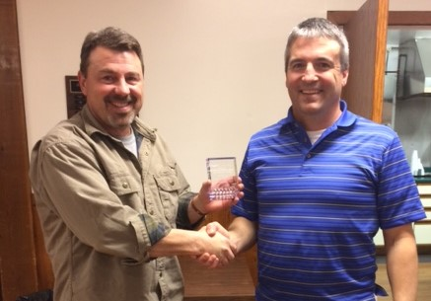

Todd Benson was presented with the Ray Ferrari Memorial Volunteer of the Year award at our February meeting by President Craig Burhoop. Congratulations, Todd!



Mission…

**WE PUMP WATER!**

Online…

Check us out at [www.mccooklakesd.com](http://www.mccooklakesd.com) and www.facebook.com/McCookLakeAssociation

"Like" our Facebook page for all the latest updates!

Meetings…

Meetings are held at the Izaak Walton Club house on the 3rd Tuesday of each month at 7 pm. **PLEASE** join us!

fb.png

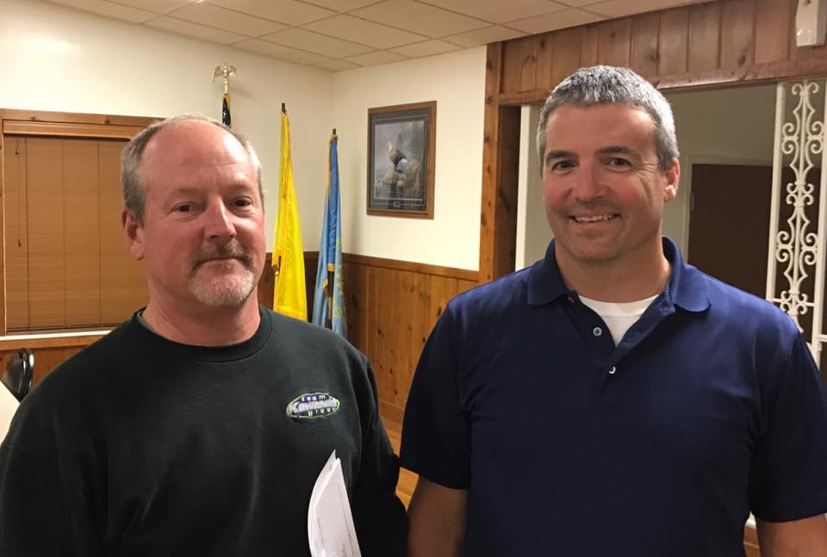

Congratulations to Jon Sandage who was named the President of the MLA at the March meeting. Thanks to Craig Burhoop for his service as President the last few years!

Pumping Update  
The pump was started March 26 and has been running on a slower speed to optimize electricity usage and energy rates. Thanks to less winter seepage and higher river levels for this time of year, the lake is coming up quickly with minimal effort.

Invasive Species Update

The South Dakota Game Fish and Parks department met with us on March 21 to update us on new boating regulations since McCook Lake is in a containment zone for zebra mussels. Pull your plugs prior to leaving boat ramp parking lots, and decontaminate ballast tanks & live wells prior to boating elsewhere. Exemptions are allowed for boaters who register their watercraft with the Local Boat Registry and stay within the zone. More information will be shared as it becomes available, but you can also visit [www.sdleastwanted.com](http://www.sdleastwanted.com) for more information.

2017 Membership Drive

We need your support to keep our lake up and enjoyable for so many. Not only does our lake provide great recreation, but it is a wonderful wildlife habitat and also maintains your property values. A lot of us have new neighbors-- please share the important work that the MLA does with them and the value of their support.

Please fill out the form below with your contribution, or keep watching our Facebook page and website for a new PayPal option coming soon! Previous members will be emailed soon.

**Thank you for your continued support!**

|  |  |
| --- | --- |
|  |  |

***Yes, I Want Water in the Lake!***

**Annual Membership Level (per household):** Name: __________________________________­­­_

* Corporate Sponsor ($1000) Street: ___________________________________
* Platinum ($500) City, State, ZIP: ___­­__________________________
* Gold ($250) Phone: ___________________________________
* Silver ($120) Email: ___________________________________
* Bronze ($50)
* Other Donation amount: $___________ □ I would like to remain anonymous

Please remit to: PO Box 1185, McCook Lake, SD 57049.

The McCook Lake Association is a 501(c) non-profit corporation and donations are tax deductible.



The MLA Thanks our 2016 Corporate Sponsors

**Billy Boy’s Drive-In**

**Ross & Kim Bacon**

**Brian & Kathy Gunderson**

**Mike’s, Inc.**

**Vern Schroeder**

**Leroy & Mindy Zachow**







18’ x 6’, closed cell foam with tether & storage straps

**605-422-1328 www.rubberdockie.com**

PO Box 1185, North Sioux City, SD 57049

Postal Customer, Route 1

North Sioux City, SD 57049

NON-PROFIT

Organization

U.S. Postage

**PAID**

North Sioux City,

SD 57049

Permit No. 100







Kids Fishing Day

The MLA has teamed up with the Ike’s Club again this year and is providing volunteers to help with the Kids Fishing Day on Saturday, June 17, beginning at 9 AM at the Ike’s Clubhouse.

The event is free and poles will be available for use. If you would like to help with this great event, please contact Kelly Kistner at 712-490-1726.

Upcoming Events-Mark your Calendars!

* MLA Meetings: April 18, May 16, June 20,
* Kids Fishing Day: June 17, 9AM-Noon

McCook Lake Association

P.O. Box 1185, McCook Lake, SD 57049

E-Mail:

Jon Sandage: [president@mccooklakesd.com](mailto:president@mccooklakesd.com)

Membership: [membership@mccooklakesd.com](mailto:membership@mccooklakesd.com)

Website: www.mccooklakesd.com

December 2010