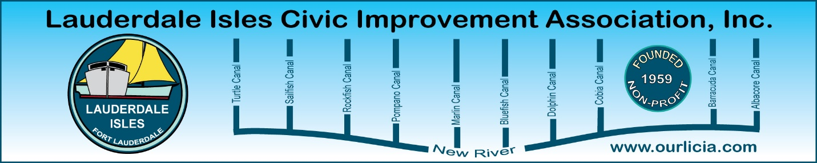
Minutes of the Lauderdale Isles Civic Improvement Association Emergency Board Meeting Zoom call October 3, 2024
The meeting was called to order by President Earl Prizlee at 7:05pm.
Roll call was taken.
Present: Earl Prizlee, Geoff Rames, Karen Rames, Dick Cahoon, Dawn Hanna, Jackie Zumwalt, Glo Knowles, Penny Shea, Trent Simpson, Joann Kratky and Andrew Silverman. Eric Silva, guest.
Purpose of meeting: At the request of Earl and Geoff at the pre-agenda meeting on September 30, Commissioner Sturman agreed to pull OFR-2 from the October 1 Commission agenda, to prevent the Commission from voting to approve the building height in our neighborhood to 35 feet.
The Board agreed that Earl was to ask Jeri Pryor, Chief of Staff for Commissioner Sturman, to set up a meeting with the City Manager and Commissioner Sturman. The Board members will attend if they can. The purpose of this meeting will be to determine why the height amendment for Lauderdale Isles is specified at 35 feet instead of 25 feet, in accordance with the straw ballot at the May General Meeting which was provided to the City. Earl also stated that he will contact Mayor Trantalis.
The Board was extremely concerned about the derogatory letter in Exhibit 8 of OFR-2 that maligned Earl. The letter was from Melanie Hnot of Key Largo Lane dated June 14. This letter was not properly processed when received by the City, and it was not distributed to the Mayor and Commissioner Sturman, nor was a copy provided to Earl. The Board agreed this letter should never have been included as part of the official record and that it should be removed. This letter is to be included in the discussion with the City Manager and Commissioner Sturman to determine how it ended up in the City Commission agenda.
Motion made by Geoff to adjourn the meeting. Dawn seconded and all approved. The meeting ended at 8:00 pm.
Submitted by Karen Rames, Secretary

