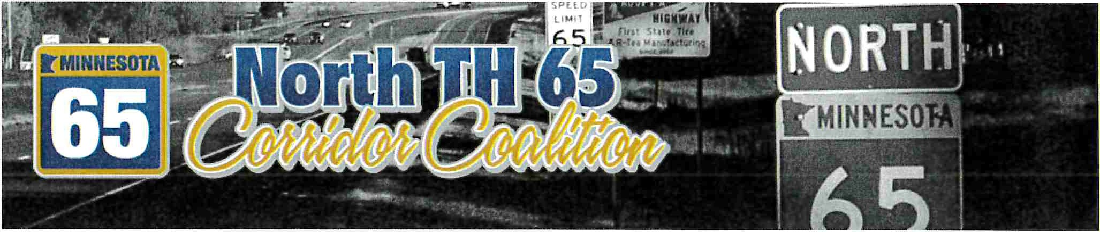

North TH 65 Corridor Coalition Agenda
February 27, 2020, 7:00 P.M.
Isanti County Government Center Cambridge, MN

- Call to Order
- Pledge of Allegiance
- Roll Call/ Establish Quorum
  - Counties: Anoka, Isanti, Kanabec
  - Cities: Blaine, Braham, Cambridge, East Bethel, Ham Lake, Oak Grove, Spring Lake Park
  - Townships: Arthur, Athens, Brunswick, Cambridge, Isanti, Knife Lake
Per JPA Article Vlf1 Section 4: 40% of the membership constitutes a quorum
(40% of 16 = 6.4)
- Approval of Minutes from the September 27, 2019 Meeting
- Treasurer's Report
  - Approval of Treasurer's Report
  - 2020 Membership Dues Status Report
- 2020 Budget Development (See attached worksheet.)
- Administrative Representative Report
  - Update on TH 65 PEL Corridor Study in the cities of Blaine, Ham Lake and Spring Lake Park
  - New Membership Request – City of Isanti
  - Discuss the Creation of Informational Videos (e.g. RCIs, roundabouts, etc.)
- Programmed Projects
  - MnDOT Metro District
  - MnDOT District 3
  - Other
- Community Updates
- Other Business
- Adjourn

