Texas History with Mr. Brown Name ____________________ Period _____
Chapter 1 Picture Search p. 10 - 25
Directions: Use the pictures, maps, graphs, Info boxes, and their captions to find the following information.

1) “No matter how far we may wander, Texas lingers with us, coloring our perceptions of the world.” This is a quote from ________________________.
2) What is the name of the Georgia O’Keefe painting on p.10? ____________________________________________
3) Which city skyline is pictured on p.11? ___________________________
4) What is the area around El Paso known as? ____________________
5) How many days of sunshine does El Paso have each year? _______
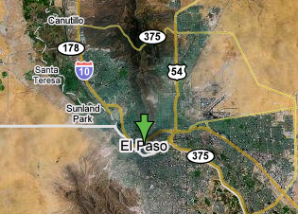
6) What cities light rail system is pictured on p.13? _______________________________

7) According to the 1850 census, how many people were living in Texas? _____________
8) What is the estimated Texas population for 2010? _____________________
9) What TV station is Troy Dungan the weatherman for in Dallas? ________________________
10) What are the four levels of drought conditions? _______________________________________________________
11) What was the 1934 record for days with out rain? ________________
12) By how many days did the year 2000 break that record? ________
13) What pairs of major Texas cities would or do benefit from short distance railway systems?
_______________________________________________________________________________________
14) Name two states that the Rio Grande flows through: __________________________________________________
15) What are the five themes of geography? _______________, _______________, ____________________________, _______________, _______________
16) What street is Memorial Middle School located on? ______________________
17) What type of plant is pictured on p.20? ______________
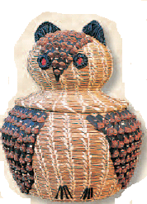
18) How much of the Texas population growth from 1990 to 1998 was from more births than deaths? ________
19) Where is the highest peak in Texas located? ____________________________
20) Which region of Texas are we located in? ______________________________
21) What is an Alabam-Coushatta basket woven from? ______________

