WAG A TAIL PAWSITTING
TERMS & CONDITIONS
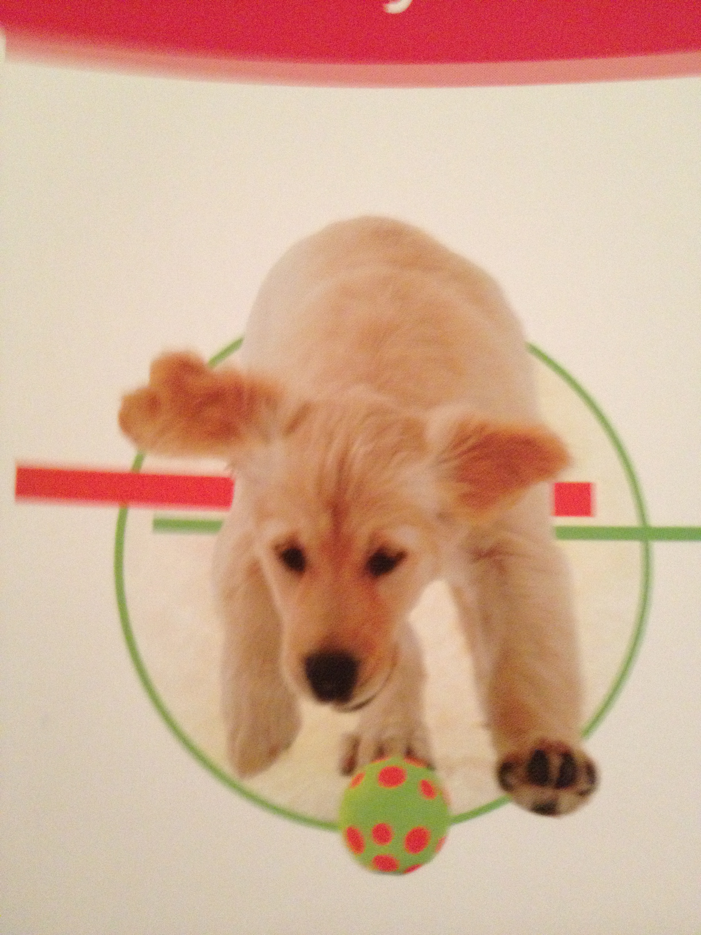
This agreement is made and entered into this _____ day of _________, 20___ and hereinafter between Wag A Tail Pawsitting & (Owner).

- For the safety of Owner’s and other client’s pets, and to prevent the spread of disease, Wag A Tail Pawsitting Services requires that Owner’s pets be healthy and current on applicable vaccinations. Owner agrees to report any contagious disease, so Wag A Tail Pawsitting can handle this situation in a safe manner.

- Owner agrees to inform Wag A Tail Pawsitting of any unwelcome, aggressive or dangerous behavior of the Owner’s pet that has the potential to cause harm to any other pet or individual. Based on each individual case, Wag A Tail Pawsitting may still take care of Owner’s pet. A waiver of liability must be signed.

- It is the Owner’s responsibility to "pet proof" all areas of Owner’s home (including yard gates, fences, etc.) and check all tools (leash, collar, etc.) that Wag A Tail Pawsitting might use. Wag A Tail Pawsitting will not be held responsible for any damage to Owner’s home or injuries to Owner’s pet due to unsafe conditions in Owner’s home or tools.

- It is the Owner’s responsibility to leave all supplies (cleaning supplies, food, litter, old towels, leash, etc.) for Wag A Tail Pawsitting in order to provide the services requested.

- If the Owner’s home poses any danger to health or safety of the pet sitter, or if forms are not filled out and signed prior to Owner leaving town, Wag A Tail Pawsitting reserves the right to discontinue any or all services at any time. Wag A Tail Pawsitting also reserves the right to take Owner’s pet to a kennel at Owner’s cost.

- Owner agrees that Wag A Tail Pawsitting will not be liable for the injury, disappearance, death or fines of any pet(s) that are left with unsupervised access to the outdoors.

- In case of extreme weather conditions, Wag A Tail Pawsitting will attempt to contact Owner and provide service to Owner’s pets as soon as it is safe to do so.

- In case of an emergency with another client’s pet, Wag A Tail Pawsitting will get to Owner’s pet as soon as possible, or will make sure another well qualified pet sitter will take care of Owner’s pet.

- Travel fees to the groomer, vet and such may apply. $20 per hour of time spent + $0.50 per mile.

- Owner releases Wag A Tail Pawsitting from any and all liability related to transportation, veterinary treatment and expenses.

- Holiday surcharge (an additional $10 per day) applies on the following holidays: Easter, Labor Day, Thanksgiving Day, Christmas Eve, Christmas Day, New Year's Eve, and New Year's Day.

- Elderly or unwell pets can be cared for, however no liability will be accepted by Wag A Tail Pawsitting for any decline in health or resulting death.

- For the well-being of Owner’s pets, Owner must contact Wag A Tail Pawsitting @ (508) 320-3947 or (508) 331-4223 upon Owner’s safe arrival home after the trip. If Wag A Tail Pawsitting doesn't hear from Owner, we will assume Owner didn't arrive home, yet. Wag A Tail Pawsitting will try to contact Owner, but will also add more pet visits to feed and take care of Owner’s pets, at Owner’s cost, if Wag A Tail Pawsitting can’t reach Owner.
- If Owner needs to cancel any scheduled services, please let Wag A Tail Pawsitting know as soon as possible. Guidelines are as follows: Dog walks & visits within 24 hours, Pet sitting visits 24 hours notice, Holidays 7 days notice. Visits canceled after these guidelines will result in a 50% non-refundable charge of the service costs within those 24 hours.
- Owner releases Wag A Tail Pawsitting from any and all liability arising out of the services provided, except for direct injuries to the pet(s) or to tangible property resulting from Wag A Tail Pawsitting gross negligence or intentional misconduct.
- Wag A Tail Pawsitting accepts cash only for dog walking and dog training; we accept cash or personal check for pet sitting.

- Upon signing this Agreement, clients agree to pay a nonrefundable 50% deposit of total fees due on the 1st day of pet services. The remaining 50% is upon Owner’s return.

- A $7.00 late fee will be incurred the first day past the due date, continuing with adding $7.00 every 7 days past the due date until amount due is not paid in full.

- A $25 charge will be added to Owner’s bill for each returned check.

By initialing here _______, Owner agrees to let his / her dog co-mingle with other dogs, while supervised.

By initialing here _______, Owner agrees to let his/her dog go off leash, while supervised unless otherwise stated.

By initialing here _______, Owner certifies that Owner will NOT hold Wag A Tail Pawsitting responsible for any damage inflicted by Owner’s pet(s) on other pets or humans as Wag A Tail Pawsitting will do it’s best to avoid any potentially dangerous or risky situations.

Should anything happen to Owner that prevents Owner’s return home, and Owner can not otherwise communicate her/his wishes while Owner’s pet(s) are in care of Wag A Tail Pawsitting, Owner authorizes that his/her pet(s) be turned over to:

Name:______________________________________Relationship:_________________________________

Address:____________________________________Phone Number:________________________________

Owner's Signature: ________________________________ Date: _________________

Owner's Name (please print): ______________________________________________ Phone Number: __________________

Owner’s Email Address: __________________________________________________

Wag A Tail Pawsitting Signature______________________________

Wag A Tail Pawsitting (Print)_________________________________ Date_________________________

