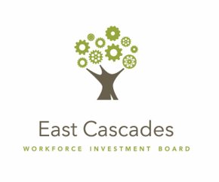

Proposal Narrative: “Moving Up”- Incumbent Worker Training Grant
Applicant Information
Lead Applicant
Primary Contact
Fiscal Contact
Partner Applicant (Name, Company, Phone, Email)
Partner Applicant (Name, Company, Phone, Email)
Partner Applicant (Name, Company, Phone, Email)
Request Information
Training Program Title
Training Period
Requested Amount
Submission Information
Date
Name
Title
Minimum Criteria Certification
In submitting this application, we certify that we have read, understand and meet all “Minimum Criteria for Consideration”, as described in Section VI. of the Request for Proposal. |  | YES/NO (Circle)

General Training Information (20 total points)

1. Briefly describe the training opportunity identified and the benefit this opportunity provides to your company(ies).
2. What is the method for delivery of training? (example: in-class room/ on-line/ on-site)
3. When will training begin and end?
Consortia Training (10 total points)

1. Will multiple companies be participating together, in the same training opportunity? If so, please list the names of each company, as well as the number of employees from each company.
Expression of Need (15 total points)

1. Please describe how this opportunity for training funds makes it possible for your employees to access training, that may have been otherwise inaccessible?
Sector/Industry Information (0 points)

1. Which industy or sector is this training or your company a part of?
Employee Information (30 total point)

1. What positions do employees accessing training current hold?Please indicate the current average wage range of these employees. (Example: $10-14/hr; $14-19/hr; $19-24/hr; $25+/hr)
2. How does training directly benefit the individuals to be trained?

3. What growth and/or promotions are expected as a result of training?

4. How many new positions will be created through the promotion of trainees?

5. Will training result in an industry recognized certificate or credential? Please explain.

