How do I… change my direct deposit information?

You can access your direct deposit information by selecting the “Profile & Settings” option on the menu panel.
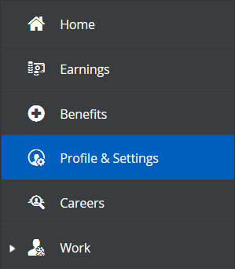

You will then select “Forms” from the options at the top of the screen.

Next, you will select “Direct Deposit” from the list of available forms.
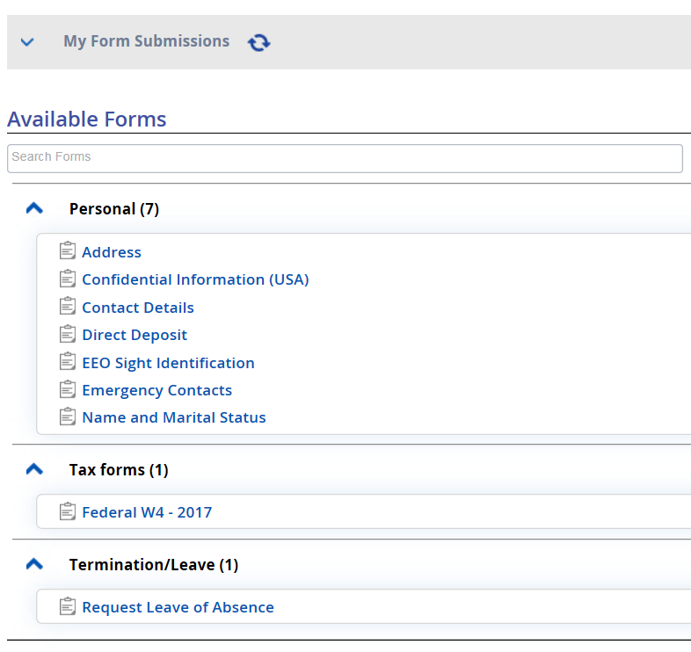
If you are changing an existing account, you will select the “View/Edit” box and update your account information.
If you are adding another account, you will select the “Add” option, and enter your additional account information.
Note: If you are adding an additional account, you will have to enter a specific amount to be deposited into that account. Your remaining funds will be deposited into the account that is marked “Remainder”.
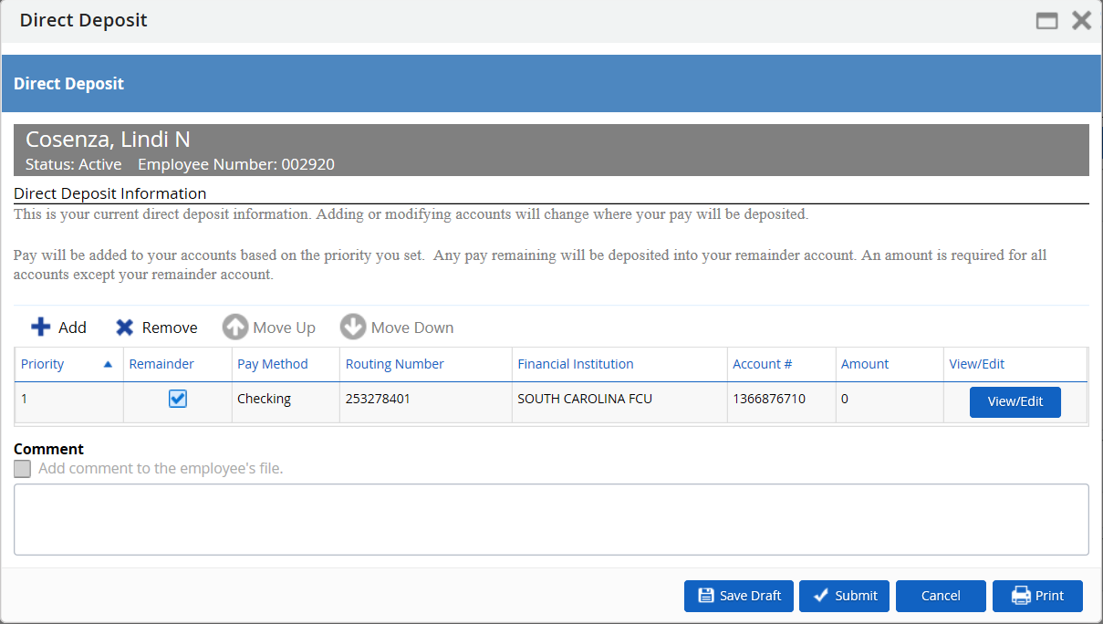
Click “Submit”
Note: when you change/add a new account, you will still receive a live check for the next pay check. The change will take effect the following pay check.

