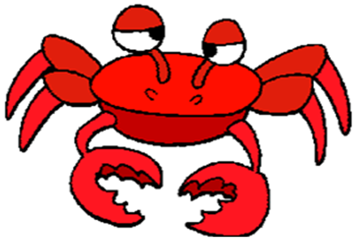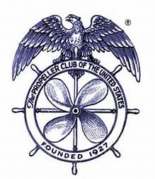

TACOMA PROPELLER CLUB

ANNUAL CRAB FEED

SATURDAY, FEBRUARY 22, 2020

FOSS WATERWAY SEAPORT

705 DOCK STREET

6:00 – 10:00 PM

SPONSORSHIP LEVELS AND VALUES

DUNGENESS - $800

Wine Toss Sponsor

8 Event tickets & 8 Drink tickets

2 Reserved parking spots

2 Bottles of wine (1 each red & white) on table

Signage

Recognition at event

KING - $500

Parking Lot Sponsor

4 Event tickets & 8 Drink tickets

Signage

Recognition at event

SNOW - $300

Dessert Dash Sponsor

2 Event tickets & 4 Drink tickets

Signage

Recognition at event

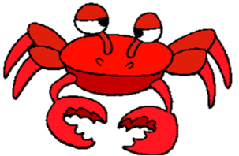

\*\*\*EVENT\*\*\* - $3000

Reserved Table

8 Event tickets & 16 Drink tickets

4 Reserved parking spots

4 Bottles of wine (2 each red & white) on table

BANNER

Signage

Recognition at event

RAFFLE TICKETS