PATIENT CONSENT FORM

Background

Fiberoptic Endoscopic Evaluation of Swallowing (FEES) is a procedure which utilizes modern technology to evaluate and manage swallowing difficulties. The procedure uses a fiberoptic laryngoscope which is passed transnasally (slides in along the floor of the nose) to the hypopharynx (the back of the throat). At this point, the larynx and the surrounding structures can be viewed. The scope hangs quite high in the throat, and does not pass between the vocal folds. Colored foods and liquid are given to the patient, and the swallow is viewed.

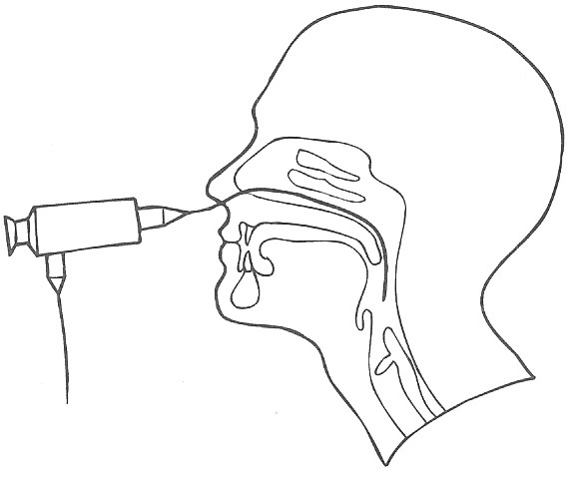
Picture to left shows scope placement
during FEES procedure.

Possible adverse reactions as reported in the literature, which have been considered prior to this patient's selection:

1. Nosebleed
2. Fainting (vasovagal response)
3. An abrupt tightening of the vocal folds if the endoscope passes between
the vocal folds (laryngospasm).

Please Sign Below:

I, ___________________________________________________,understand that the FEES has been ordered
for: ____________________________________________________. The procedure has been explained to me, including the adverse reactions. I give my consent for this procedure and for the recording of this procedure. I understand that the recording and its images may be used for evaluation, educational, research, and teaching or publication purpose, and if so utilized will be de-identified. I give my consent to the therapy provider _____________________________________________________________________________ (facility name) to release any medical information necessary to process claims for this service, and I authorize my insurance company and/or Medicare to make payments on my behalf.

CONSENT GIVEN: Verbal via Phone Contact

_______________________________ 1st witness __________ Date __________ Time

_______________________________ 2nd witness __________ Date __________ Time

Written in person

______________________________ Patient or patient representative __________ Date

______________________________ witness ___________ Date

