Breast is Best!
Willow Woods Learning Center’s
Breast Feeding
Policy &
Information
Booklet

Our belief is that because breast feeding provides the healthiest, normal way to feed babies, providing ideal nutrition and many health benefits for mother and baby, it is important for Willow Woods Learning Center to support and encourage breastfeeding.

Our promise is to ensure that all breastfeeding families have the support they need to continue breastfeeding while their baby attends our center. We encourage Mothers to come and breastfeed their baby as often as they can throughout the day. Mom’s will have the opportunity to breast feed their baby at any time, bottles will be held off, if possible, when mom is due to arrive to breast feed her baby. Formula and solid foods will not be provided unless the mother has requested.
Our Center provides a private room for parents and staff, to breastfeed their babies or express milk. It is located downstairs near our Pre-K classroom. The room provides a refrigerator, where mothers may store their expressed breast milk. Containers should be clearly labeled with name and date. The room also provides electrical outlets, a comfortable chair, a table and a sink. The door has a lock and all that we ask is for Mom’s to hang the “Nursing” or “Pumping” sign outside the door so others will know the room is in use.
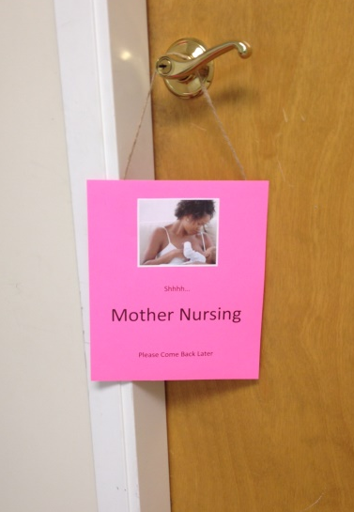

We would like mothers to feel free to use this space as often as they like! Staff will be provided a flexible schedule for breastfeeding or pumping.

Our Staff are trained each year about the importance of breastfeeding, storage and handling of breast milk, and ways to support breastfeeding families. We ensure staff will communicate with parents on how they would like staff to handle certain feeding situations. Staff know that with breastfed babies, feedings are more frequent than formula fed babies because breast milk is digested quickly and easily. When bottle feeding a breastfed baby staff know to always hold the baby close and never prop the bottle.
To ensure breastfed babies are getting the very best care, we will develop a specific breastfeeding-friendly feeding plan with each family.

For Questions or Concerns call 858-5437 anytime or you may stop by the Office to speak with Megan or Leslie.

