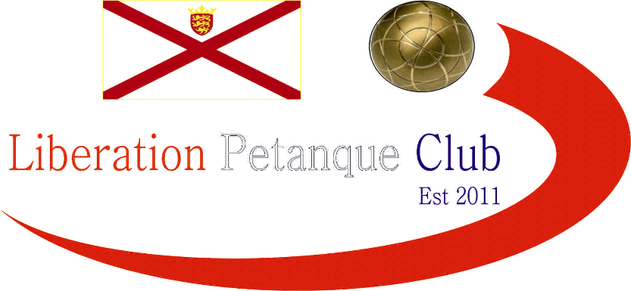

# Summer 2017 Season

# Week 13

# 21st June 2017

# LIBERATION CUP (Doubles)

# CARREFOUR SINGLES OPEN – Sat 24th June 2017

# Just 13 teams played this years competition after a few late withdrawals, but it didn’t affect the quality of the play on the day.

# Matt Pinel & Toby Northern winners in 2015 (Matt also in 2012, 2013 and Toby in 2011) were off to the best possible start winning 13 – 0 against Jean Stewart & Chris Le Gallias.

# A close match between Jake Romeril & James Gennoe v David & Brigitte with the latter just edging the win 13-11. There was a shock though with Last years winner Ross Payne being partner by his new league partner Neil Selby. They lost 13-10 to Harrison Marie & Richard Williams who are relatively new to the sport and joined the club this Summer.

# Round two saw Harrison & Richard play Toby & Matt who went 12 nil up and despite Toby firing out Harrison’s boule Richard placed his last one on the coche to get a point (25 straight points for Toby & Matt), it ended there though as Toby & Matt to the match 13 – 1.

# A really close match saw Andrew Bellamy-Burt & Callum Stewart get 2 points on the last extra end to make it 8 – 8 with Ross & Neil. So the final end was played and Neill missed 2 fires to give the match to Andrew & Callum.

# Alan & Craig played really well to beat Joey Le Clech & Jonny Hill 13 – 2 and David & Brigitte Ibitson beat James & Jake 13 – 11 to move into contention.

# Round 3 didn’t see any change as excellent placing by Toby & firing by Matt saw another 13 – 1 win over Matt Buesnel & Nathan Wheller.

# Callum & Andrew played David & Brigitte which resulted in another draw after the extra end, meaning another one to get a winner, which again Callum & Andrew did.

# The result of the round though was a fanny certificate handed out to Ross & Neil by Joey & Jonny, who had only scored 7 points in their first 2 matches.

# The final round saw the two teams on 3 wins play each other and yet again Callum & Andrew took it into extra time this time against Toby & Matt, but it was the latter who won with boules to spare to finished no.1 ranked team.

# Alan & Craig beat David & Susan Le Gresley 13 – 10 to finish 4th place this was due to David & Brigitte also winning 13 – 10 against Joey & Jonny this mean’t David & Brigitte missed out on a Semi-Final spot by 2 points on points difference.

# Matt Buesnel & Nathan Wheller took 3rd place with a win in a close match 13 – 10 over Harrison & Marie who would have made the top 4 had they won.

# 

# 

SEMI – FINALS

Ranked Ranked

1st  Matt Pinel & Toby Northern v Alan Oliveira & Craig Kelly 4th

2nd Andrew Bellamy-Burt & Callum Stewart v Matt Buesnel & Nathan Wheller 3rd

Well its all about taking your chances and Alan & Craig would end up rueing the first two ends, as instead of being 6 or 7 points up were 3 – 0 down. It kept going that way as any boule anywhere near the coche was fired out time after time by Matt Pinel as himself and Toby went 12-1 up as they looked for another big score. But credit to Alan & Craig as consistent placing and firing and Toby placing deserting him, helped them back to 12-9 but Toby & Matt took the final point to make the final.

The second semi-final was nip and tuck at the beginning as they tied at 6 – 6, but the experienced pair of Callum & Andrew (who won the competition in 2014) took control to make the final.

3rd Place Play-Off

Alan & Craig took third place with ease as Matt Buesnel & Nathan Wheller struggled with the fading light and finishing at 10.30.

FINAL

Toby & Matt took early control of the final as Toby started to place really well and when Andrew did manage to out place him, Matt Pinel fired him out. Despite Callum also firing and placing well Toby & Matt went 12 – 1 up beforew Toby missed a chance to win it. Callum & Andrew did make it to 5 points before Matt’s firing proved the difference after Toby had outplaced 5 boules on the next end.

Matt Pinel increases his record of wins in the competition to 4 and the pair have now won 4 titles together (2 Liberation Doubles Cup and 2 Island Doubles Championships), not a bad record.

Thank you to everyone for taking part especially in the hot weather.

***NEXT WEEK***

**Singles League – Start Time 6pm**

**WEBSITE** [**www.liberationpetanque.co.uk**](http://www.liberationpetanque.co.uk)

**EMAIL** [**liberationpc@gmail.com**](mailto:liberationpc@gmail.com)

**Kind Regards**

**Liberation Petanque Club**

# SPONSORED BY

# http://nebula.wsimg.com/135a1bd6338e1b589a50cdec98bd84d1?AccessKeyId=C6E923731F1A482DD910&disposition=0&alloworigin=1