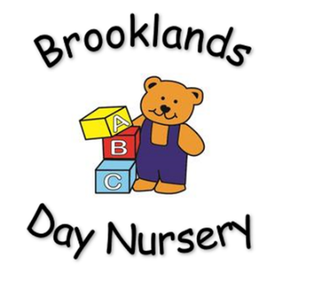
Brooklands Private Day Nursery
Illness Policy

Children who are not well SHOULD NOT be at nursery. Parents will be contacted if their child is displaying any signs of being unwell. Any child who has been sent home from nursery because of ill health will not be re – admitted for at least 24 hours.
If 3 or more develop a similar illness within a short period of time this would prompt an immediate deep cleaning of all the rooms and antibacterial cleaner and/ or Dettol spray will be used when children are out of the room to help prevent the spread of any contagious infection spreading. The manager of the setting will inform parents via tapestry / front door.
Any child suffering from diarrhoea and/ or vomiting will not be re – admitted for 48 hours from the last episode of diarrhoea or vomiting.
Should a child be on any prescribed medication, it is the responsibility of the parent/ career to notify the nursery manager and to sign the necessary forms consenting to administration of this medicine. All medication must be handed in to the nursery manager for proper storage. All prescribed medication must be clearly labelled with the child’s name, dosage and date prescribed. The nursery will not administer over the counter medication that is brought in. If a child is prescribed antibiotics, they will not be allowed to return to nursery for 24 hours from the first dose.
Parents must inform the nursery if a child has been treated with paracetamol or ibuprofen for a temperature as this child will not be admitted to the nursery to minimise the spread of any bugs/ illnesses.
This policy will be reviewed every 12 months by management.

