Kennedy High School
Advisor: Barry Wilson
Crew Chief: Jamie Voorhees (11th Grade)
Driver: Julia Hefel and Jamie Voorhees
Documentation Writer: Julia Hefel (11th Grade)
4545 Wenig Rd. NE, Cedar Rapids, IA 52402
319-784-7697
BWilson@cr.k12.ia.us
1/1/17-1/31/17
30 Car, Class 2
Over the month of January, Jamie has worked aggressively on increasing the aerodynamics of the electric car. To achieve this Jamie has specifically cut off the old aluminum role bar and frontal impact bar that was fitted around the 30 car’s driver for last season who is no longer associated with this particular car. The old role bar was raised at an angle to allow the old driver’s helmet to fit, but now since that raised role bar is no longer needed, the role bar will be lowered. The process of cutting the welds of the old aluminum role bar and old frontal impact bar was loud and time consuming, which caused agitation for Jamie as well as the rest of the people in the room. Everyone in Cougar Electric Car was sincerely grateful when Jamie had completed the removal of the old role bar and old frontal impact bar.
Then next task Jamie tackled was bending one-inch aluminum pipping for the new frontal impact bar. Jamie wanted to be as precise as possible so that both sides of the frontal impact bar were very close in size. So, she spent about two weeks bending and re bending metal pipping to her liking. One issue Jamie encountered was that it was the whole process was trial and error due her new design of the car that was not done previously, so she made a lot of errors. Also she had difficulty setting the frontal impact bars up to be welded because they needed to be symmetrical.
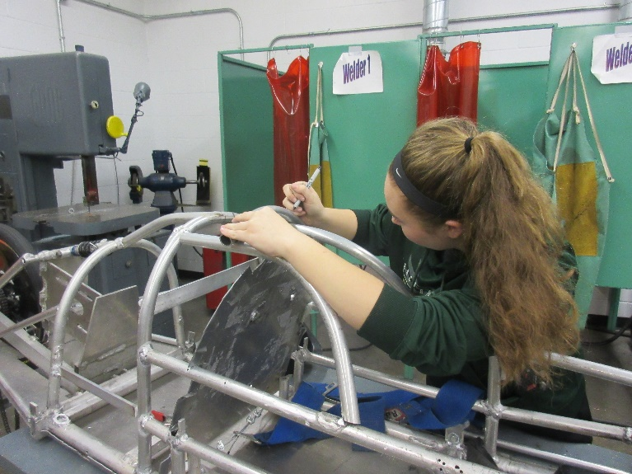

Kennedy High School
Advisor: Barry Wilson
Crew Chief: Hunter Torrey-McAdam (12th Grade)
Driver: Unknown
Documentation Writer: Julia Hefel (11th Grade)
4545 Wenig Rd. NE, Cedar Rapids, IA 52402
319-784-7697
BWilson@cr.k12.ia.us
1/1/17-1/31/17
20 Car, Class 1
Hunter and our advisor Barry have been working over the month of January on bending aluminum piping. The design of the car requires four pieces of aluminum piping bent in perfect circles. Two of the circles have the dimension of 21 inches, while the other three have the dimensions of 14 and 19 inches. This process has had many trials and many errors. The first step was ordering and assembling the pipe bender that is able to bend perfect circles. After Hunter had completed that, he started trails of bending pipe and learning how the bender worked. This process was frustrating for me because it took a lot of time to learn how to get the circle dimensions he wanted. Next month, the goal is to design and construct the role bar and the frontal impact bar for the 20 car. Hunter hopes that bending aluminum piping will go faster this month than last month. Hunter and Barry will continue to work closely together in designing and constructing this new 20 car.
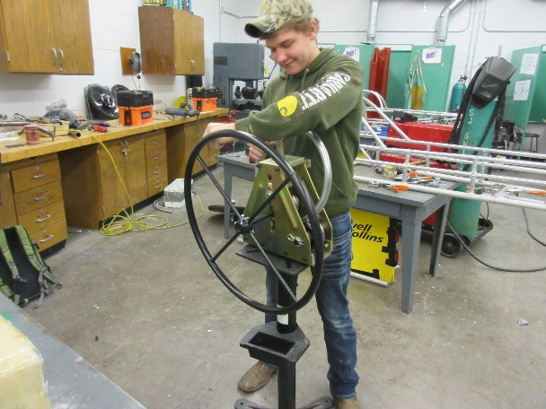

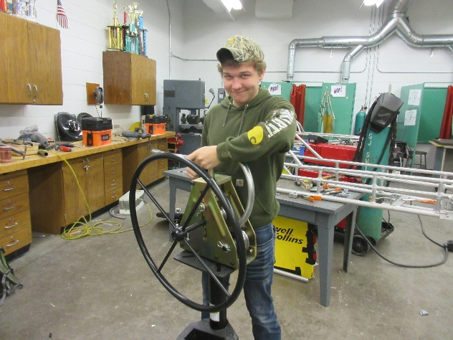

Kennedy High School
Advisor: Barry Wilson
Crew Chief: Derek Severson (10th Grade)
Driver: Molly Sullivan and Hance Throckmorton (12th Grade)
Documentation Writer: Molly Sullivan (11th Grade)
4545 Wenig Rd. NE, Cedar Rapids, IA 52402
319-784-7697
BWilson@cr.k12.ia.us
1/1/17-1/31/17
40 Car, Class 1
Our goal for the month of January is to get the tubing cut and bent the correct way so we can start assembling the car. We have been planning and measuring and planning some more for the past couple months. Since the bench has been dedicated to our car, we have gotten the bottom rails attached to the swing are and have started the process of cutting the rest of the pieces for the car. We are going to accomplish this by using the time we have to get as much done as possible. As parts are made they will be welded on to the car in hopes of it getting as much done each day as possible.

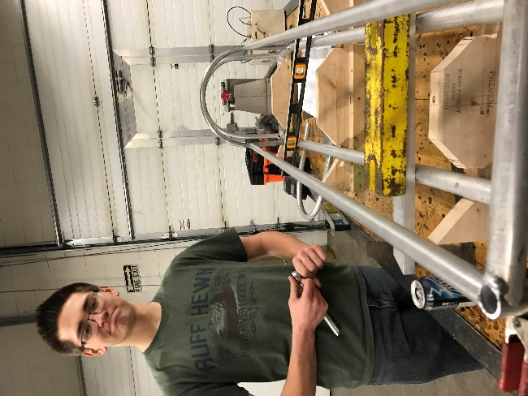
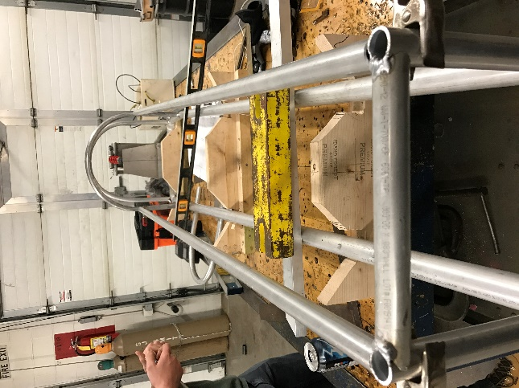

Kennedy High School
Advisor: Barry Wilson
Crew Chief: Ian Carlson (12th Grade)
Driver: Natalie McAllister (11th Grade) and Ian Carlson
Documentation Writer: Julia Hefel (11th Grade)
4545 Wenig Rd. NE, Cedar Rapids, IA 52402
319-784-7697
BWilson@cr.k12.ia.us
1/1/17-1/31/17
50 Car, Class 1
Ian has taken on the challenge of constructing an electric car for the first time. During the month of January, he encountered multiple design and execution problems. While bending the steel axle, he faced the difficulty of ensuring that the axle would be symmetrical. Due to this issue it’s self it caused him to spend multiple days on that project alone.
Once the axle was completed, Ian mounted it on the 50 car without any problems. After adding wheels to the car, it was placed on the ground to measure if it had two inches of clearance. Unfortunately, the electric car was 1/8 inch under the clearance that is required by the rule book. His next plan of action was to cut out the axle of the car and lower it, hoping this would solve his issue quickly. He soon found out that due to the mounting brackets that hold the axle in place within the car, that plan would not be possible. The axle that was cut out of the 50 car had two holes in due to the metal grinder that was used, rendering the axle weak in those two points and it becoming unusable.
Ian was left was with only one option, bend a new steel axle. Once the new axle was complete and mounted, the 50 car passed the two-inch clearance that is required. The second time Ian went through this process it went smoother than the first attempt.
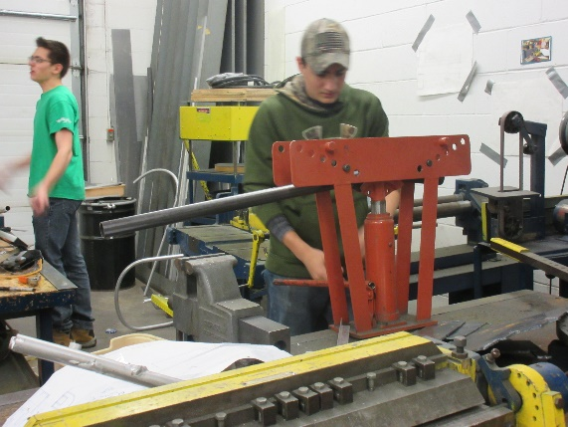
The goals for the month of February for the 50 car is to start and finish the steering column and swing arm.

