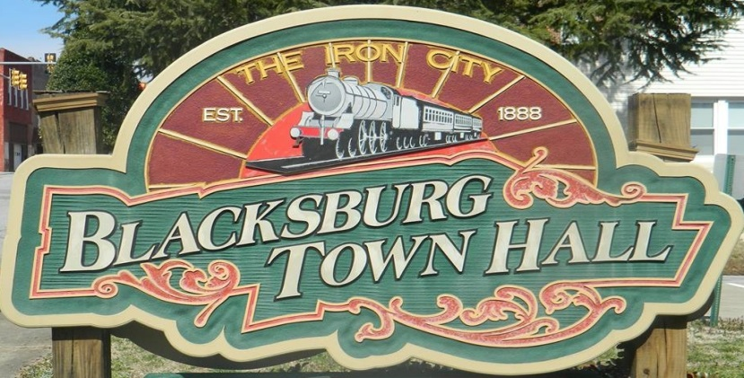

Town of Blacksburg
Help Pave Blacksburg Museum of History Courtyard
HAVE THE LIFE OR MEMORY OF A LOVED ONE IMMORTALIZED OR HAVE YOUR NAME ENGRAVED ON A BRICK PAVER AT THE MUSEUM FOR ALL TO RECOGNIZE AS A CONTRIBUTOR
PAVER ORDER FORM
$75 EACH for first paver
$50 EACH for additional pavers
PAYABLE TO: TOWN OF BLACKSBURG
3 LINES OF COPY WITH A MAXIMUM OF 14 LETTERS PER LINE

SIGNATURE

ADDRESS AND TELEPHONE
For any additional information please call (864) 839-2332

