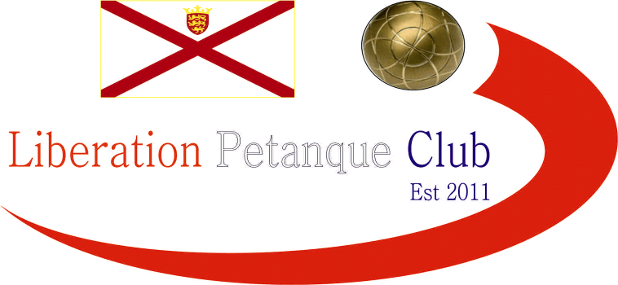

20212
Charity Triples Open
In aid of Jersey Children’s Charity

Just 6 teams took part in this year’s competition, the lowest entry numbers in seven years. Entries and donations though helping raise £270 towards supporting the Charity. Five full rounds played under a league format.

Last years champions Brian Harris and James Gennoe were this year playing with Dawn Buckley, they started off well winning 13 – 7 over Colin, Jim and Ian.

A big match between Geoffroy, Laurent and Toby versus Matt Pinel, Gavin Scott and John Lane went heavily in favour of Geoffroy, Toby & Laurent 13 – 1, leaving the latter a tough way back in the competition. Neil, Paul and Ross had been Runner’s Up in the previous two years started off with a win over Callum, Cassie and Jean.

Round two saw Geoffroy, Laurent and Toby beat Neil, Paul and Ross 13 – 9 for a crucial win with Toby placing perfectly onto the coche through a deep puddle to seal the win.

Gavin, John and Matt beat last years champions also 13 – 9 and Callum, Cassie and Jean took the win over Colin, Jim and Ian.

Well it went down to the extra, extra end and at 12-12 Callum fired taking the coche out, which had to be replaced. This was enough to help Geoffroy, Laurent and Toby take the match. Gavin, John & Matt just made it two wins in a row, winning 13 – 10 over colin, Jim & Ian. Neil, Paul & Ross handed Brian, Dawn & James their second defeat.

Two matches timed out, not making it to 13 as Geoffroy, Laurent & Toby found the going tough against Colin, Jim & Ian winning 12 – 8 in the end. Neil & Paul & Ross also won 12 – 9 over Gavin, John & Matt ending their hopes with Callum, Cassie & Jean taking the win over Brian, Dawn & James.

Going into the final round of the competition, a win for Geoffroy, Laurent & Toby over last year champions would seal them the title and they did that in style winning 13 – 0! Neil, Paul & Ross took the runners Up spot for the third straight year beating Colin, Jim & Ian.

Another 13 – 0 as Callum, Cassie & Jean beat Gavin Scott, John Lane and Matt Pinel.

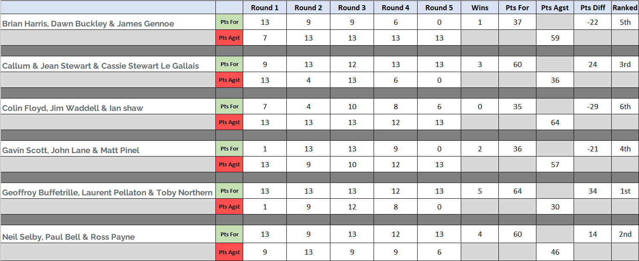

WINNERS

Laurent Pellaton, Toby Northern & Geoffroy Buffetrille

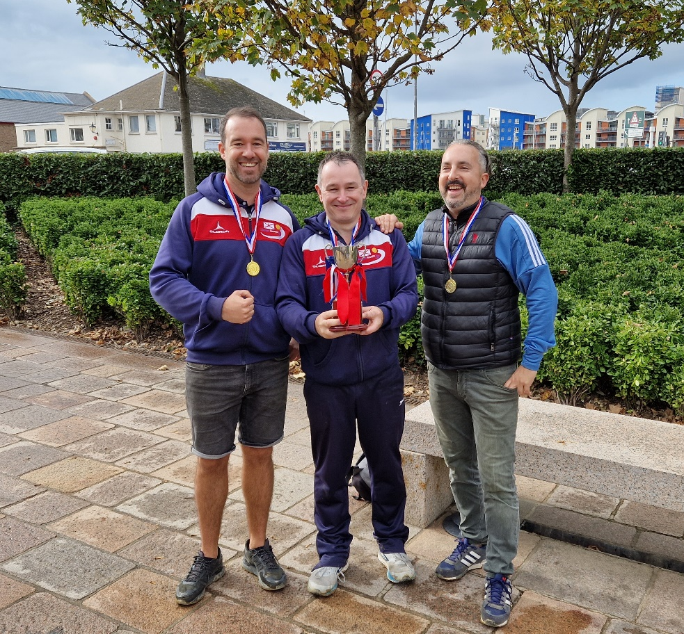

Special thanks to everyone who took part in the competition and helped raise money for a good cause and also those who donated and helped organise the competition.

Kind Regards

Toby Northern

Chairman

Liberation Petanque Club

