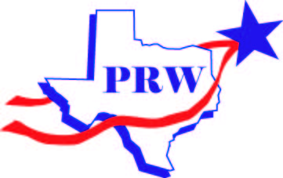
Please mail this form with your check made payable to PRW:
Plano Republican Women
P. O. Box 940461
Plano, Texas 75094
CORPORATE CHECKS CANNOT BE ACCEPTED

PLANO REPUBLICAN WOMEN MEMBERSHIP/SPONSOR FORM Year: 2017

Memberships:
_____ $30 Full Active Single Membership
_____ $35 Full Active Membership with Spouse
_____ $25 Associate Membership – for Men or Active Members of other Republican Women Clubs
Sponsors:
_____ $200 Platinum: Ad in Directory & Newsletter; PRW Webpage image w/link to your website
& associate membership for your spouse
_____ $150 Gold: Newsletter Ad, PRW Webpage image w/link to your website & spouse associate membership
_____ $100 Silver: Ad in the Newsletter & listing on the Website OR Webpage image w/link to your website
_____ $75 Bronze: Ad in the Membership Directory and listing on the Website
Additional (Optional):
_____ $1 TFRW Scholarship Donation _____ $8.00 Magnetic PRW Name Tag
_____ $3 Mail Delivery of the annual PRW Membership Directory

TOTAL: _________________________ Check #: _______________________

Please provide the information to be included in the PRW Membership Directory

Name_____________________________________________________ Spouse_________________________

Address __________________________________________________________________________________
Street City Zip code + 4
Phone numbers: (home) __________________ (Office) __________________ ( Cell) ____________________

Email* _____________________________________________Precinct# _____ Birthday (month & day) _______

Spouse Email*___________________________________________
* Email is used for newsletters and other PRW announcements

The information requested below is required by the Texas Ethics Commission:

Occupation ___________________________________Employer _____________________________________

