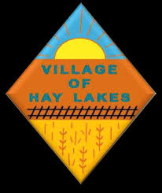
AGENDA OF THE REGULAR MEETING OF COUNCIL
OF THE VILLAGE OF HAY LAKES
In the Province of Alberta held on
May 22, 2024, at 7:00 p.m.
In the Hay Lakes Recreation Centre

- CALL TO ORDER:

- ADOPTION OF AGENDA:

- DELEGATIONS:

- GENERAL GOVERNMENT:
- Minutes of the Regular Meeting of Council April 15, 2024
- Minutes of the Committee of the Whole Meeting (Financial) of Council held on May 6, 2024

- STANDING REPORTS:
- Public Works Report
- Financial Report
- First Quarter Report by Rod Griffiths
- Financial Action List
- CAO’s Report & Action List
- Council and Committee Reports (attached Schedule)

- NEW BUSINESS:

- OLD BUSINESS:
- Cameron Martin: Commercial Development
- Lift Station Upgrades

- BY-LAWS/POLICY:
- Bylaw: N/A
- Policy:

- CORRESPONDENCE:

- CONFIDENTIAL ITEMS:

- ADJOURNMENT:

Next Regular Meeting of Council to be held on June 17, 2024.

