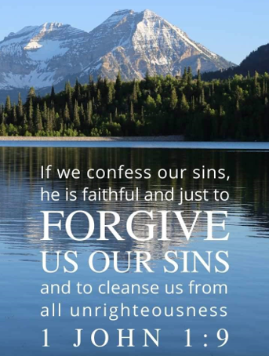

September 5, 2021

15th Sunday after Pentecost

Carson City United Methodist Church

10:00 am
Prelude/Greeting
*Indicates stand as you are able

Call to Worship
From Revelation 21

L: We long for the day when we hear.

P: A loud voice from the throne saying, “Look! God’s
dwelling place is now among the people,

L: And God will dwell with us.

P: We will be his people, and God himself will be with us and be our God.

L: God will wipe every tear from our eyes.

P: There will be no more death’ or mourning or crying
or pain, For the old order of things has passed
away.”

*Hymn: America the Beautiful UMH 696

Opening Prayer: (unison)
Gracious Heavenly Father, we do not come to your table this morning, trusting in our own goodness. We come trusting in your all-embracing love and mercy. We know we are not worthy to gather the crumbs from under your table. But it is your nature to always have compassion and mercy. So feed us with the body and blood of Jesus Christ this morning, your Son, our savior, and Lord so that we may forever live in him and he in us AMEN.
Contemporary Song: Don’t Tread on Me (We the Kingdom)

Gospel Reading: MATTHEW 18:21-35
Old Testament: PROVERBS 28:13
Epistle Lesson: 1 JOHN 1:5-10

THE MESSAGE
Communion

Children’s Song: Every Where I go, I go with You (VBS)

Sharing of our joys and concerns

Call to Prayer: Turn Your Eyes Upon Jesus
UMH 349

Pastoral Prayer

Offering/Offertory Prayer

Doxology UMH 95

*Hymn: The Battle Hymn of the Republic
UMH 717

BENEDICTION

CCUMC – Announcements

========================================
Office closed: In observance of Labor Day CCUMC office will be closed Monday, Sep 6th.
========================================
Volunteers needed for: Lighting of Candles and Passing of Collections Plate starts Sunday, Sep 12th. The signup sheet will be passed around today and will be placed on the table with the Sunday Bulletins.
========================================
Event questionnaire: You will find an insert within the bulletin that we would like all to out. Please return it to the office.
========================================
Nursery returns on Sunday, 9/12/21. The schedule will be posted on the Nursery window at the
end of August.
========================================
***Important update***
Effective Sunday, 9/12/21, we will continue with one Worship Service, but it will start at 10:30 am.
=========================================
Come join the fun on Sun, Sep 12th @ 9:15 am for lots of activities to welcome back our Sunday “Cool” Hour. Kids, Teens, are invited. Adults are invited to help.
=========================================
A.R.K. begins Sep 15th @ 6:30 pm to 8:00 pm in Daniels Den. We will be learning about the Names of God in the Old Testament. All kids welcome from ages 3 through 7th grade. Snacks are included.
=========================================
Join us for our next Soup Lunch
Fri, Sep 17th, 11 am - 1 pm
Soup Luncheons email umwluncheon@gmail.com
Announcements cont’d
=========================================
Women’s Small Group Studies will begin again from 6:30-8:00 pm on Sept 19th. All women who would like to be refreshed and energized in this world of ever-increasing fear, bad news and disappointment, are invited to come check us out! We laugh, learn, and intentionally connect with God and each other. New faces are always welcomed and cared for. Contact Nancy Wilson for more info. 989.763.5975
=========================================
Church Directory: It’s time for a new directory. Schedule your photo session on Oct 10 & Oct 11 from 2-8:30 pm. There are signup sheets located on the Welcome Center. Informational documents & instructions are located Welcome Center & on table with the Sunday Bulletins.
========================================

Sunday Worship | 9/12 starts @ 10:30 am
Nursery | 9/12 during Worship Svcs
A.R.K. | 9/15 from 6:30-8:00 pm
Sundays Cool Hour | 9/19 from 9:15-10:20 am
Women's Group | 9/19 from 6:30-8:00 pm
Euchre | 10/9 from 5:00-7:30 pm
Dorcas | 10/4 starts @ 10:00 am

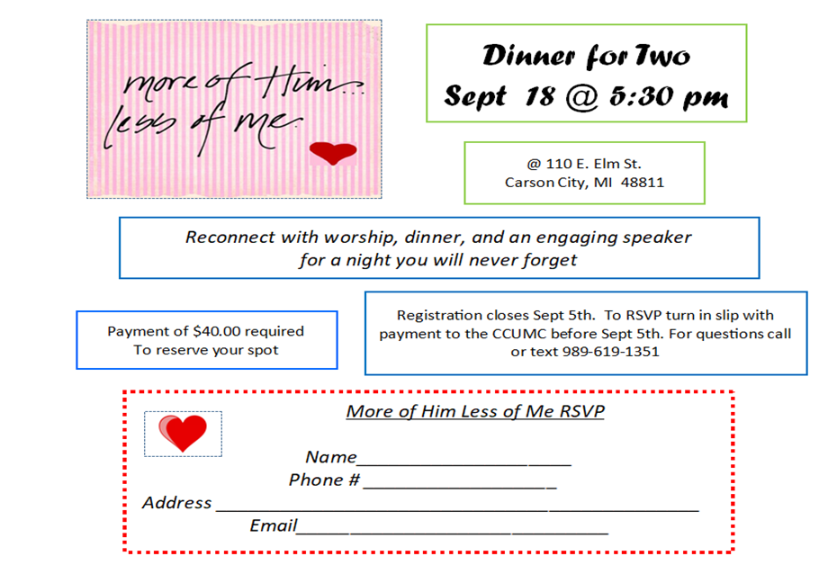
Please note, you can also prepay for above via Vanco Online giving website
You’re Invited

Serving and Supporting Sunday Worship
Audio/Video: Pat Monroe

Joys, Concerns & Prayer Request
For those battling cancers: Wendy Crawfis,
Beth Grienke, Jim Dunlap,
Carolyn Nykerk, & Ray Seaman

For everyone who needs support,
guidance or has health concerns.

Monthly Giving
8/1 $2095.57 8/8 $4197.57
8/15 $2070.57 8/22 $4335.57 8/29 $910.01

Coming Up
9/06 Labor Day – Office Closed
9/12 Funday Sunday 9:15 am
9/13 UMW Come Eat with Us 5:30 pm

Our Church in Ministry This Week

Mon 6:30 pm | Personal Transformation Class

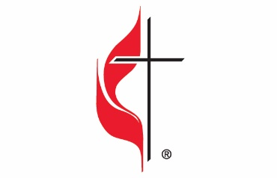

Carson City United Methodist Church
Location: 119 East Elm St., Carson City, MI
Mail: PO Box 298, Carson City, MI 48811
Phone: 989-584-3797 Email: carsoncityumc@gmail.com
Website: carsoncityumc.com
Office Hours: Monday-Thursday, 9:00 am-12:00 pm
After hours by appointment
Pastor: Ian McDonald 906-322-5318
Secretary: Bonnie Seaman 989-763-1674

Weekly Sunday Bulletin now available on our website
@ www.carsoncityumc.com

“Jesus, help me travel lightly according to Your wisdom and to finish well”

