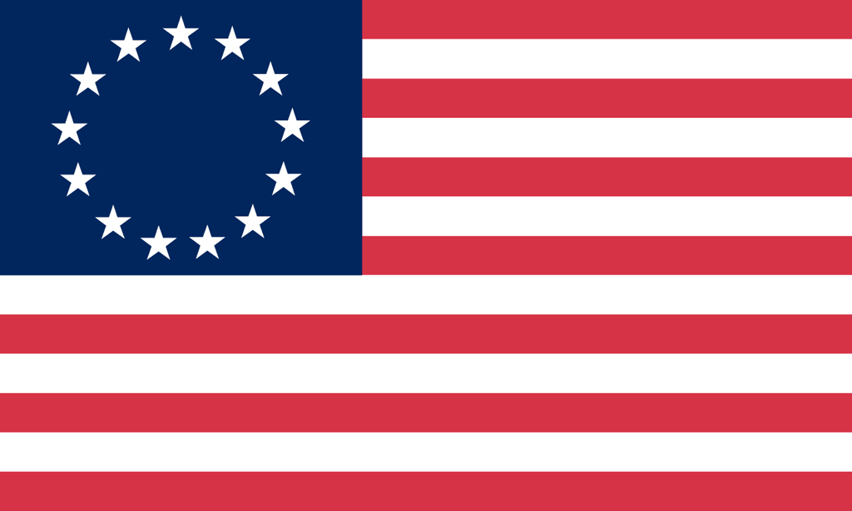U.S. History with Mr. Brown Name _______________________________ Period _____
Vocabulary Terms
Ch 5.3 French and Indian War

Directions: Use the text book to define the vocabulary terms in the space provided below.

French and Indian War
Albany Plan of Union
Battle of Quebec
Treaty of Paris (1763)
Pontiac’s Rebellion
Proclamation of 1763

