Eastern Shore Nostalgia:
Rustic Buildings & Structures
61st Members Show

(A) Oils/Acrylics/Pastels  (B) Watercolor/Gouache/Alcohol inks  (C) Graphics, Pen & ink, Printmaking  (D) Mixed Media/Collage  (E) Photography  (F) 3-D (includes sculpture and jewelry)  SHOW RULES  - Each artist may enter up to three works in any Category with a maximum of three works for the show. Work must be original (no reproductions), and not previously exhibited at KIFA.  - KIFA Guidelines for hanging will be strictly enforced. The guidelines can be found on the Gallery Exhibits page on the KIFA website. All works on paper with no glass must be sealed with art wax, framed with wire taped on the ends  - 2-D Art: Submissions cannot exceed 36” x 48” including the frame. Sculpture, including the base, may not exceed six feet.  - All entries must remain on display through the end  of the show except for when a piece is sold to an  out-of-town buyer.  - KIFA reserves the right to reject submissions deemed unsuitable.  - KIFA is not responsible for loss or damage to works, but reasonable caution will be taken.  - KIFA will take 30% commission on all works sold during the show. | ENTRY FEES  Members $20 up to 3 images  Non-Members $25 up to 3 images  Youth $2/image up to 3 images  Youth is anyone under 16 years old.  Due to space limitations in the galleries, it is advisable to enter as early as possible. Entries received after the limit is reached will be returned with entry fee to the artist.  Make check payable to KIFA  Bring completed Entry Form and Fee to  KIFA or mail to: KIFA Gallery Show  405 Main Street, Stevensville MD 21666  Pre-registration is appreciated, but not required.  By entering, you agree to all the stipulations of this prospectus.  KIFA MEMBERSHIP DUES  Seniors (62+) $35 / Individuals $40  Family $50 / Military $25 / Youth & College $15  A membership fee may be combined with entry fee. Please specify the type and amount on the check.  QUESTIONS??  Please contact the KIFA office at 410-643-7424 or Margaret at (410- 271-3730  Co-Chair Pat Spinella.
CATEGORIES

Entry Form Part 1
Attach to Entry
Name_______________________________________________
Address________________________________________________ Phone_______________ Email___________________________

Piece 1
Name_______________________________________________ Title________________________________________________ Price _________ Size framed ______________
Category: (A)___ (B)___ (C)__ (D)__(E) ___ (F) ___
Piece 2
Name_______________________________________________ Title________________________________________________ Price________ Size framed ______________
Category: (A)___ (B)___ (C)__ (D)__(E) ___ (F) ___

Piece 3
Name_______________________________________________ Title________________________________________________ Price________ Size framed ______________
Category: (A)___ (B)___ (C)__ (D)__(E) ___ (F) ___

Cut and Attach Separately to Your Work
…………………………………………………………………………………………
Entry Form Part 2 – Attach to each piece.
Piece 1
Name_______________________________________________ Title________________________________________________ Price________ Size framed ______________
Category: (A)___ (B)___ (C)__ (D)__(E) ___ (F) ___

Piece 2
Name_______________________________________________ Title________________________________________________ Price________ Size framed ______________
Category: (A)___ (B)___ (C)__ (D)__(E) ___ (F) ___

Piece 3
Name_______________________________________________ Title________________________________________________ Price________ Size framed ______________
Category: (A)___ (B)___ (C)__ (D)__(E) ___ (F) ___

Our Judge…
TBD

KIFA’s Upcoming SHOWS

^{July/August Photography Show}

September/October Abstract Show

Nov/Dec Comfort Zone & Holiday Art

SHOW CALENDAR

Sunday, June 2, 1-5pm
Monday, June 3, 11-3pm
Drop-off Work

Thursday, June 6
Show Opens with Reception
5 pm to 7 pm

Sunday, July 21
Show closes 4 pm

Monday, July 22
Pick-up work, 2 pm -6 pm

KIFA is partially funded by Maryland State Arts Council, Mid-Shore Community Foundation, Queen Anne’s County Arts Council, QA County Government, United Way, as well as patrons, members, and donors. Thank you!

KENT ISLAND
FEDERATION OF ARTS

61st Members Show
Eastern Shore Nostalgia:
Rustic buildings and structures
with floral creations by the
Kent Island Garden Club
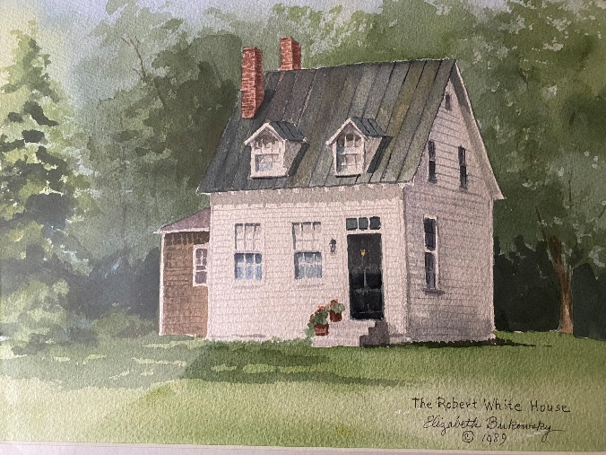

Show Dates: June 6 – July 21

Reception June 6
5:00 – 7:00 pm

