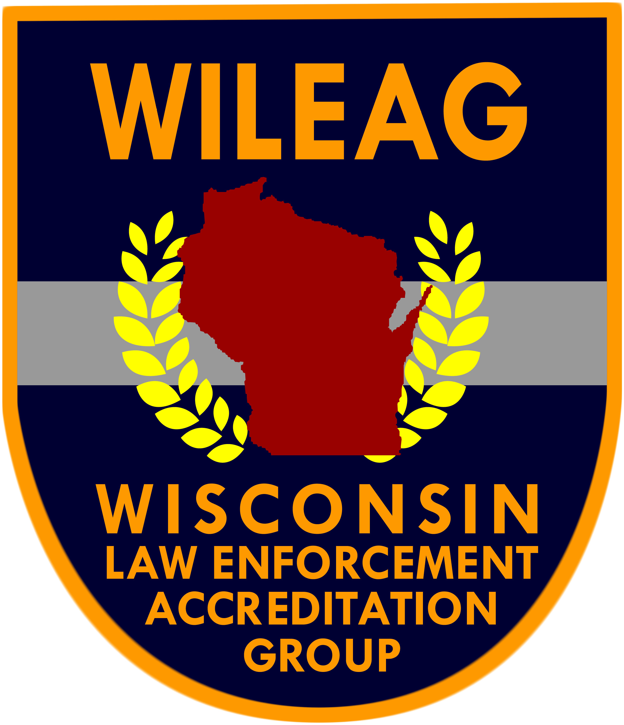 | Accreditation Compliance Report  (5th Edition)
 | Accreditation Compliance Report  (5th Edition) | Chapter 6
 | Accreditation Compliance Report  (5th Edition) | Operations
 |  | Section 5
Standard #: 6.5.1 |  | Special Investigations
Assigned to: |  | Standard 1
Prepared by: |  | Vice, Drugs, and Organized Crime

WILEAG Assessor Use Only
Compliance Verified Non Compliance Not Applicable by Function
Assessor Comments:
Assessor Signature: Date:

Scope and Dimension(s)
A written directive requires the agency to have policies covering receiving, processing, recording, and investigating vice, drug, and organized crime complaints.

Agency Compliance Information
Written Directive:
Written Documentation:
Observation of:
Interview with:
Agency Comments:
Not Applicable by Function: Explain:

