**Beaufort County Economic Development Report October 2017**

**Industry-Ready Building Under Construction**

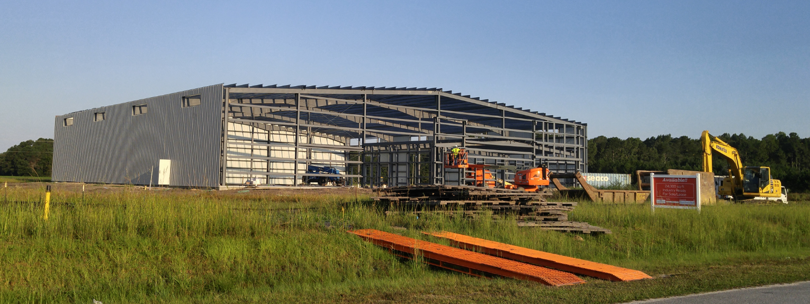

Rapid progress is being made on the Industry-Ready Building, so if you hear of any company needing a building in which to locate or relocate, please have them contact Martyn Johnson at [martyn.johnson@beaufortedc.com](mailto:martyn.johnson@beaufortedc.com) or call 252-946-3970.

The Industry-Ready Building specifications in summary are:

Size: 24,300 sq. ft.

Material: Steel/Masonry

Eaves: 26 feet

Floor: 6 inches reinforced concrete

Truck bays: 3 dock high

1 drive-in

Lighting: Fluorescent

Transom skylights

Plumbing: Office roughed-in

Sprinkler system installed

Electrical: Roughed-in

Security system

Office Space: Skills Center for start-up

Space designated

Expansion to: 48,600 sq. ft.

Completion: December 2017

**September 2017 Project Submissions**

**Industry Jobs Invest Need**

Pressure Vessels 30 $ 5 M Bldg.

Textiles 50 $ 4 M Bldg.

**September 2017 Project Visits**

**Industry Jobs Invest Need**

Electronics 65 $ 3 M Bldg.

**PAS Purchases Manufacturing Facility**

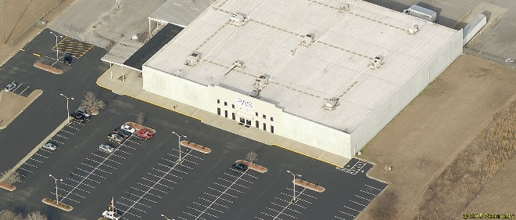

On October 2, 2017, the Beaufort County Committee of 100 financially assisted PAS’s parent Prettl to purchase the building PAS has occupied for the past 15 years. The purchase will allow PAS to focus on increasing their sales and expanding their business with the knowledge their manufacturing footprint is secure. PAS USA Inc. Washington, NC produces control panel systems for major appliance manufacturers. PAS Group companies provide system solutions for appliance manufacturers, produced at facilities in Germany, Poland, China, Turkey, the US and Mexico.

