6/3/2017 The Dust Test

The Biblical Dust Test

If a husband became jealous of his wife, having the feeling that she might have committed adultery, there was a test that the Priest would give the woman in order to determine if she had been unfaithful to her husband. The dust of the Tabernacle floor would be mixed with water before YaHuWaH and the woman would drink the water. YaHuWaH 's verdict would be apparent to everyone.

Numbers 5:11 And YaHuWaH spake unto Moses, saying,
12 Speak unto the children of Israel, and say unto them, If any man’s wife go aside, and commit a trespass against him,
13 And a man lie with her carnally, and it be hid from the eyes of her husband, and be kept close, and she be defiled, and there be no witness against her, neither she be taken with the manner;
14 And the spirit of jealousy come upon him, and he be jealous of his wife, and she be defiled: or if the spirit of jealousy come upon him, and he be jealous of his wife, and she be not defiled:
15 Then shall the man bring his wife unto the priest, and he shall bring her offering for her, the tenth part of an ephah of barley meal; he shall pour no oil upon it, nor put frankincense thereon; for it is an offering of jealousy, an offering of memorial, bringing iniquity to remembrance.
16 And the priest shall bring her near, and set her before YaHuWaH :
17 And the priest shall take holy water in an earthen vessel; and of the dust that is in the floor of the tabernacle the priest shall take, and put it into the water:
18 And the priest shall set the woman before YaHuWaH , and uncover the woman’s head, and put the offering of memorial in her hands, which is the jealousy offering: and the priest shall have in his hand the bitter water that causeth the curse:
19 And the priest shall charge her by an oath, and say unto the woman, If no man have lain with thee, and if thou hast not gone aside to uncleanness with another instead of thy husband, be thou free from this bitter water that causeth the curse:
20 But if thou hast gone aside to another instead of thy husband, and if thou be defiled, and some man have lain with thee beside thine husband:
21 Then the priest shall charge the woman with an oath of cursing, and the priest shall say unto the woman, YaHuWaH make thee a curse and an oath among thy people, when YaHuWaH doth make thy thigh to rot, and thy belly to swell;
22 And this water that causeth the curse shall go into thy bowels, to make thy belly to swell, and thy thigh to rot: And the woman shall say, Amen, amen.
23 And the priest shall write these curses in a book, and he shall blot them out with the bitter water:
24 And he shall cause the woman to drink the bitter water that causeth the curse: and the water that causeth the curse shall enter into her, and become bitter.
25 Then the priest shall take the jealousy offering out of the woman’s hand, and shall wave the offering before YaHuWaH , and offer it upon the altar:
26 And the priest shall take an handful of the offering, even the memorial thereof, and burn it upon the altar, and afterward shall cause the woman to drink the water.
27 And when he hath made her to drink the water, then it shall come to pass, that, if she be defiled, and have done trespass against her husband, that the water that causeth the curse shall enter into her, and become bitter, and her belly shall swell, and her thigh shall rot: and the woman shall be a curse among her people.
28 And if the woman be not defiled, but be clean; then she shall be free, and shall conceive seed.
29 This is the instruction of jealousies, when a wife goeth aside to another instead of her husband, and is defiled;
30 Or when the spirit of jealousy cometh upon him, and he be jealous over his wife, and shall set the woman before YaHuWaH , and the priest shall execute upon her all this instruction.
31 Then shall the man be guiltless from iniquity, and this woman shall bear her iniquity.

The Emergency Room

My wife needed to go to the emergency room on 6/1/2017. She has Dementia and was suffering from a painful case of the Shingles and other ailments. Because of the Dementia, she's unable to tell me where she hurts, or even if she's hurting, or what other problems she might be experiencing. She had eaten just a few bites of food in the last 3 days and had was able to drink only a very small amount of water each day and her urine was darkening, so off we went to the emergency room.

While at the emergency room, we overheard a teenage patient on the other side of the privacy curtain describe her condition to the doctor. She had been riding through the woods on a 4 wheeler with friends and some dust was kicked up into her eye. Along the way her eye was splashed with swamp water. Her eye became infected with a small cut from the dust and she came to the emergency room for treatment.

I mention the event because the eye is symbolic of the spirit. The Hebrew word for eye is ayin. Ayin is also a letter of the Hebrew alphabet. The Ayin of the ancient Paleo Hebrew alphabet of 3,000 years ago looked just like a human eye.

The teenage girl in the emergency room had dust mixed with water introduced into her eye and the eye had become infected. This is mindful of the test for the adulterous woman recorded in Numbers 5 above. Because it was the eye, the ayin, that had become infected because of the dusty water, and the eye is symbolic of the spirit, we associate the outcome of the "test", the infected eye, as being symbolic of spiritual adultery.

Spiritual adultery is committed when a person is married (has pledged his devotion and heart) to a certain god, and then decides to give his love and devotion to another god. YaHuWaH Elohim said that His people had pledged their devotion to Him by accepting His Ten Commandments, and then left off loving Him and bowed themselves to idols. They had committed spiritual adultery, giving their love to other gods and calling upon those gods to meet their needs for healing, sustenance, and protection.

Matthew 6:24 No man can serve two masters: for either he will hate the one, and love the other; or else he will hold to the one, and despise the other...

The Image of Jealousy

Because we are, or should be, YaHuWaH 's temple, His earthly dwelling place, there should be nothing in our hearts that would detract from our loving Him above everyone and everything else. What we do physically is an indication of who we are spiritually.

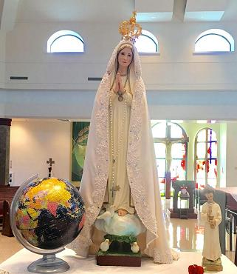
Above: An Image of Jealousy

This world is filled with idols. Idols are the things that modern man spends his time thinking about, considering them in his heart, and to which he attributes power, prestige, and devotion. The modern "Cathedrals of Idolatry" are the sports stadiums and movie theatres filled with people adoring their "mighty ones". The movie, Wonder Woman, a supernatural savior, is a depiction of the latest manufactured idol to be adored by millions of people.

The modern household idol is the TV set with it's selection of idolatrous images available in private. The people of YaHuWaH were doing the same thing on a limited scale over 2,500 years ago.

Ezekiel 8:12 Then said He unto me, Son of man, hast thou seen what the ancients of the house of Israel do in the dark, every man in the chambers of his imagery? for they say, YaHuWaH seeth us not; YaHuWaH hath forsaken the earth.
13 He said also unto me, Turn thee yet again, and thou shalt see greater abominations that they do.

The Image of Mary and statues of Saints have been previously mentioned as being distractions from the highest love and devotion that we need to have reserved for only our heavenly Father. If we devote more love to Mary than to our heavenly Father, her image can become an Image of Jealousy, a detestable thing in our heavenly Father's sight.

Bowing the knee to statues is forbidden by our heavnely Father. This has been hidden from the sight of most Roman Catholic parishioners by removing the 2nd commandment from Catholic bibles. Man's authority is not above that of YaHuWaH Elohim. Remember that outward physical actions, such as bending the knee to men or statues, are indications of the condition of a person's heart.

Revelation 19:10 And I fell at his feet to worship him. And he said unto me, See thou do it not: I am thy fellowservant, and of thy brethren that have the testimony of YaHuShua: worship YaHuWaH : for the testimony of YaHuShua is the spirit of prophecy.

The Vision of the Dust

The night of 6/2/2017 I awoke from sleep and there a short distance away was the earth, appearing to be about the size of a quarter dollar coin. Immediately the earth changed to a torus, a donut shaped cloud of dust. Then immediately the torus shaped cloud changed to a spherical cloud of dust, with the dust particles moving chaotically in all directions.

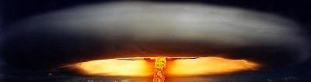
Above: A depiction of the vision of the torus of dust, but there was no yellow color in the vision.

Below: The torus changed into a chaotic spherical ball of dust.
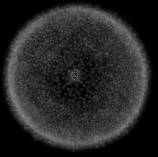

The Water Bearer Mixes the Nuclear Dust with the Water

It was mentioned in a previous article how that the solar eclipses of 6/8/1918 and 8/21/2017 are related to Jerusalem and also to Uranium via the planet Uranus, etc.

Below: The symbolic mixing of water with the dust of nuclear fallout by the heavenly water bearer.
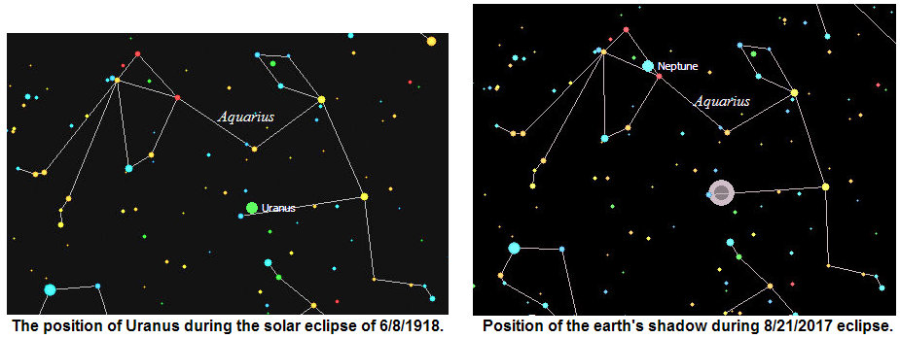

Above: In the heavens, the Tabernacle of YaHuWaH Elohim, the dust of nuclear fallout is symbolically mixed with water and given to the "woman" to drink. If the woman has been unfaithful to her husband her belly will swell and her thigh will rot and she will die.

YaHuShua Visits Babylon

We know that YaHuShua visited ancient Babylon. The account is given in Daniel chapter 3. King Nebuchadnezzar had a statue of gold constructed and ordered everyone to bow before it. Three of Daniel's friends were present and refused to bow to the statue at the risk of their lives, following YaHuWaH Elohim's 2nd commandment not to bow to statues. An irate King Nebuchadnezzar ordered a furnace of fire be heated 7 time hotter than normal and the 3 Hebrews thrown into the flames.

The King was surprised to see the young men walking alive in the fire, along with another person who "looked like the Son of Elahh" (Strong's 0426 - The Aramaic word for "God"). The Elahh of Daniel is not the Muslim god Allah.

Daniel 3:24 Then Nebuchadnezzar the king was astonied, and rose up in haste, and spake, and said unto his counsellors, Did not we cast three men bound into the midst of the fire? They answered and said unto the king, True, O king.
25 He answered and said, Lo, I see four men loose, walking in the midst of the fire, and they have no hurt; and the form of the fourth is like the Son of Elahh.

Repentance Brings Life

If we have bowed our knees and given our devotion and love to that which is not Elohim, we need to repent and turn our hearts to our heavenly Father. It might be that YaHuShua will again visit Babylon and walk the fires of nuclear holocaust alive with His faithful people.

We all might have to take the test of spiritual adultery, and drink the dusty water of nuclear fallout, but if we have been faithful to YaHuWaH Elohim, He will cause us to survive and live without ill effects. Others, however, will have to depend on their own mighty ones to deliver and rescue them. They will die.

Daniel 3:28 Then Nebuchadnezzar spake, and said, Blessed be the Elahh of Shadrach, Meshach, and Abednego, who hath sent His angel, and delivered His servants that trusted in Him, and have changed the king’s word, and yielded their bodies, that they might not serve nor worship any god, except their own Elahh.
29 Therefore I make a decree, That every people, nation, and language, which speak any thing amiss against the Elahh of Shadrach, Meshach, and Abednego, shall be cut in pieces, and their houses shall be made a dunghill: because there is no other Elahh that can deliver after this sort.

President Obama is Again a Marked Man

President Obama received the Nobel Prize for Peace in Norway on 12/10/2009. The previous night there was a strange whirling light in the sky seen from Norway that was eventually attributed to an errant Russian missile. The problem is not that there was a missile accident, but that there was an odd sight in the sky the night before Obama received the Nobel Peace Prize. The strange sight was seen from the very same country where Obama received the Nobel Prize the next day.

Exactly 7 years later on 12/10/2016 the strange "X" comet P2010 A2, appeared to sharply reverse course in the sky just as it was approaching the constellation Leo. Leo signifies the "Lion of Judah", Israel's Messiah.

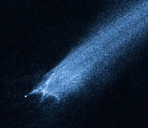
Above: The strange comet, P2010 A2, appeared to sharply reverse course on 12/10/2016 as it approached the constellation Leo.

Below: Conception and Birth Date of recent Presidents of the United States. The conception dates were arrived at by subtracting 280 exclusive or inclusive days from the birth dates.

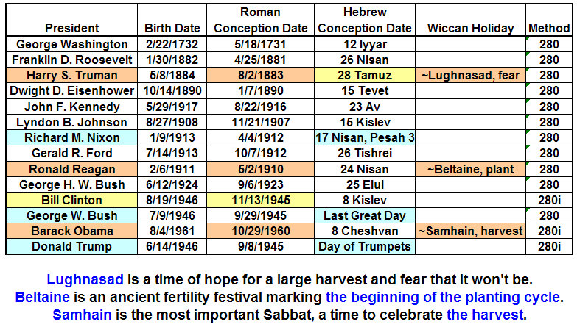
We can see from the graphic above that former President Obama was conceived on or around the Wiccan Samhain harvest festival. Note that Obama's grandparents, who were communists, attended a Wiccan congregation near Seattle, Washington. Also note that Samhain is a time of high sexual activity for Witches (Wiccans).

The image below is the nearest I could find to the vision of the torus of dust that I saw on the night of 6/2/2017.

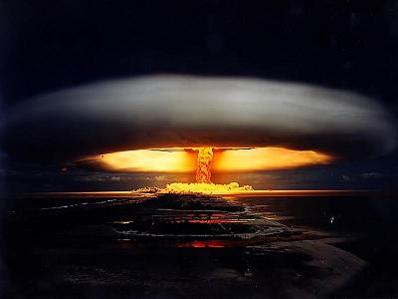

Above: The 57 megaton Tsar Bomba being tested over Novaya Zemlya archipelago on 10/23/1961. The donut shaped torus is a cloud probably formed by the shockwave. Note that the total solar eclipse of 8/1/2008, part of a "Tav" or "X" placed on the earth by our Creator Elohim, passed over Novaya Zemlya.

Note that the date of President Obama's calculated date of conception is 10/29/1960.

10/29/1960 + 360 inclusive days (exactly 1 prophetic year) = 10/23/1961, the date of the largest nuclear test man has ever conducted.

President Obama was supposedly born on 8/4/1961

8/4/1961 + 80 days = 10/23/1961

Both numbers above are significant in the bible. The number 360 being the length of the year in the time of Noah's flood. The number 80 being the age of Moses when he returned to Egypt to pronounce plagues upon Pharaoh.

Summary

The faithful people residing in Babylon might have to walk the nuclear fires with the angel of YaHuWaH Elohim. That angel might be the Son of YaHuWaH , Messiah YaHuShua Himself. There are some people who think there might be multiple comings of Messiah in the last days.

Those who venerate other mighty ones will have those as their protection. Many will die.

We all might have to drink the dusty water of nuclear fallout, but only those who are lovingly faithful to YaHuWaH Elohim will survive unhurt by the poison.

Former President Obama is a man with many spiritual marks assigned to him. Be mindful of his actions.

Walking with YaHuWaH Elohim in faithful devotion to Him is the only key to our future survival. We have forgivness of sins and access to Him via prayer through His Son YaHuShua.

