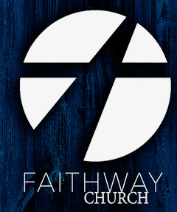

**1207 W. Viggie St.**

**Hebbronville, TX 78361**

[**faithwaycc@gmail.com**](mailto:faithwaycc@gmail.com)

**(361)527-3804**

**FAITHWAY**

Community Church

**SERVICE TIMES**

**Sunday– 10 am Worship Experience**

**Wednesday – 5:30 pm Prayer**

**Wednesday – 7 pm Midweek Worship**

**CONNECT WITH US**

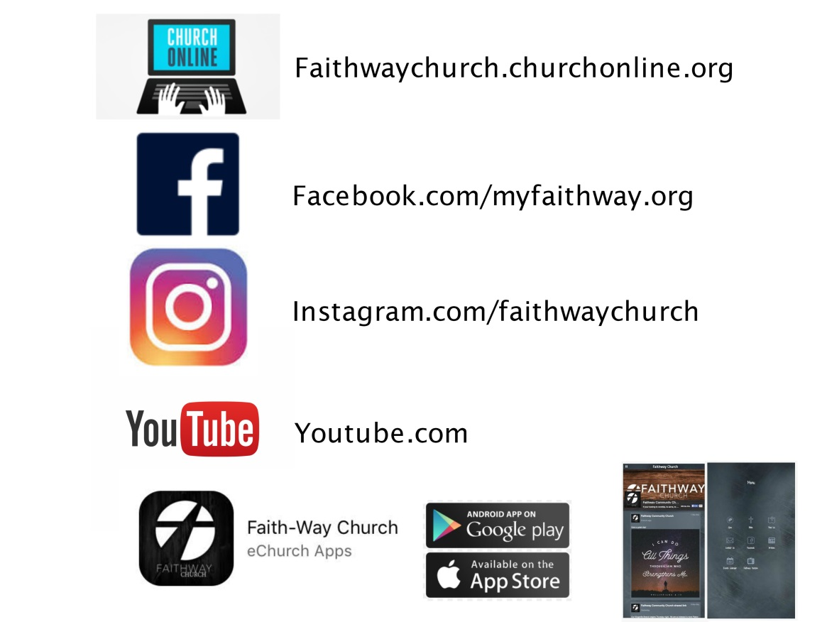



***Experience Life in a New Way***

Community Church

**FAITHWAY**

-

[www.faithwaycc@gmail.com](http://www.faithwaycc@gmail.com)

(361)527-3804

***APRIL 2018***

**FAITHWAY**

**HAPPENING THIS MONTH**

**WELCOME**

* **APR 7th- Project Building His Vision- Sat @ 9 am. All talents, tools, & time welcome.**
* **APR 15th-Special service with Pastor Yoel Silva from Santa Clara Cuba. Hebbronville 10am, and Laredo @6 pm . Embassy Suites 110 Calle Del Norte.**
* **APR 19th- (Thursday) 7 pm Leadership Training with Pastor Mel Mullen. All current and future volunteers must be present. Everyone is welcome and encouraged to invite.**
* **APR 20th- (Friday) 7 pm Success Builders with Pastor Mel Mullen. Boost your Business with this free seminar. Everyone is Welcome.**
* **APR 22nd Special Worship service with Pastor Mel Mullen 10 am.**
* **Apr 26th- #FOR HEBBRONVILLE - Autism Awareness 5K Join our team . Get more info at the welcome center.**
* **APR 28th- Water Baptism Celebration. Sign up at the Welcome Center**
* **MAY 5th- Children’s Ministry Fund’s Hamburger Combo Sale 11 am -2 pm/ Faithway Parking lot.**

Community Church

**OUR MISSION**

**….**

If you are newto Faithway**,**

**We are glad** you chose to worship with us today. Here at Faithway Community Church, we are committed to sound biblical teaching, genuine worship, authentic relationships, and serving Christ.

**We are** a family of believers from all walks of life joined together by a shared faith in God. Faithway is truly a place to belong.

**We love** Hebbronville and all of its surrounding communities, and are committed to reaching people with the saving message of Jesus Christ.

**Thank you** for joining us today, and please stick around after service. I look forward to meeting with you to introduce myself and to answer any questions you may have.

**We would** love to connect with you and get to know you more. Please fill out the communications card found in the new visitors welcome pack, return it to a team member at the welcome center, and collect your free gift. Or download the Faithway app and fill out the “ I’m New” section and collect your free gift after service.

**Welcome to the Faithway Family!**

In His name,

Pastor Kelvin & Monica Box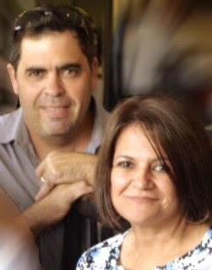

At FCC we exist to lead people to be fully devoted followers of Christ. LOVE GOD LOVE PEOPLE

**ANNOUNCEMENTS**

**PARENTS**- Please don’t forget to sign your child in with your name and number for security & emergency policies. Thank you.

**FAITHWAY App-** Are you a first time Guest? Download Faithways free app to stay connected and up to date. You can also enter your information into the “ I’m New” section and collect your free gift on your way out. The app also includes the free bible app, online giving, and more.

**Leadership Training-** If you are currently serving or planning on serving in anyof Faithway’s teams, you must attend this free service Thursday 4/19 at 7 pm. Pastor Mel Mullen will be giving insights and interactive ways to accommodate and improve Faithway’s operations. Jump in and join us in this amazing season. Everyone is welcome.

Business Owners- Are you a small business owner or do you plan to or desire to be a business owner? Then join us on Friday 4/20 at 7 pm for a Success Builders seminar with Pastor Mel Mullen. Gain insights and take your business to a higher level with this completely free service. Spread the word and invite. Everyone is welcome

**Laredo Service**

Every Sunday at 6 pm

Embassy Suites

110 Calle Del Norte

**Take that step of Faith and share God with someone. Listen to his call & bring that someone to church, or to a life group meeting. One word from God can change their life!**

**In The**

Mix

FOR

**PRAY**

**Are you a musician? Play an instrument?** We would love to have you on our team. Speak to any praise and worship team member to get involved.

**Water Baptism- Baptism is the most meaningful next step to take after you have given your life to Christ. Sign up for this life event celebration to show your outward reflection of your commitment to Christ. There will be a water Baptism class held on the 25th, we can’t wait to join you!**

**Hamburger Combo Sale-** Get tickets or information from any Men’s Ministry member or the Welcome Center. Be a blessing to Faithway’s children’s ministry outreaches.

**Cuba and Puebla** : Pray for restoration, and a contagious spirit of revival for our missions. We believe God will protect and guide, our Pastors, leaders, and our brothers and sisters, and bring a widespread love for the Word of God.

**Laredo**: Join us in prayer for a building location in Laredo. The church plant has begun and is alive. Pray for favor, fellowship, teams, and transformations. Join us in the act of the Great Commission!

#FORHEBBRONVILLE

“FOR God so loved the world, that he gave his only begotten son, that whoever believes in him shall not perish but have everlasting life.” John 3:16

**This month’s series is**

**“*Evidence“***

Learn and see the evidence of God’s faithfulness. Turn your dreams into a reality, and learn how to exercise your faith.