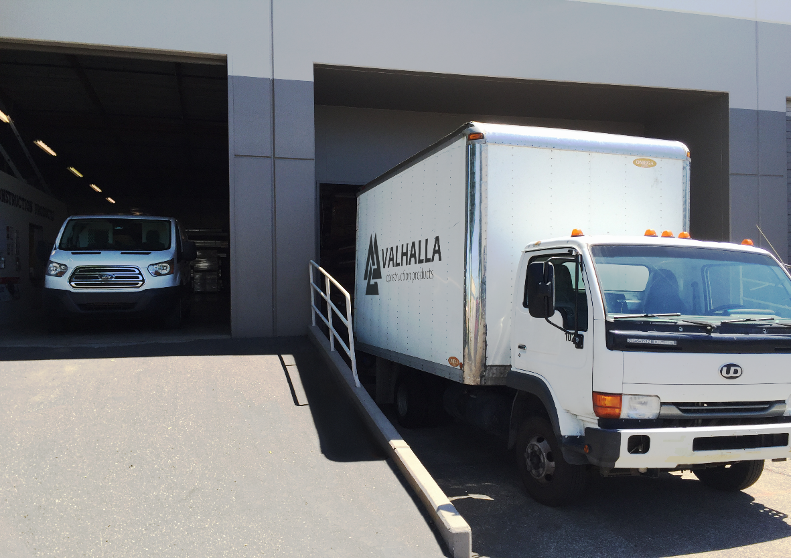 |  | Ever wondered if Valhalla can get its products to you? It can!

valhalla’s fleet is always ready to go!

From Us to You
At Valhalla Construction Products we are not only committed to offering you the best products possible, but we are also committed to getting them to you! Does a product need to be delivered to a job site? Your warehouse? Valhalla Construction Products is equipped to get your product to where you need it.
With a fleet comprised of large box trucks as well as standard trucks and vans, Valhalla Construction Products has a vehicle for every need.
Our Lakewood office is proud to serve all of the green state of Washington! It doesn’t matter what side of the state you find yourself on, Valhalla Construction Products can reach you!
Likewise, our Clackamas office proudly serves all of Oregon! No matter where your job or office is in The Beaver State, our Clackamas warehouse can get out to you!
However, it’s not just the fleet that makes Valhalla Construction Products so capable. At each warehouse location we have a dedicated staff who is ready to load your personal vehicle should you choose to will call, or to get your material onto our trucks so they can head out your way!
We are committed to meet our customers’ needs. Because of that commitment, delivery convenience is always our focus. So no matter where you are in our states, we will serve you.
Thank you for using Valhalla Construction Products for your construction product needs! We’ll see you where and when you need us!

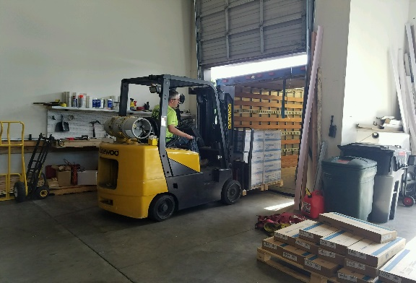
Industrial Capability
Valhalla Construction Products has full warehouse operations at all offices. Any product you need can be loaded into your vehicle at our warehouse or onto our trucks and sent to you! Our dedicated staff works hard to load vehicles like our 22-foot box truck (depicted below)!
