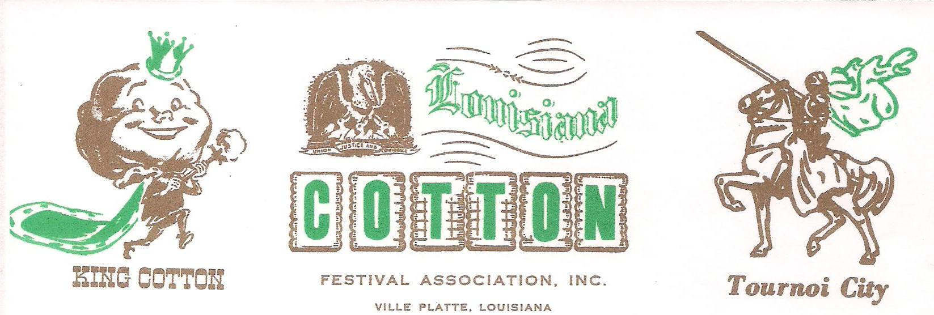
Dear Friends,
The 2016 Grand Parade of Cotton is just around the corner. We would be honored to have you be a part of this year’s event. This year’s parade is scheduled for Sunday October 16, 2016. Lineup will begin at 10:30am.
We, the parade committee, are presently completing plans to ensure that this year’s parade is bigger and better than ever. Your consideration and participation would be greatly appreciated.
For more information please contact Kelli R. Buller at 337-831-3340 or Vicky at City Hall 337-363-2939
Sincerely,

Kelli R. Buller
Secretary/ Pageant Director
Louisiana Cotton Festival
1293 Lee Street
Ville Platte, La 70586

