Rock City Church Unoffendables
Curriculum

Contents

Introduction………………………………………………………………………..........Page 4

Table of Contents

Lesson 1: “A Clean Heart”……………………………………..………………….....Page
Lesson 2: “It’s Not Fair”...........…………………………………………………….. Page
Lesson 3: “Mad at Dad: When Fathers upset us.…………………………..Page
Lesson 4: “Because I say so”………...……………………………………….........Page
Lesson 5: “Stronger than the Giants”…………………………………………..Page
Lesson 6: “A Precious Stone”…………..…………….………………………........Page
Lesson 7: “Building others up”..………………………………..…………..........Page
Lesson 8: “Forgiving others” ………………………...........................................Page
Lesson 9: “He is My Defender”………….………………………………………...Page
Lesson 10: “Don’t Judge Others”……………………………………………........Page
Lesson 11: “Getting It Right”.........………………………………………………..Page
Lesson 12: “Will you Forgive Me?”……………………….................................Page
Lesson 13: “Walking in Forgiveness”…………………………………………...Page

Don’t Quit, Stay and Obey
Luke 22:42
Jesus matured through obedience and suffering.
We need to grow in our attitudes, thoughts and emotions to avoid taking up an offense against others or God when we face suffering or are required to fulfill obedience.

KINGDOM KADETS: FALL LESSON 1
AGE: NURSERY (INFANTS & TODDDLERS 0-2)
Adopted from Bait of Satan by John Bevere

Lesson Topic: Don’t Quit, Stay and Obey!!

LESSON | WHAT CHILDREN DO | SUPPLIES | PREPARATION
1  Getting Started | Introduction/Ice Breaker:  Simon Says!! | No Supplies Needed | Simon says teaches kids to follow/obey instructions.
2  Bible Exploration.  Key Verse Activity | Key Verse:  Luke 22:42  Bible Story: Luke 22: 39-44
 | Bible Activity for Toddlers: Growing beans on cotton balls  Bible Activity for Infants: Discovery Bottles | -Glass jars or clear plastic cups.  -Cotton wool balls.  -Spray bottle.  -Beans.  -Small empty water bottles (10fl oz).  -Variety of seeds and/or beans. | Stuff cotton balls in cup.  Stuck one bean on each side of cup.  Spray with water until cotton balls are damp but not too wet.  Fill clear (and dry) water bottles with a variety of seeds and/or beans.
LESSON | WHAT CHILDREN DO | SUPPLIES | PREPARATION
3  Weaving Faith  Into Life | Craft/Make and Take for Toddlers:  Paper Sunflower | -White cupcake liners.  -Yellow crayons.  -Brown and green -construction paper.  -Green craft sticks.  -Scissors.  -Glue.  -Clear tape.  -Black Marker. | You can pre-cut the brown circles and the leaves ahead of time.  See instruction below on the lesson description.
Prayer Points:
Surrendering all in obedience to God and offering yourself as a vessel willing to suffer for Christ.

4  Lasting Impressions | Faith at Home:  Talk about how to share what they learned with their families. |  | What parents can do at home:  Use the bean plant to remain your kids that like Jesus we also need to grow in God.

Lesson Topic: Don’t Quit, Stay and Obey!!

Lesson Background/Foundation for Teachers:
Jesus matured through obedience and suffering. We need to grow in our attitudes, thoughts and emotions to avoid taking up an offense against others or God when we face suffering or are required to fulfill obedience.

Introduction Activity: Simon Says!!
Simon Says is a classic that teaches kids how to follow instructions. You are Simon and what you say goes. Be sure to throw in some funny commands,—do a silly dance, wiggle your ears, hop like a frog.

Praise & Worship:
- Song 1: 2 Peter 3:18 Glory, Glory, Glory (The Rizers)
- Song 2: Obey,Obey the Lord
- Song 3: You Forgive me (Lifetree kids)

Key Verse: Luke 22:42 New Living Translation (NLT)
⁴² “Father, if you are willing, please take this cup of suffering away from me. Yet I want your will to be done, not mine.”

Bible Story:

A Dark Night The Message (MSG)
³⁹⁻⁴⁰ Leaving there, he went, as he so often did, to Mount Olives. The disciples followed him. When they arrived at the place, he said, “Pray that you don’t give in to temptation.”
⁴¹⁻⁴⁴ He pulled away from them about a stone’s throw, knelt down, and prayed, “Father, remove this cup from me. But please, not what I want. What do you want?” At once an angel from heaven was at his side, strengthening him. He prayed on all the harder. Sweat, wrung from him like drops of blood, poured off his face.
Scripture Reference: Luke 22: 39-44

Narrative of Story: Jesus matured through obedience and suffering, He didn’t hold onto an offense against God when he had to face suffering or was required to fulfill obedience.
Jesus laid down his life in obedience to God. He always obeyed God even when God’s will for his life wasn’t the “easiest way” and when things got hard- Jesus Stayed and Obeyed!!

Bible Activity for Infants: Discovery Bottles
You’ll need small empty water bottles (10 fl oz) and a variety of seeds and/or beans.

Instruction:
Fill clear (and dry) water bottles with a variety of seeds and/or beans. Each bottle shall contain a different type and size of seed/bean. Replace cap on bottle and close tightly.
Let babies and toddlers manipulate the bottles and notice the different sounds they can produce by shaking them.

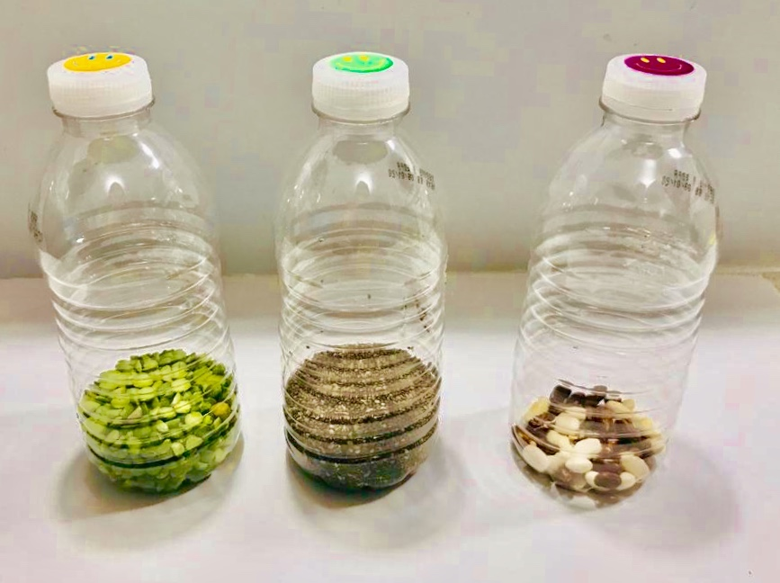
Green Peas, Chia Seeds, Beans

Bible Activity for Toddlers: Growing beans on cotton balls
All you need for this easy activity is glass jars or clear plastic cups, some cotton wool balls, a spray bottle and some beans!

Instructions:
-Stuff cotton wool balls into clear plastic cup.
-Stuck one bean on either side of the plastic cup so that the kids can watch the beans growing.
-Next, water it with the spray bottle until the cotton wool is damp but not too wet.
NOTE: Remind parents to place the cup in the window at home.

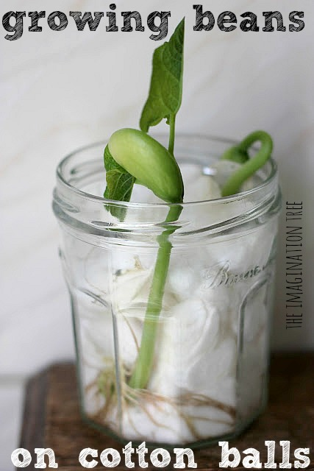

Activity from theimaginationtree.com

Craft/Make & Take for Toddlers:
- Title: Paper Sunflower
- Supplies Needed:
-White cupcake liners.
-Yellow crayons.
-Brown and green construction paper.
-Green craft sticks.
-Scissors.
-Glue.
-Clear tape.
-Black Marker.

- Directions:
-Pre cut brown construction paper circles and green leaves. The circles should be as big as the center of the cupcake liners and the leaves proportional to the size of the flower.
- Write the key verse on the brown circles (Luke 22:42) and the phrase “Grow in God”.
- Give each kid a cupcake liner to color on with the yellow crayons.
-Help the kids to glue the brown circle to the center of the cupcake liner.
-Snip the cupcake liner in to the center of the circle, but stopping at the fold. The liners will become the petals of the flower.
-Tape the green craft stick to the back of the flower.
-Glue or tape the green leaf to the side of the craft stick.

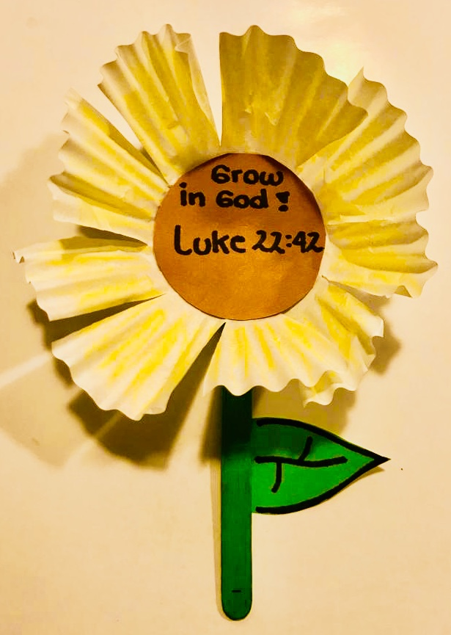

Closing Prayer: Surrendering all in obedience to God and offering yourself as a vessel willing to suffer for Christ.

Faith At Home:
- Description: Take home the plastic cup with the seed and watch it grow with your toddler. Use the plant to remind your kid(s) that we need to grow and mature in God.

