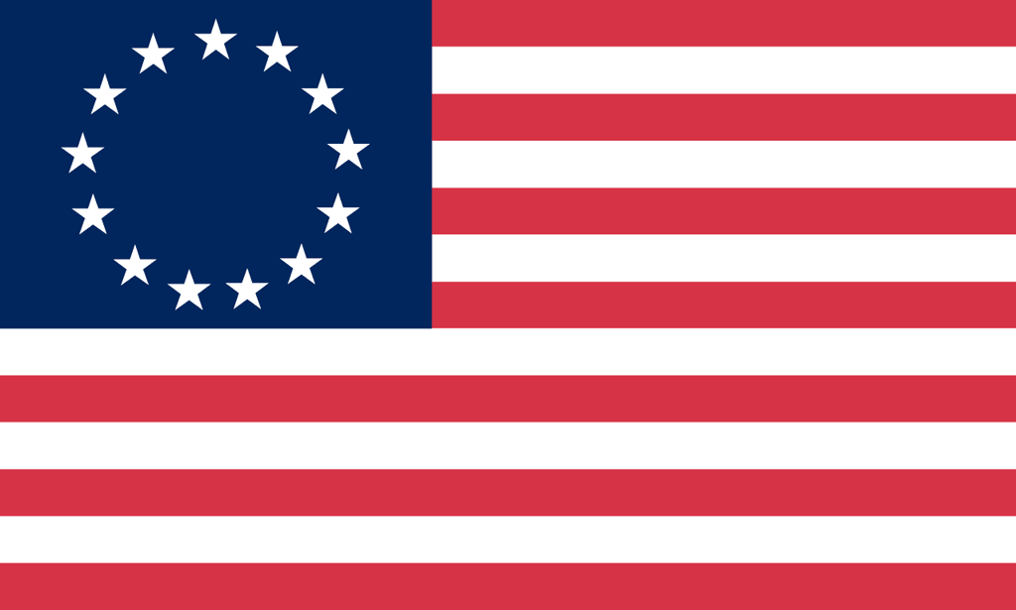U.S. History with Mr. Brown Name _______________________________ Period _____
French and Indian War Quiz

Directions: Use your binder to answers to the following questions.

1) A revolt in which Native Americans attacked and destroyed British forts in the land west of the Appalachian Mountains:

2) An idea proposed by Benjamin Franklin that intended to unite the colonies for defense:

3) The turning point battle of the French and Indian War:

4) Law that prevented English settlers from moving west of the Appalachian Mountains into the newly acquired land.

5) Treaty that ended the French and Indian War:

6) War between England and France for land in North America:

____________________________________________________________________________

7) England and France were enemies that often fought over ______________.

8) From whom did the English colonists gain permission to settle west of the Appalachian Mountains?

9) After the French settler attacked and defeated the British colonists, who did the colonists send to negotiate peace with the French?

10) Why did England have to step in and win the war for their colonists?

11) After the war France signed the treaty of ________________ which gave up all their land in North America.

More on the back

12) Label the Spanish and the English territory in North America after the treaty of Paris:
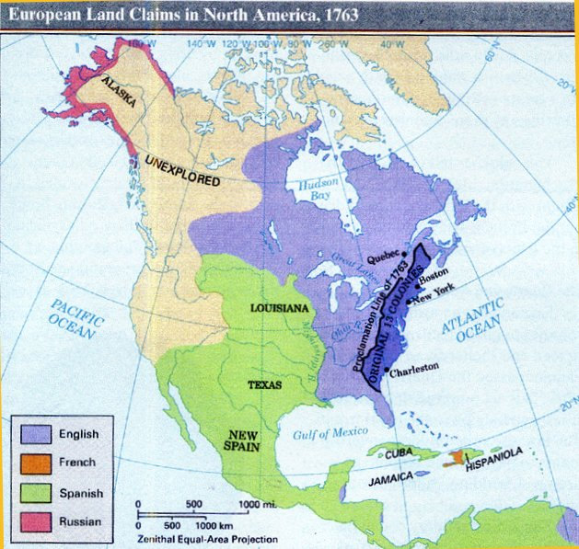

16) Why is England upset with the colonists after the French and Indian War?

17) What law made it illegal for the English colonists to cross the Appalachian Mountains and settle in the newly acquired territory?

____________________________________________________________________________

18) What year was Jamestown founded?

19) What year was the Mayflower Compact signed?

20) Which group of colonies Had Rich soil, a long growing season, plantation farms, and slave laborers?

