GFWC BWC NEWS
  - club Monthly updates
Members painted ROCKS  to be given to crime victims  to comfort and inspire them.  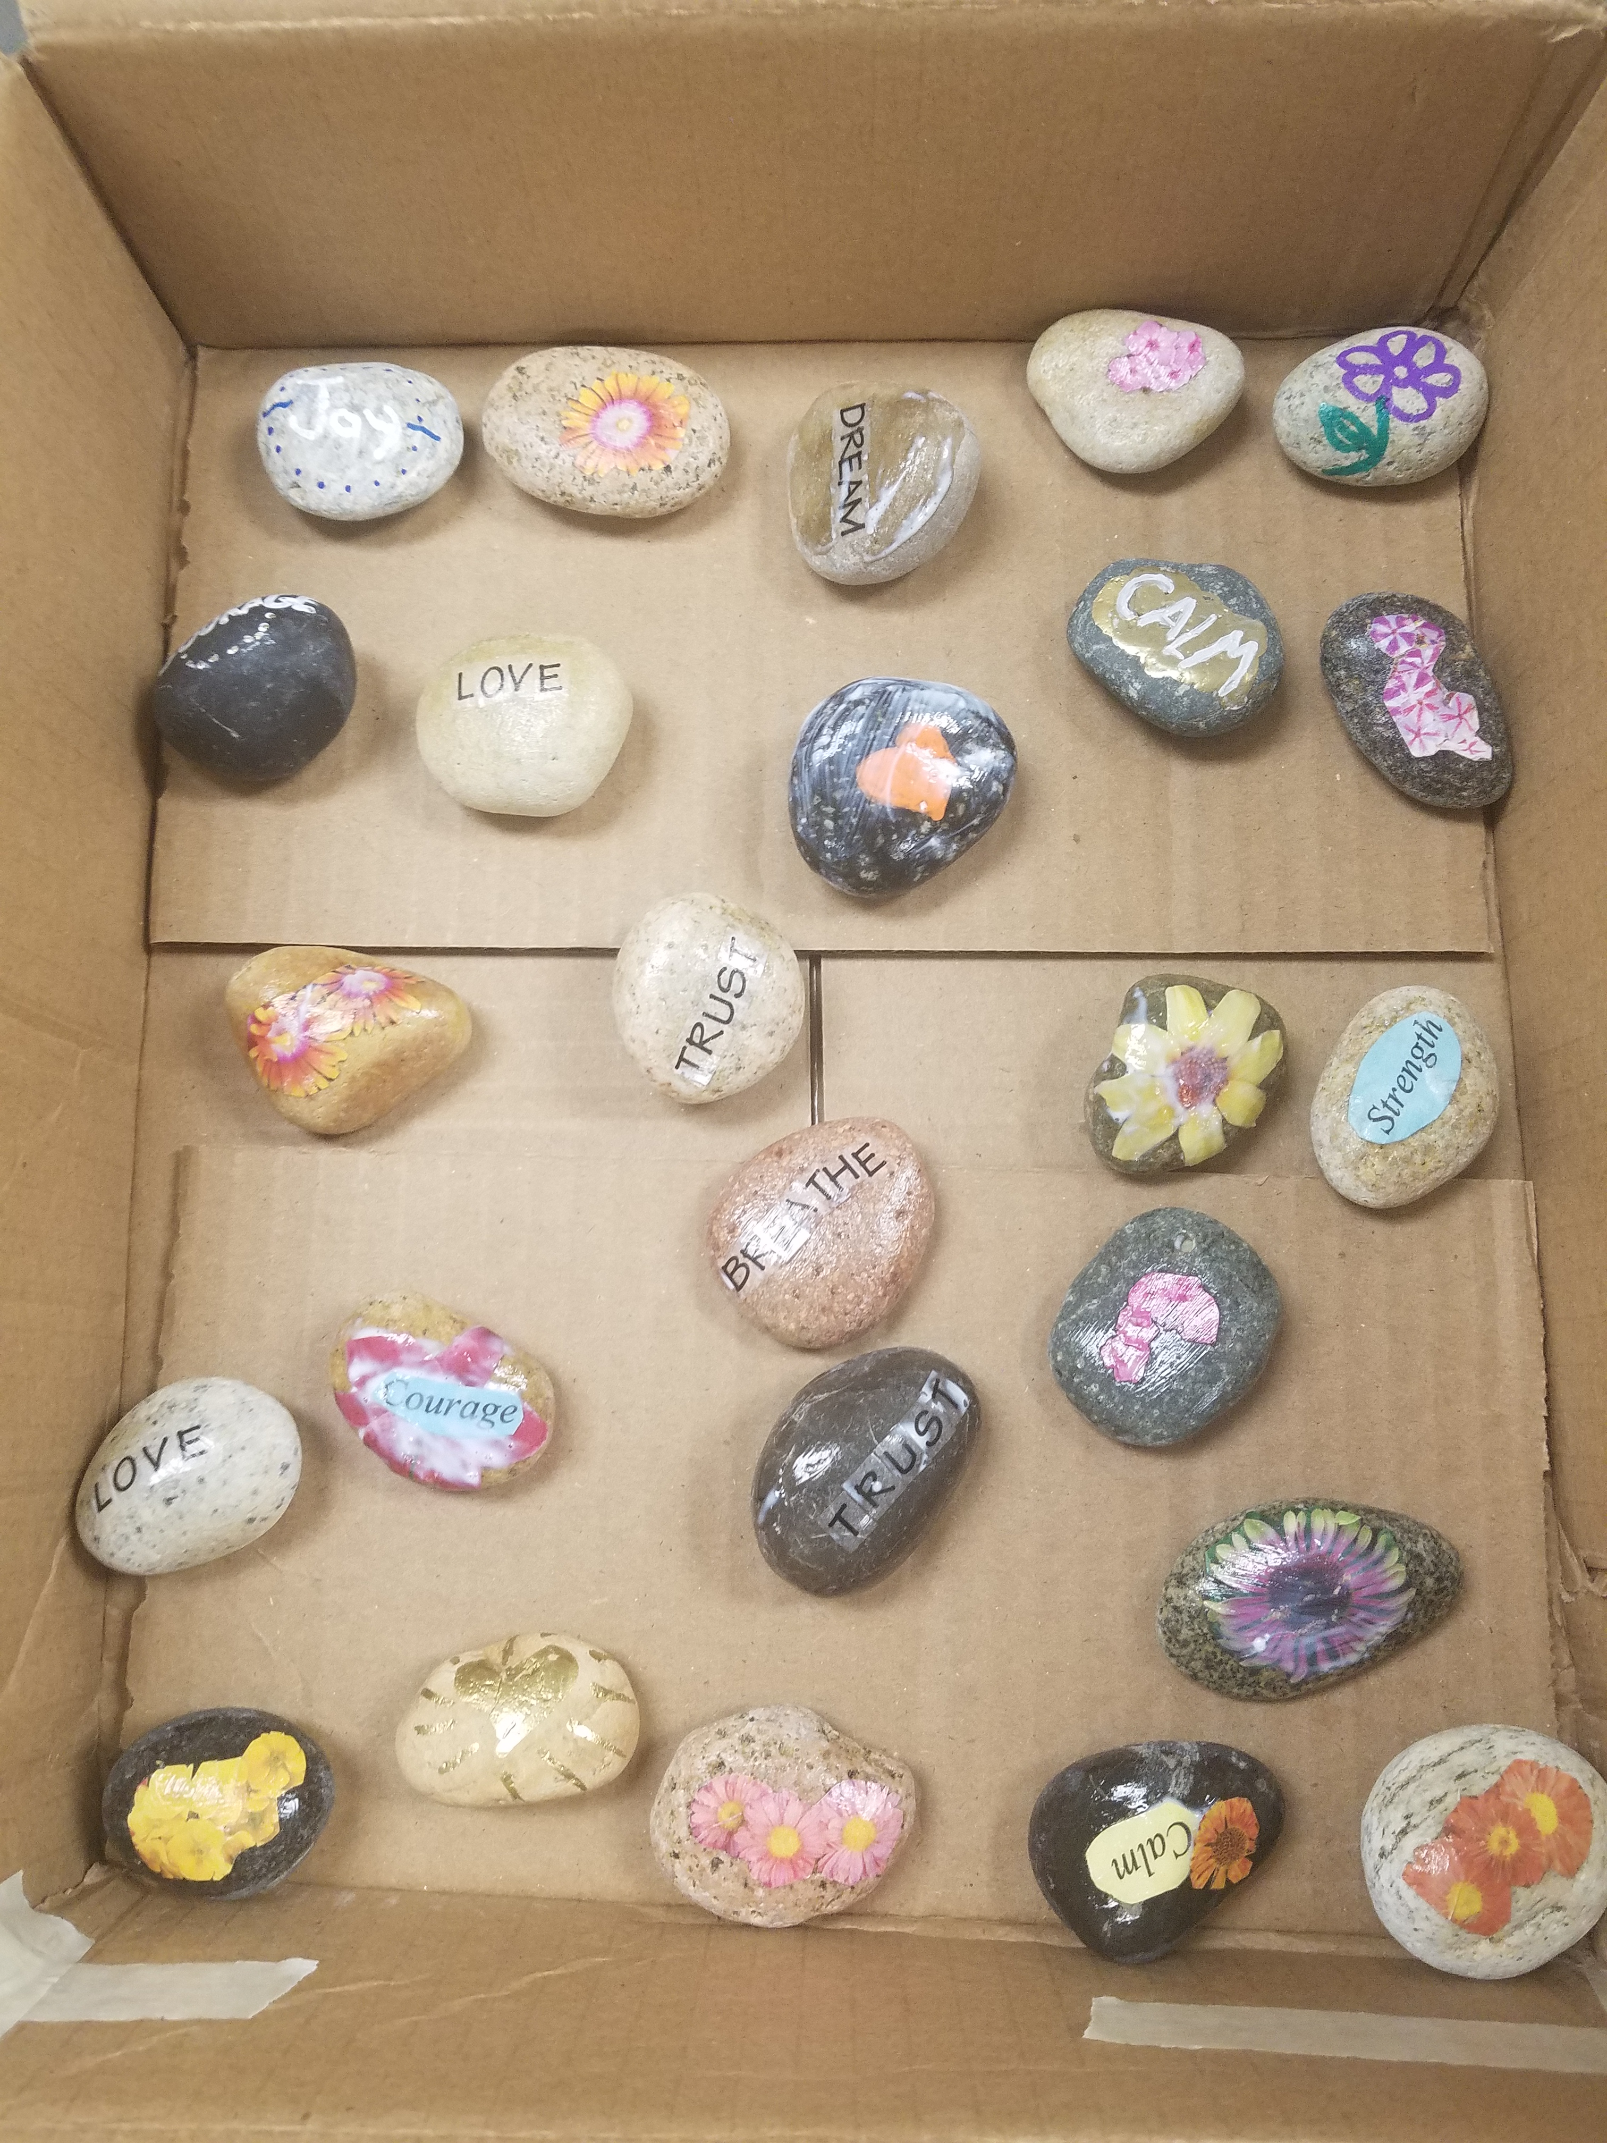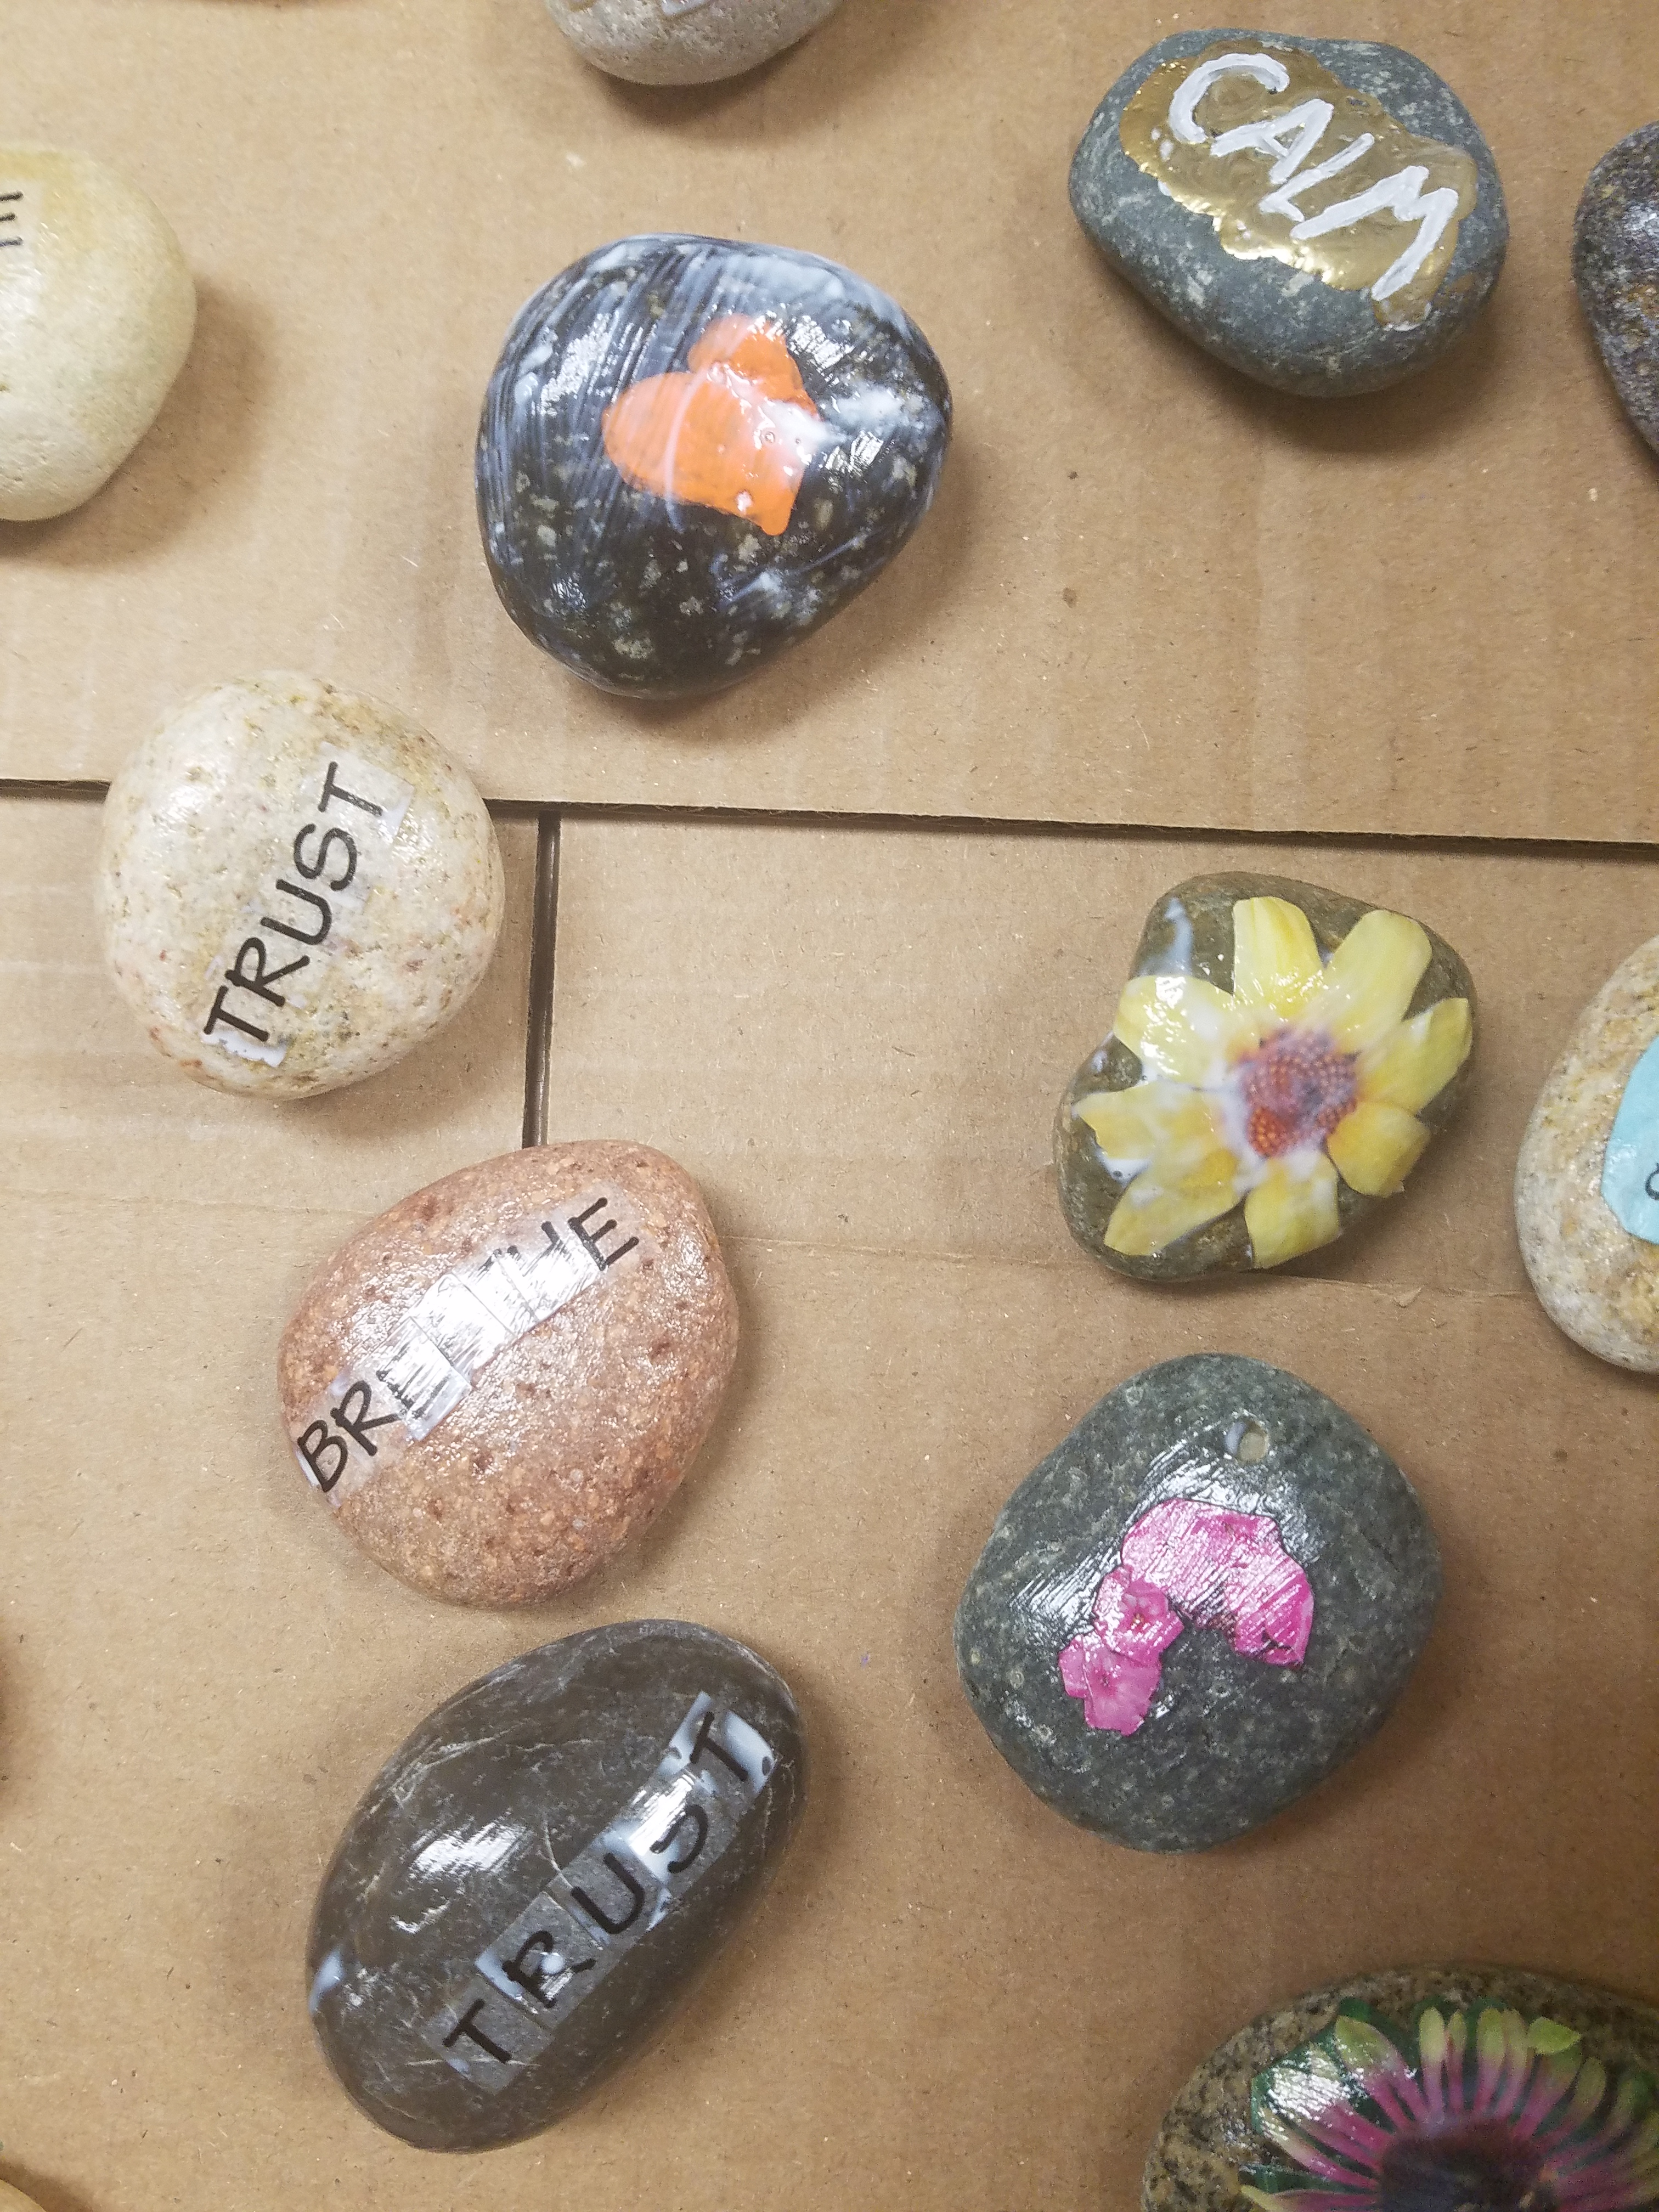  BLANKETS FOR PROJECT LINUS  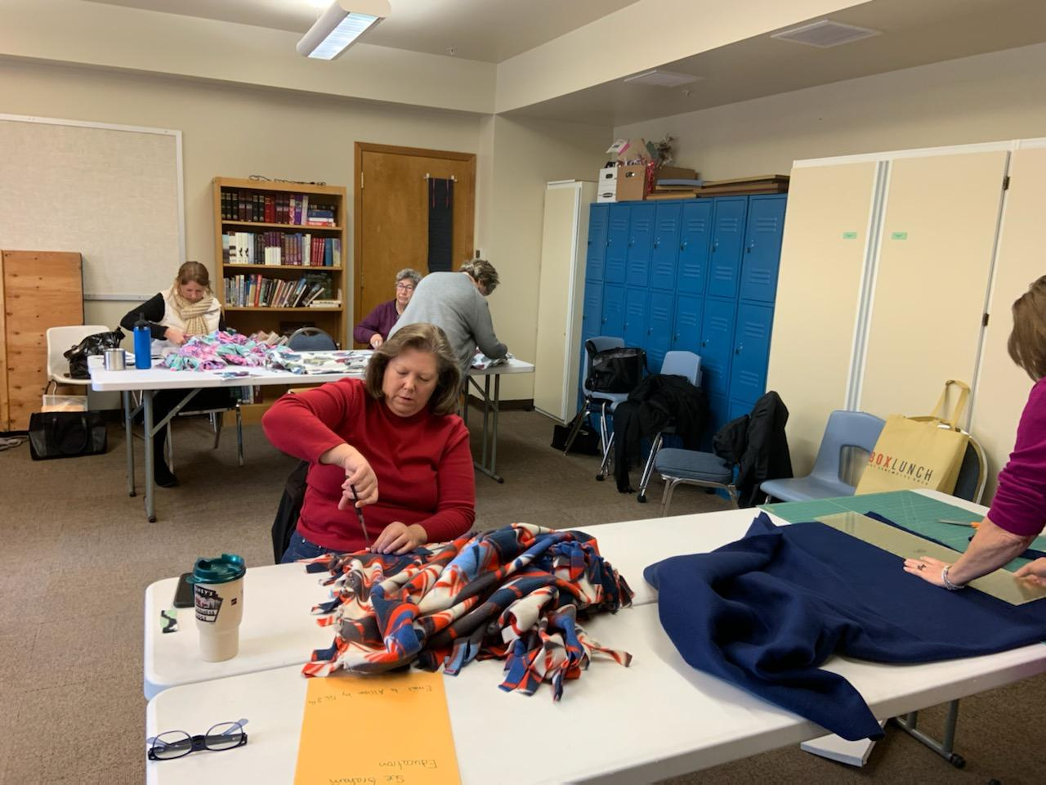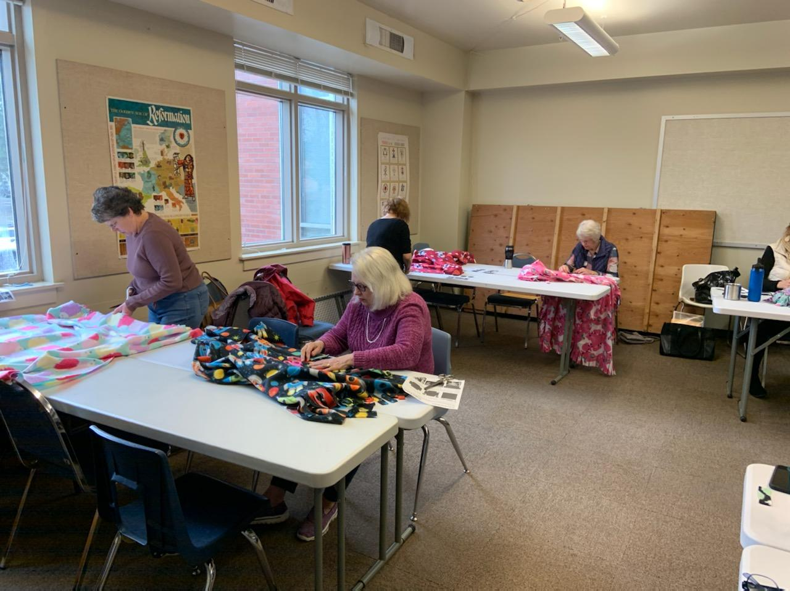  9 members participated in Martin Luther  King Day of Service and completed 10 blankets to be given as comfort blankets.  20th Tea  Check out our WEBSITE  http://www.beavertonwomansclub.com/ | SNACKS DONATED  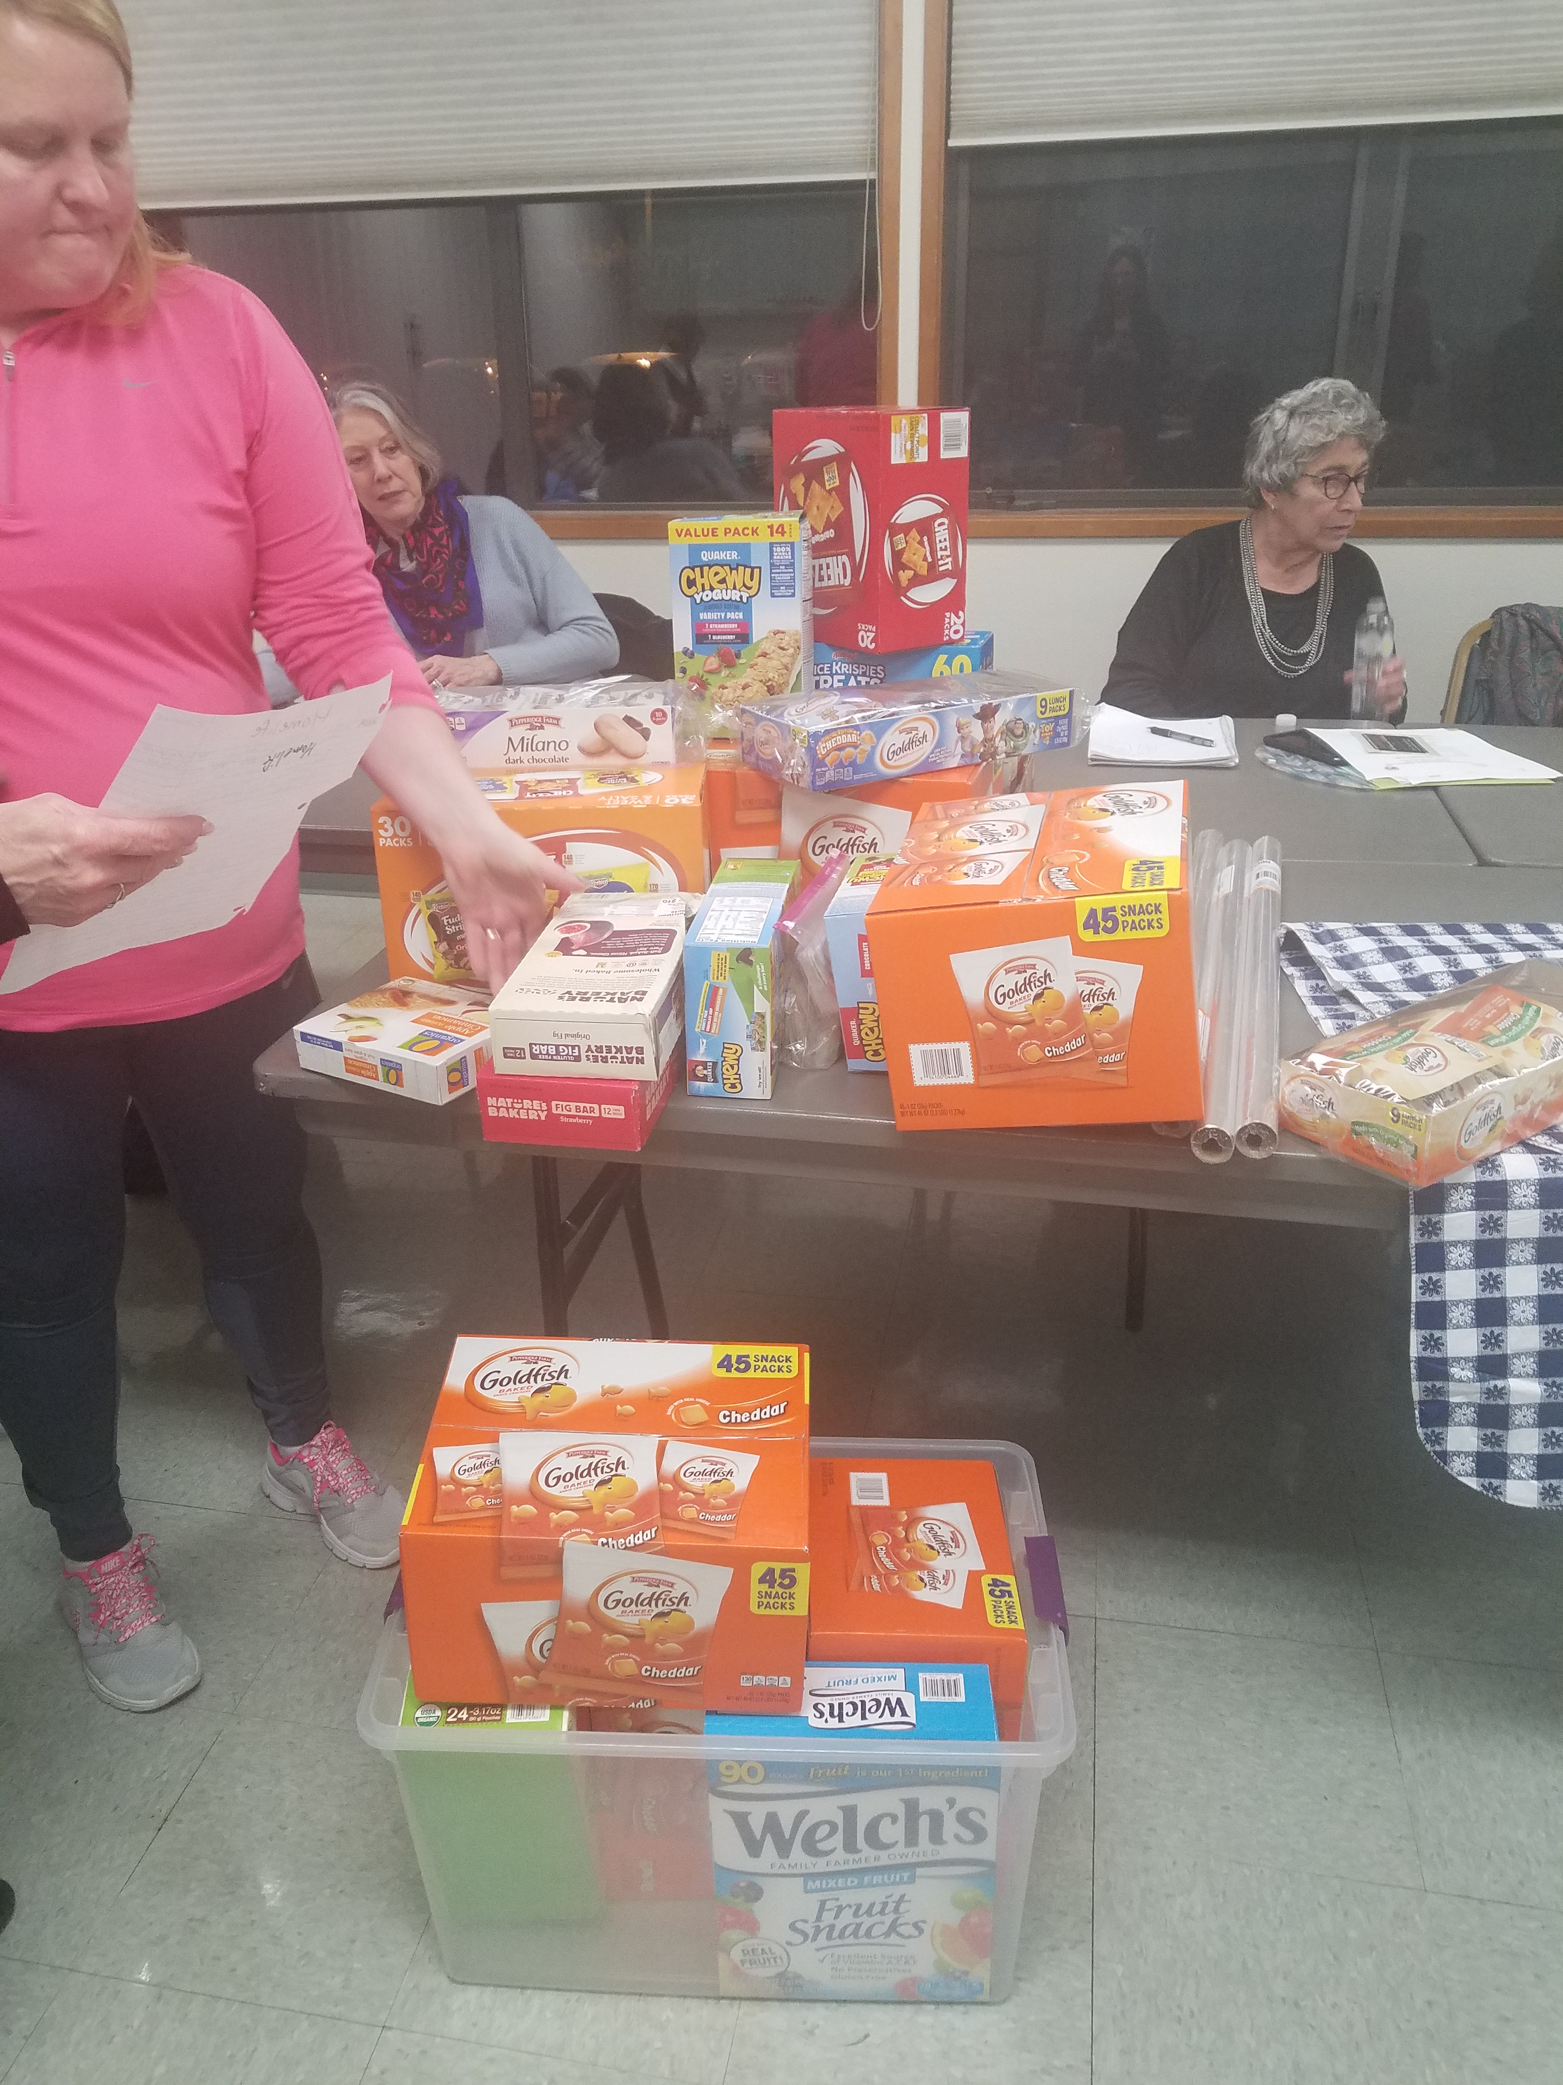  222 Granola Bars  270 Fish Crackers  180 Fruit Snacks  Donated to Hiteon, Nancy Ryles and Greenway Elementary Schools  UPCOMING EVENTS:  Dr. Suess Day  Reading at Greenway Elementary: March 2nd 9:30  MARCH Club Meeting: March 7 th  Griffith Bldg. Room 100  6:00 Tea Meeting 7:00 Club Meeting  Program: Education  Speaker: Lisa Mentasana (BSD homeless education liaison)  OFWC Leadership Seminar for Club members  March 14 Independence  Fine Arts Scholarship Contest: April 11 Independence 10 AM  Volunteer Fair: April 18 Beaverton Library 9:30  OFWC MAY CONVENTION May 15-17 ASTORIA

