Assessment and Treatment of Shoulder Pain
with Dr. James Mally
September 25, 2017
Monday 9 am - 6 pm (8 hours)
$120
When a client presents with shoulder pain, you need to know how to properly assess the cause of the pain and to formulate effective treatment strategies.
This workshop covers evaluation and treatment of some of the most common causes of shoulder pain, including:
- Adhesive capsulitis
- Impingement and bursitis
- Rotator cuff tears
- Slipped bicipital tendon
- Thoracic outlet syndrome
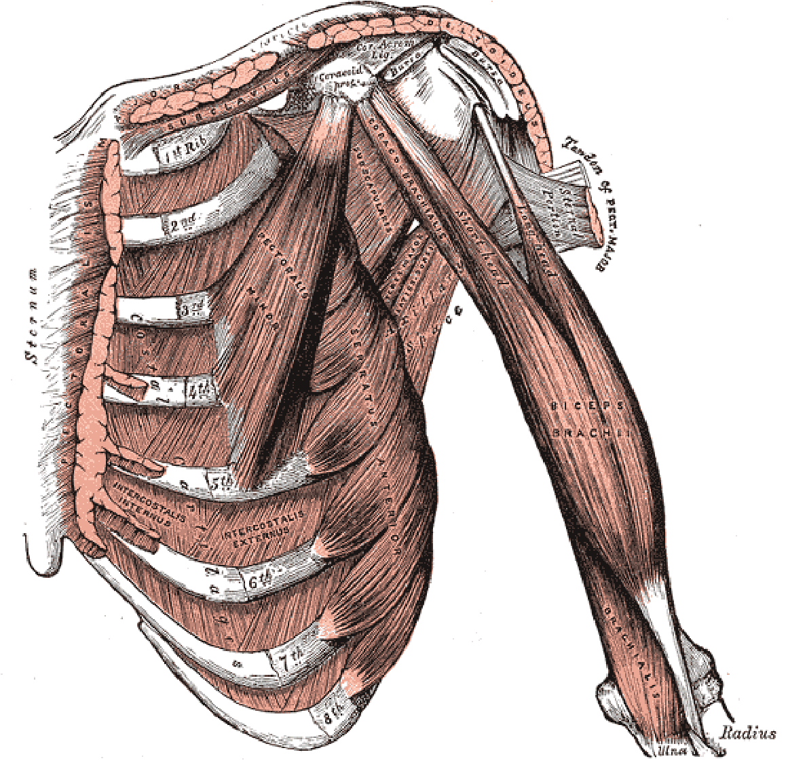
Expand your toolbox of assessment and treatment strategies through a series of demonstrations and practice of these techniques:
- Joint capsule release
- Soft tissue release
- Multidirectional friction and eccentric contraction
- Trigger point therapy
- Strain-counterstrain
- Reciprocal inhibition
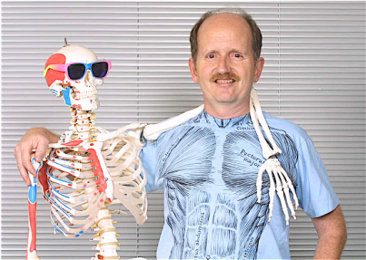
Dr. James Mally has been doing massage professionally in many different settings since 1975. He has been teaching massage certification programs since 1979, and was director of Healing Arts Institute in Citrus Heights, California for 21 years.
James R. Mally, N.D. is approved by the National Certification Board of Therapeutic Massage & Bodywork (NCBTMB) as a Continuing Education Approved Provider. Provider # 451329-10.
Dr. James Mally
(the one on the right)

Carlson College of Massage Therapy
11809 County Road X-28
Anamosa, IA 52205 319-462-3402 www.carlsoncollege.com

