REGULAR MEETING
JANUARY 20, 2022
The Regular Meeting of the Town Board of the Town of Hampton, County of Washington and the State of New York was held at the Town Hall, 2629 State Route 22A, Hampton, New York, also via Zoom and live streaming on the You Tube Channel for “Town of Hampton New York” on the 20th day of January 2022.

Due to the Corona Virus, occupancy inside the Town Hall is limited at this time. Supervisor O’Brien did provide a link to join the meeting via Zoom.

PRESENT: David K. O’Brien------------Supervisor
Donald Sady-----------------Councilman – via zoom
Tamme Taran----------------Councilwoman
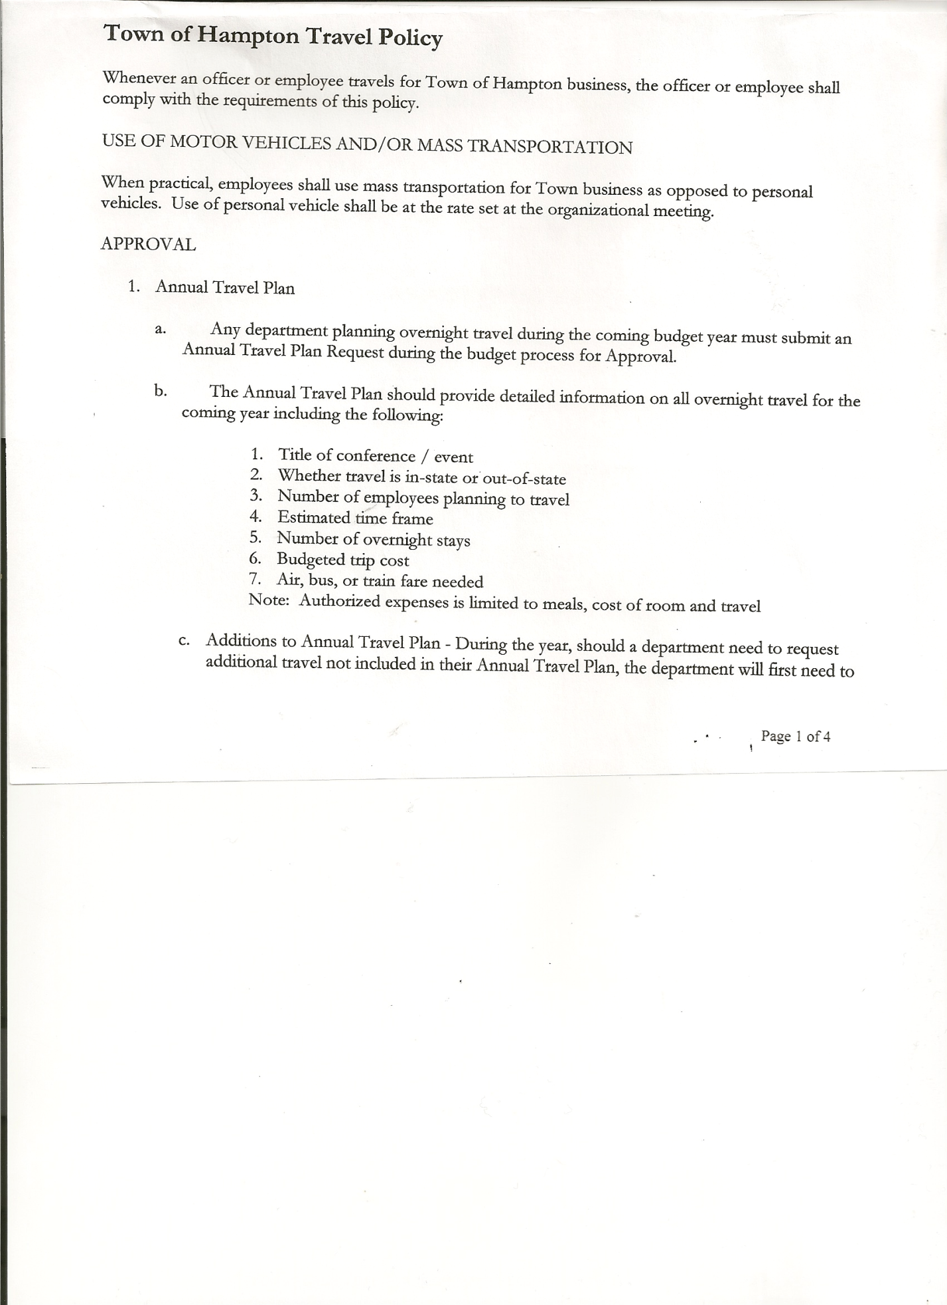
Michael Pietryka------------Councilman
Travis Dean------------------Councilman
Rebecca Jones---------------Town Clerk
Camilla Shaw----------------Tax Collector/Deputy Town Clerk
Tyler McClure---------------Highway Superintendent

Planning Board Member(s):… Bonnie Hawley, Chair and Matthew Pratt
Others present at the Town Hall: Artie Pratt

The Regular Meeting was called to order by Supervisor O’Brien at 7:33pm, followed by the Pledge of Allegiance. Location of Fire Exits were given. Quorum of board members present.

RESOLUTION NO. 7-2022
APPROVAL OF THE MINUTES
On a motion of Councilwoman Taran, seconded by Councilman Pietryka, the following resolution was ADOPTED: AYES 5 O’Brien, Sady, Taran, Pietryka, Dean
NAYS 0
RESOLVED, that the Regular Town Board Meeting Minutes for December16th , 2021; the Special Town Board Minutes for December 30th, 2021 and the Special Town Board Minutes for January 3, 2022 are approved.

Larry Carman, Dog Control Officer submitted his report, which was read by Supervisor O’Brien, copy of report is attached.

Camilla Shaw, Tax Collector….has collected over $300,000 so far. Money to Supervisor each week. Submitted December 2021 collection report and 2021 Yearly Report. Also Submitted Bank Statement to the Board for review and signatures.

Bonnie Hawley, Chair gave Planning Board Report……copy of the minutes of their meeting held January 12, 2022 are attached. Next meeting is scheduled for February 9th, 2022.

TOWN BOARD MEETING
JANUARY 20, 2022 PAGE 2

Tyler McClure, Highway Superintendent submitted his report, copy of which, is attached.
The computer in the garage has been replaced with a new laptop.
Highway crew has been doing some grading, taking off ice layers. It removes salt/sand to make things better in spring when everything thaws.

SUPERVISOR’S REPORT/ COUNTY UPDATES/ COMMUNICATIONS

RESOLUTION NO. 8-2022
BUDGET AMENDMENTS-GENERAL FUND
On a motion of Councilwoman Taran, seconded by Councilman Sady, the following resolution was ADOPTED:
By Roll Call Vote: Supervisor O’Brien AYE
Councilman Sady AYE
Councilwoman Taran AYE
Councilman Pietryka AYE
Councilman Dean AYE
RESOLVED that, the following Budget Amendments to the General Fund are approved:
EXPENSES:
Increase Central Printing & Mailing CE Account A1670.4 in the amount of $4,159.75
Increase Unallocated Insurance Account A1910.1 in the amount of $ 924.35
Increase Garage CE Account A5132.4 in the amount of $3,173.36
Increase State Retirement Account A9010.8 in the amount of $6,431.50
Increase Justice CE Account A1110.4 in the amount of $16,802.02
Increase Contingent CE Account A1990.4 in the amount of $8,065.21
INCOME:
Increase Federal Aid Other Health Account A4489 in the amount of $37,099.19
Increase Fines & Forfeited Bail Account A2610 in the amount of $2,457.00

RESOLUTION NO. 9-2022
BUDGET AMENDMENTS-HIGHWAY FUND
On a motion of Councilwoman Taran, seconded by Councilman Sady, the following resolution was ADOPTED:
By Roll Call Vote: Supervisor O’Brien AYE
Councilman Sady AYE
Councilwoman Taran AYE
Councilman Pietryka AYE
Councilman Dean AYE
RESOLVED that, the following Budget Amendments to the Highway Fund are approved:
EXPENSES:
Increase General Repairs Personal Service Account DA5110.1 in the amount of $9,555.84
Increase Capital Outlay Account DA5112.2 in the amount of $45,222.38
Increase Machinery CE Account DA5130.4 in the amount of $55,873.40
Increase Miscellaneous CE Account DA5140.4 in the amount of $59.57
Increase State Retirement Account DA9010.8 in the amount of $5,881.50
Increase Social Security Account DA9030.8 in the amount of $816.47
Decrease General Repairs CE Account DA5110.4 in the amount of $63,467.25
INCOME:
Increase Consolidated Highway Account DA3501 in the amount of $44,666.47
Increase Federal Aid Other Health Account DA4489 in the amount of $9,275.44

TOWN BOARD MEETING
JANUARY 20, 2022 PAGE 3

RESOLUTION NO. 10 -2022
APPROVAL OF SUPERVISOR’S MONTHLY REPORT AND 2021 YEARLY REPORT
On a motion of Councilman Sady, seconded by Councilman Pietryka, the following resolution was ADOPTED: AYES 5 O’Brien, Sady, Taran, Pietryka, Dean
NAYS 0
RESOLVED that, the Supervisor’s Monthly report be accepted as submitted for DECEMBER
11/30/21 12/31/21
ACCOUNT BALANCE RECEIPTS DISBURSEMENTS BALANCE
General Fund $ 55,311.11 $ 106,115.83 $ 109,968.83 $ 51,458.11
Highway Fund $ 45,663.66 $ 96,667.74 $ 11,858.50 $ 130,472.90
Equipment Reserve $ 79,921.42 $ 2.04 $ 0.00 $ 79,923.46
Fire #1 $ 21,648.50 $ 0.00 $ 21,648.50 0.00
Fire #2 $ 5,100.00 $ 0.00 $ 5,100.00 $ 0.00
Cemetery $ 1,754.64 $ 0.53 $ 0.00 $ 1,755.17
Totals $209,399.33 $ 202,786.14 $ 148,575.83 $ 263,609.64

FURTHER RESOLVED that, the Supervisor’s Yearly Report for 2021 be accepted as submitted.
01/31/21 12/31/21
ACCOUNT BALANCE RECEIPTS DISBURSEMENTS BALANCE
General Fund $ 37,129.86 $ 141,804.08 $ 127,475.83 $ 51,458.11
Highway Fund $ 55,987.62 $ 470,580.66 $ 396,095.38 $ 130,472.90
Equipment Reserve $ 54,898.02 $ 25,025.44 $ 0.00 $ 79,923.46
Fire #1 $ 0.00 $ 43,297.00 $ 43,297.00 $ 0.00
Fire #2 $ 0.00 $ 10,200.00 $ 10,200.00 $ 0.00
Cemetery $ 1,743.00 $ 12.17 $ 0.00 $ 1,755.17
Totals $149,758.50 $690,919.35 $577,068.21 $263,609.64
All Board Members present signed Supervisor’s Report.

NEW BUSINESS
2021 ANNUAL AUDITS

RESOLUTION NO. 11 -2022
END OF YEAR COURT AUDIT
On a motion of Councilwoman Taran, seconded by Councilman Pietryka, the following resolution was ADOPTED: AYES 4 O’Brien, Taran, Pietryka, Dean
NAYS 0
ABSTAIN 1 Sady
RESOLVED, to accept the Court Audit for 2021

RESOLUTION NO. 12 -2022
END OF YEAR AUDITS FOR TOWN CLERK AND TAX COLLECTOR
On a motion of Councilman Pietryka, seconded by Councilman Sady, the following resolution was ADOPTED: AYES 4 Sady, Taran, Pietryka, Dean
NAYS 0
ABSTAIN 1 O’Brien
RESOLVED, to accept the Town Clerk and Tax Collector Audits for 2021.

TOWN BOARD MEETING
JANUARY 20, 2022 PAGE 4

RESOLUTION NO. 13 -2022
END OF YEAR AUDIT FOR CHIEF FISCAL OFFICER (BOOKKEEPER)
On a motion of Councilwoman Taran, seconded by Councilman Dean, the following resolution was ADOPTED: AYES 4 Sady, Taran, Pietryka, Dean
NAYS 0
ABSTAIN 1 O’Brien
RESOLVED, to accept the Chief Fiscal Officer (Bookkeeper) Audit for 2021.

RESOLUTION NO. 14 -2022
AUDIT OF CLAIMS
On a motion of Councilwoman Taran, seconded by Councilman Pietryka the following resolution was ADOPTED: AYES 5 O’Brien, Sady, Taran, Pietryka, Dean
NAYS 0
RESOLVED that the bills have been reviewed by the Town Board and are authorized for payment in the following amounts.
General Fund No. 1 through No. 18 $ 10,328.42
Highway Fund No. 1 through No. 16 $ 12,933.83
Total both funds $ 23,262.25

The Town Clerk’s report for December 2021 was submitted to the Board. The Town Clerk had Board Members review and sign bank reconciliation statements for the Town Clerk Account and Special Clerk Account dated December 31, 2021.

Town Clerk Jones also shared Town Clerk Annual Reports from 2017 to 2021.

RESOLUTION NO. 15-2022
MEETING ADJOURNED
On a motion of Councilman Pietryka , seconded by Councilwoman Taran, the following resolution was ADOPTED: AYES 5 O’Brien, Sady, Taran, Pietryka, Dean
NAYS 0
RESOLVED that the meeting adjourned at 8:20pm.

Respectfully submitted,

Rebecca S. Jones, RMC
Town Clerk

