2017

May

TRUE LIES

The Stuart Rod & Reel Club Newsletter

*The Stuart Rod and Reel Club is dedicated to improving local fishing through by increasing angler knowledge, encouraging conservation and maximizing the fun involved in light tackle fishing in the Stuart Florida area. We hold monthly meetings on the second Thursday of each month, year round. Please join us or contact any board member for more information on how you can become a member of the Stuart Rod and Reel Club.*

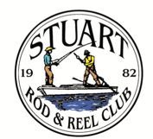

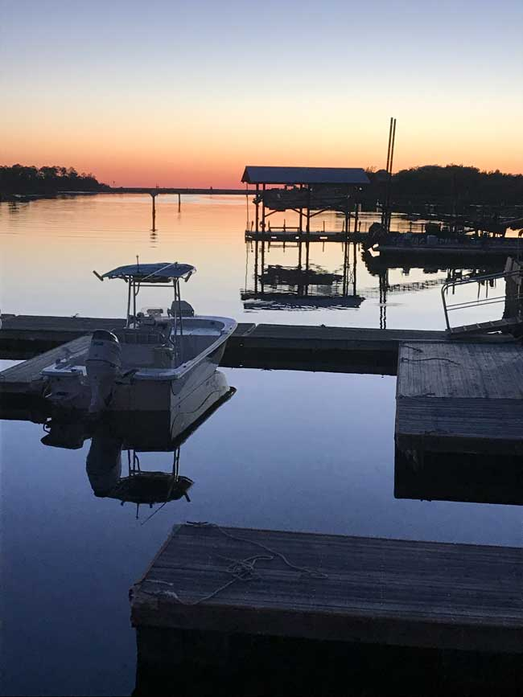

*A peaceful sunset at the end of a productive fishing day at Steinhatchee, FL*

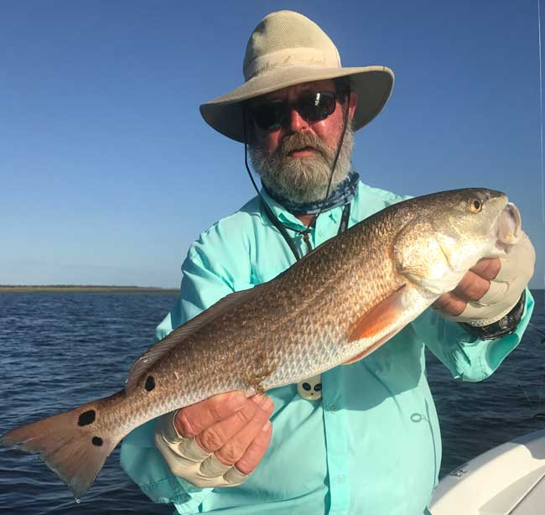 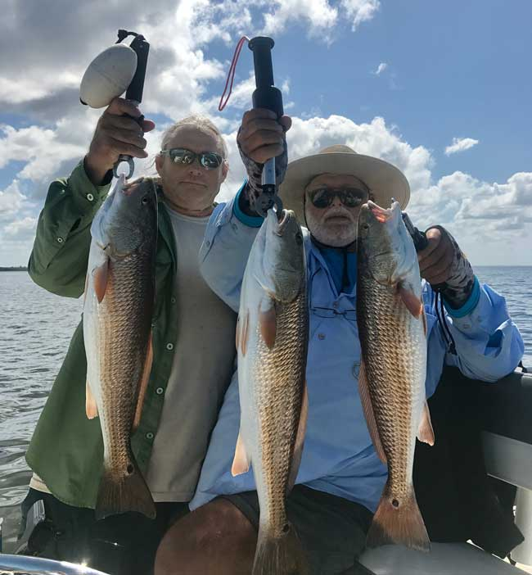

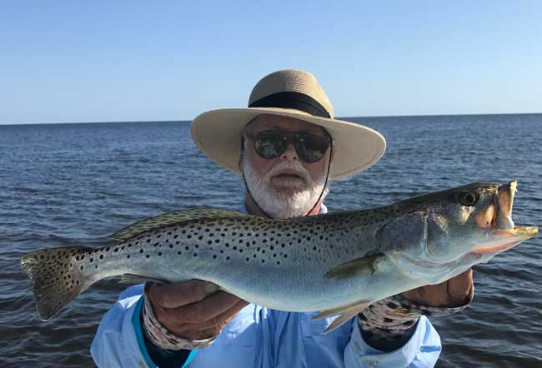

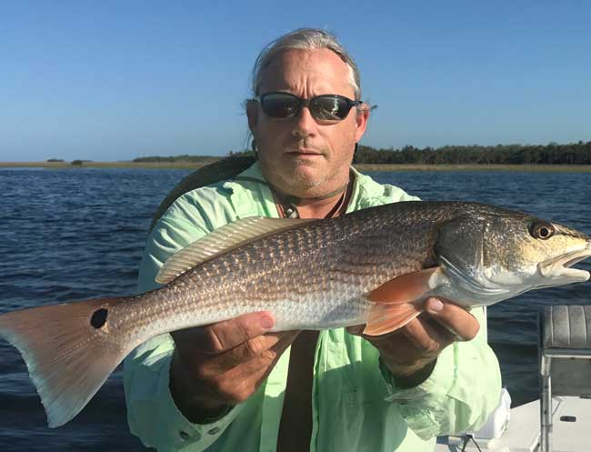

*Beautiful days at bucolic Steinhatchee, FL. Top Left:: Phil Norman with a nice redfish.*

*Top Right: Jay Honan and Jim Bohrer with a triple header.*

*Bottom Left: Jay Honan with a colorful redfish.*

*Bottom Right: Jim Bohrer found a trophy sized trout in the Steinhatchee area.*

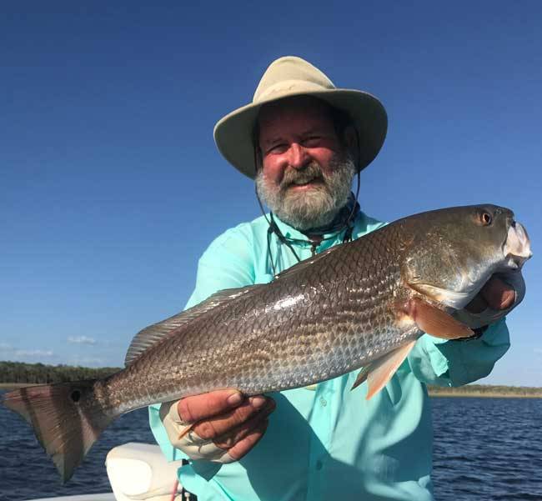

*Phil Norman with another fine redfish*

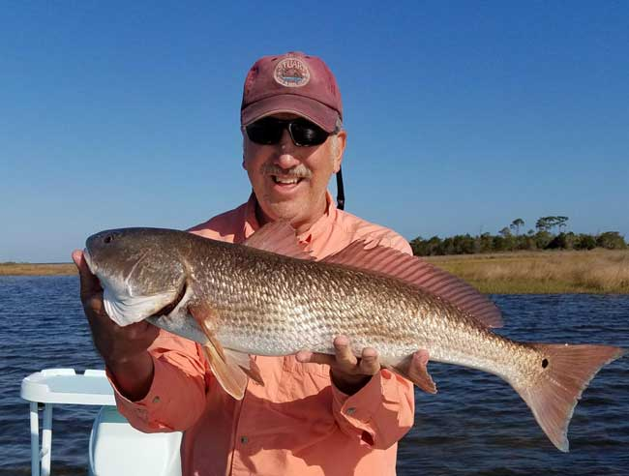

*Richard Matteson landed this nice redfish near the grass edges outside of Steinhatchee. Richard was fishing with Phillip Quick on Phillip’s boat.*

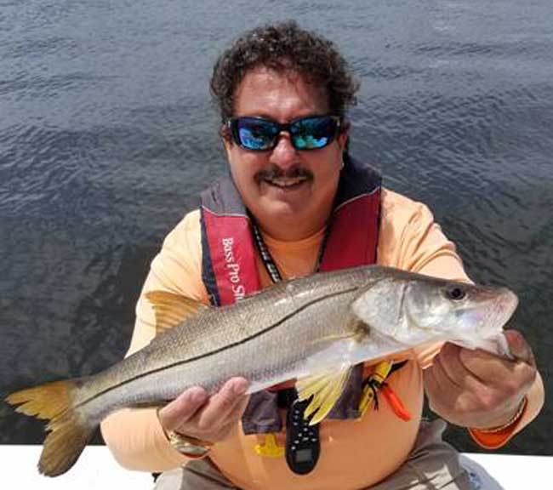

*Keith Palant with a nice snook caught near Stuart.*

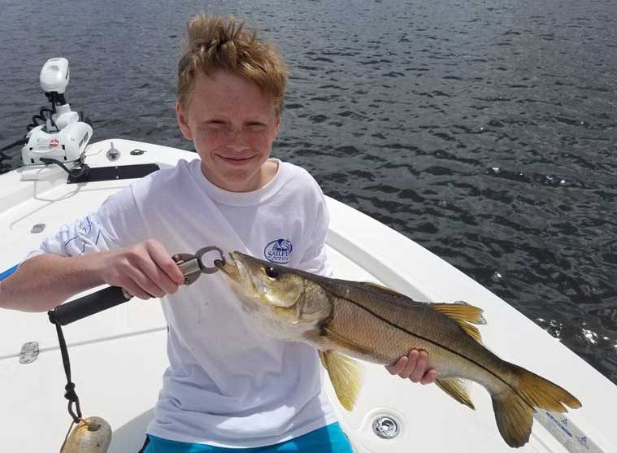

*Keith Palant loves to take people fishing. Here is Brian on Keith’s boat with a fine looking snook. A bright smile on a bright day.*

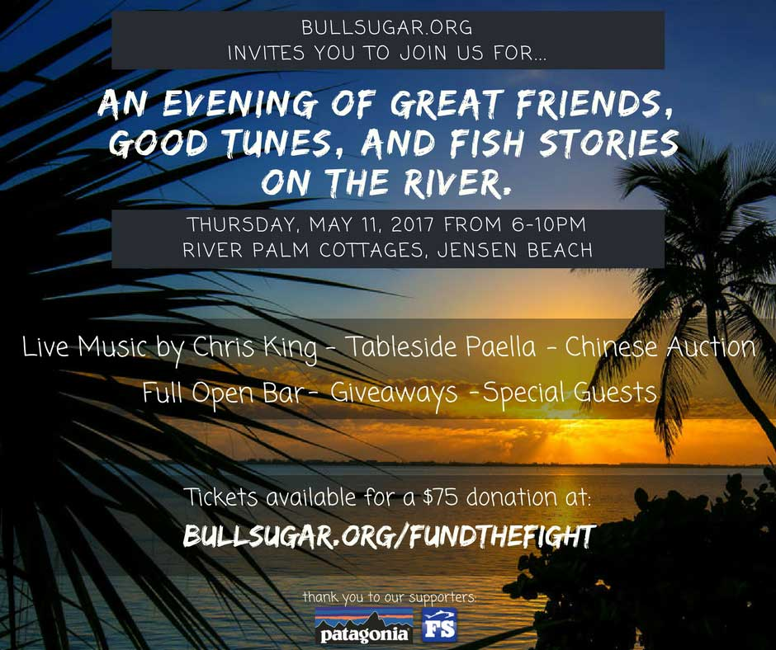

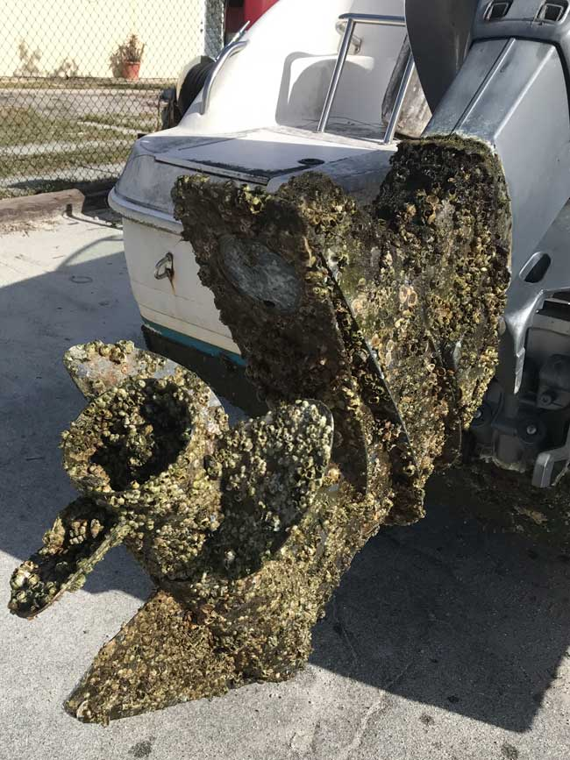

*I don’t know, Mr. Mechanic, my outboard is not running up to snuff. Could you check it for me?*

GUEST SPEAKER FOR THE MAY GENERAL MEMBERSHIP MEETING-

Captain James Cronk, a licensed local fishing guide, will be our guest speaker at the May meeting. Please join us on May 11th at Flanigan’s on US-1. Dinner begins at 6PM and the presentation begins at 7 PM.

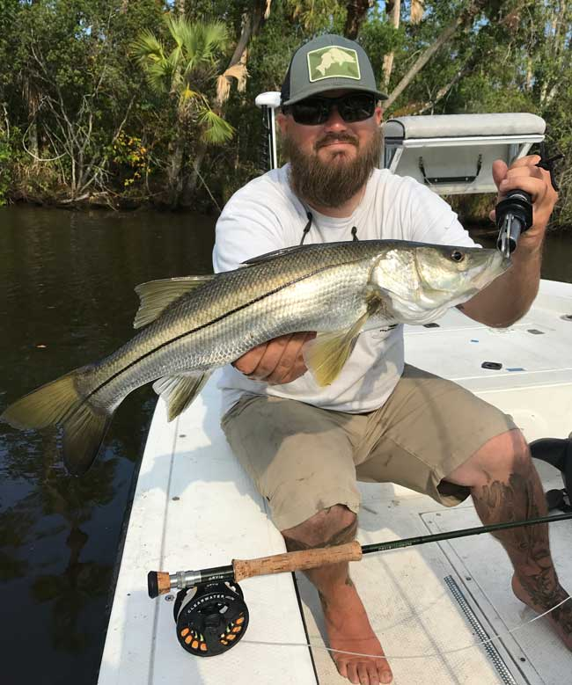

*Capt. James Cronk caught and released this nice snook with a fly in the back country near Stuart*

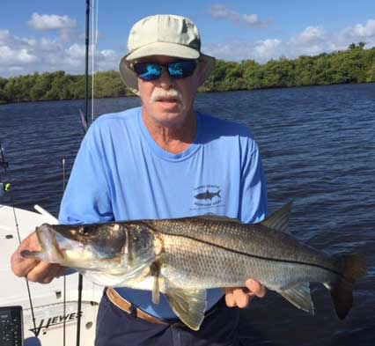

*Jim Harter with a South Fork snook that he caught and quickly released.*

|  |  |  |  |  |
| --- | --- | --- | --- | --- |
|  |  | | **Club Officers** |  |
| President | Jim Bohrer | | halieutics@gmail.com | 301-648-2052 |
| Vice President | Jim Bowdish | | jlsb@crarybuchanan.com | 772-475-5068 |
| Treasurer | Pete Noll | | mpnoll@aol.com | 772-223-2136 |
| Secretary and Newsletter Editor | Fred Bartlett | | fredbart@aol.com | 913-909-9326 |
|  | | | | |
|  | |  | **Board of Governors** |  |
| Director | | Roy Buckley | rlbuckley007@aol.com | 772-871-7008 |
| House Committee | | Jerry Hoge | jhoge@hogeengineering.com | 772-485-7267 |
| Angling Committee | | Frank Miller | frmiami2@gmail.com | 305-469-4654 |
| Membership Comm. | | Eric Rosenberg | [erosen1031@aol.com](mailto:erosen@aol.com) | 772-210-5563 |
| Meeting Speakers | | Jim Bohrer | halieutics@gmail.com | 301-648-2052 |
| Raffle Chairman | | Jim Harter | pjharter@comcast.net | 772-223-0648 |
| Conservation Coordinator | | Jim Harter | pjharter@comcast.net | 772-223-0648 |
| Events Coordinator | | Bob Ruggeri | bob.ruggeri@yahoo.com | 772-285-4264 |
| ***E-mail all* newsletter *copy and photos to Jim Bohrer at*** halieutics@gmail.com ***or to Fred Bartlett at*** [fredbart@aol.com](mailto:fredbart@aol.com). Closing date for photos and copy is the 25th of the month preceding publication. | | | | |

|  |  |
| --- | --- |
| All Stuart Rod and Reel Club Outings are based purely on the Honor System. All scheduled Club Outings will be “Daylight Outings”. You can fish any of the dates listed above. Event will begin at the first safe light in the morning with lines out of the water by 1PM. Scores must be turned into the Angling Director or other board member by email, phone or verbally by 2 PM local time on the day after the event.  Natural Bait (alive or dead) is allowed except for March, May and July. Bait restriction is in effect for September.  Guests and spouses are invited to attend the food services on Saturday at Sandsprit Park. For food at restaurants, guest and spouses will be charged for their meal and beverage costs. | Family members under the age of 18 must be accompanied by a parent or legal guardian to participate in an outing. While guests are always welcome to join members during our outings, you must be a paid member of the Stuart Rod and Reel Club to be eligible to win an outing. Outing scores shall be published in the Club’s Newsletter following the Outing. Outings cancelled due to weather shall be rescheduled for the following weekend. Outing result disputes shall be settled by the Angling Director.  OUTING SCHEDULES AND RULES MAY CHANGE DURING THE YEAR.  FISHING BOUNDARIES  Boundaries will extend from the south shore of the Jupiter Inlet to the North Vero Beach Bridge. |

|  |  |  |  |  |
| --- | --- | --- | --- | --- |
| Date | Outing/Event | Details | Host/Food Service | Rules |
| May  12, 13, 14 | Top Water Lures Only | Most Points Total - Snook =2pts.  Trout =1pts. and Redfish 3pts.  Max. 3 per species. | Sandsprit Park 1:00 PM Stuart, May 13th. | Total Points. No bait or jigs allowed. |
| June 9, 10, 11 | Most Species Caught-Must be legal size fish | Any species of fish caught. | Sandsprit Park 1:00 PM  June 10th | TBA |
| July  14,15,16 | Local Tarpon Outing | Most Tarpon: 3 Points for angler touching the leader, 1 point for a jumped fish. One point per jumped fish only. No natural bait allowed. | Shrimper’s Restaurant, Port Salerno 1:00PM, July 15th. | Three points for caught fish, one point for each jumped fish. |
| August  11, 12, 13 | Local Trout and Redfish Outing | Largest Trout & Redfish, total inch length | Sandsprit Park 1:00 PM Stuart, August 12th. | Longest total trout and redfish combined. |
| September  15, 16, 17 | Longest Snook | Longest Snook –Bait Restriction: Any snook caught on bait is worth ½ a fish caught on an artificial lure. 24” snook minimum length | Sandsprit Park 1:00  PM Stuart, Sept 16th. | Longest snook, minimum 24” |
| October  13, 14, 15 | Pine Island | Total Length in Inches: 1 Trout, 1 Redfish, 1 Snook (24” minimum on snook) | Pine Island Away  No Local Luncheon | Longest total length |
| November  10,11,12 | Local Redfish | Longest Overall Redfish | Sandsprit Park 1:00 PM, Nov 11th. | Longest total length |
| December 9 | Christmas Party | No Outing | Dolphin Bar & Fish House Jensen Beach | No Outing. |
|  |  |  |  |  |

2017 TOURNAMENT OUTING SCHEDULE

**Support our Advertising Sponsors**

We are very fortunate to have many local businesses that advertise on our web site and provide additional sponsorship support to the Club. These businesses provide a wide range of products and services for the entire community. Whether you are looking for lodging, restaurants, fishing supplies, boat repair and restoration, guide services, legal services, or roof repair our sponsors deserve your consideration. You can learn more about these businesses by visiting our website at [www.stuartrodandreel.com](http://www.stuartrodandreel.com). Click on the advertiser’s tab and you will find a brief description of our sponsors with contact information and links to their websites. Make our advertising sponsors your priority when shopping. Please let them know that you learned about them through the Stuart Rod and Reel Club and that you appreciate their support.

|  |  |
| --- | --- |
| **Bait & Tackle**   * Crowder Rods * D.O.A. Lures * Fish Heads of Stuart * Snook Nook * Treasure Coast Rod and Reel * White's Tackle * T & A Jigs, Inc. | **Area Lodging**   * Marriott - Hutchison Island Resort |
| **Area Dining**   * Big Apple Pizza * Crawdaddy’s * Dixie Grill * Manatee Island Bar & Grill * Manero’s Restaurant * Polka European Deli * Rancho Chico * Shrimper’s | **Guide & Charter Services**   * Cajun Fishing Adventures Louisiana * Catch 22 Charters Florida * The Fish Intimidator Louisiana |
| **Marine Products & Services**   * C&H Trailer * Manatee Marina * Marine Customs Unlimited * Marine Parts Outlet * Master Repair * Metco Marine Electronics * Outboards Only * Sailfish Marina * Stuart Propeller * Treasure Coast Battery & Alternator | **General Business**   * Capps Roofing * Inn of the Dog * Plaza 95 Marathon, Dairy Queen and Highway Café   **Professional**   * Crary Buchanan Attorneys |

***MEMBER’S INFORMATION***

**MONTHLY MEMBERSHIP MEETINGS WITH SPEAKERS:** The monthly membership meeting is the second Thursday of the month. Our home port is The Quality Inn/Flanigan’s Bar & Grill located at 950 SE Federal Hwy. (US 1) Stuart, FL. We have the privilege of listening to many fishing industry and conservation leaders in the Southeastern Florida region. These experts include tackle manufacturers, tournament winning Captains and guides, television and print journalists, and academic researchers. We have a guest speaker from this pool at each monthly meeting. Speakers will address topics of interests such as how to fish for the upcoming outing’s targeted species and our diverse estuary system. This is a great way to gain additional local knowledge of this fishery. Dinner begins at 6PM with Meeting at 7 PM.

**MONTHLY OUTINGS:** The Club sponsors a fishing outing each month. All outings are based on an Honor System. You don’t have to keep your catch or take a picture of it either. Outings are scheduled for the weekend following the general membership meeting. Outings are usually three day events where anglers select to fish Friday, Saturday or Sunday. Most outings are scheduled from first safe light till 1PM. The targeted fish and scoring change from month to month with interesting twists such as more points for one species than another. The intent is to have fun! The winner of each monthly outing receives a Club logo embroidered fishing shirt. As part of the outing we have several lunches at restaurants along with club and family cook-outs. Additionally, the Board is encouraging members to partake of the lunch regardless of the day fished. These are no-cost events. With two away outings and the remainder based at Sandsprit Park, there is opportunity to participate without travelling around the state. Frank Miller as the Angling Committee Chairman will also consider your ideas about other outings in other parts of the state. This year’s outing schedule was developed to increase participation, emphasizing the fun of fishing. You are able to view the schedule in every edition of True Lies.

**NEWSLETTER:** We publish a newsletter, True Lies, each month. It is circulated by e-mail. We are constantly looking for your fishing reports, pictures, recipes, and any other Club related information for inclusion. Submitting information is easy. You can send an e-mail to Jim Bohrer (halieutics@gmail.com).

**WEB SITE:** The Club’s web site (www.stuartrodandreel.com) is a wealth of information. You can find the latest weather and tides, fishing tips and information on our advertisers/sponsors.

**RAFFLE:** An activity at our membership meetings that generates a great amount of interest is the “Raffle”. Tickets are $1 each or 6 for $5. Raffle prizes vary monthly but usually include a fishing rod, reel or combination. Other prizes have been tackle bags, boxes, pliers, lures and boating accessories. Your purchase of raffle tickets gives you a good chance of winning and helps support the activities of your club.

**MEMBER DISCOUNTS:** Your Club membership can help you to save some money. White’s Tackle offers a 10% store discount on all purchases. Be sure to mention that you are a current member of the Stuart Rod and Reel Club and that you appreciate the support that they give the club.

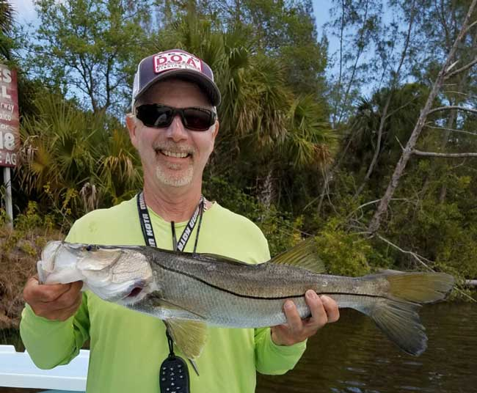

*Phillip Quick caught and released this fine snook near the St. Lucie River Spillway and Locks. Phillip reports that the fish are right under the mangroves in very shallow water so accurate skip casts are* *essential.*

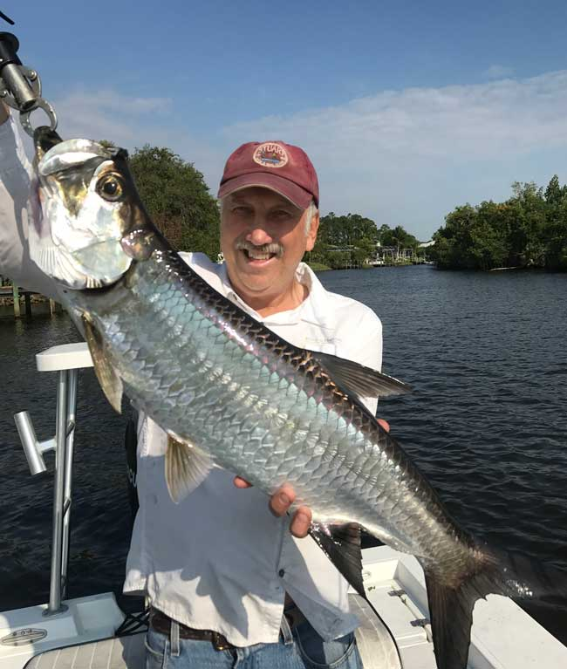

*Richard Matteson caught and released his very first tarpon. This is a great sized fish, perfect for fighting and jumping, yet not a back breaker. These fish are showing up in our area as the water warms. Richard caught this fish with Jim Bohrer.*

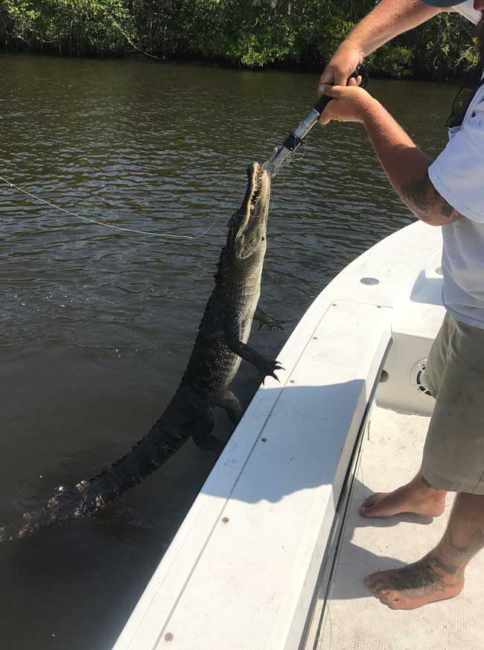

*Capt. James Cronk deciding what to do with a juvenile gator that took a lure. Of course, you want your lure back, but how do you go about getting it? Better make sure that the Boga Grip is a strong one. This could get painful in a hurry.*

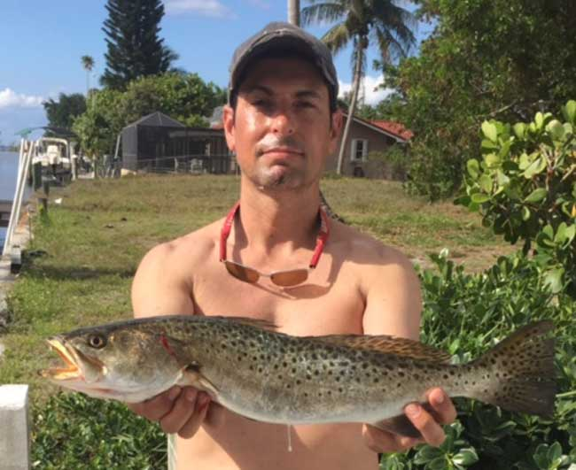

*Mike Bowdish caught this fine trout in Jug Creek, Bokeelia, Florida on a floating plug with a jig head and curly tail dropper. This is on North Pine Island on the west coast of Florida.*

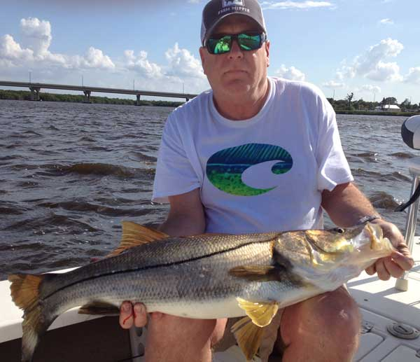

*Dave Huntington, fishing with Jim Tuten, caught and released this magnificent 35 inch* snook.

to

**WINNER OF THE APRIL ANGLING TOURNAMENTS**

Mike Chilton won the April Tournament Event with a total of four species landed. He wins an embroidered shirt.

Fish of the Month March-April 2017

Glenn Kellis, another new member, fished day and night to catch and release an amazing 46 snook during the April Fish of the Month Contest. Glenn wins a logo cap and is entered into the annual contest.

**2017 Annual Dues**

Dues for 2017 are now past due. Fully paid memberships begin the first day of January, and end on the thirty first day of December of each calendar year. An individual membership is one adult 18 years of age or older. Family memberships consist of the member, their spouse or significant other and their children under the age of 18.

**Individual membership** for a full year is $80

(January thru December)

**Family membership** for a full year is $95

(January thru December)

**Send your checks payable to:**

Stuart Rod and Reel Club, Inc.

c/o Pete Noll, Treasurer

1888 S. W. Mooring Dr.

Palm City, FL 34990

***Membership entitles a single person (or family as applicable) to participate in all outings and to enjoy a meal at every local outing. Members also receive an included meal (with soft drinks) at Shrimper’s and Manatee Island Grill on the appropriate dates. We hold monthly meetings with interesting speakers and share information on where and when to fish in our area.***

**2017 SRRC Fish**

**of the Month Contests**

The Fish of the Month Contest will run from the day after the monthly membership meeting and end at 12 Noon the day of the following meeting. All fish need to be legal size except for Snook that must be 18 inch minimum. Natural bait (live or dead), artificial lures and flies are allowed. The member catching the most fish will be the monthly winner. The monthly winner will receive a monogrammed club hat.

|  |  |
| --- | --- |
| Date | Species |
| Jan 13 thru  Feb 09 | Snapper, Bluefish |
| Feb. 10 thru Mar. 09 | Most Pompano |
| Mar. 10 thru April 13 | Most Snook |
| April 14 thru May 21 | Largest Trout |
| May 12 thru June 18 | Most Snook |
| June 19 thru July 13 | Most Redfish |
| July 14 thru Aug 10 | Most Trout |
| Aug. 11 thru Sept 14 | Most Tarpon Caught and Released |
| Sept. 15 thru Oct 12 | Largest Snapper |
| Oct. 13 thru Nov 9 | Largest Redfish |
| Nov 10 thru Dec 13 | Most Black Drum |

The Winner of the Year Overall will be the person catching the most total species during the calendar year. The overall prize is a $50 gift certificate to White’s Tackle in Stuart.