Rail Fence Block Susan Greene: 2023

CUTTING:

From each of the three fabrics cut four (4) strips 2 ½ by 6 ½ inches.

Unfinished size will be 12 ½ inches. Please do not trim.

Choose three fabrics for this block. Fabric A: a light value, Fabric B: a medium value, and Fabric C : a dark value.

(strong contrasts between the values) Any combination of colors, prints or batiks will be fine. I want a “scrapy” look.

ASSEMBLY: STEP 1

Use ¼ inch seams throughout.

Stitch Fabric A strip to Fabric B strip. Press away from fabric A. Make four (4)

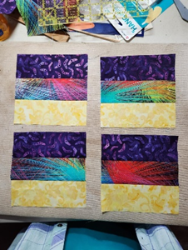

ASSEMBLY: STEP 3

Arrange sections so that Fabric A (light value) meets in the center.

Stitch together as shown. Press seams away from the light valued fabric.

ASSEMBLY: STEP 2

Stitch Fabric C to Fabric B.

Press away from Fabric C.

On each four from Step one.

