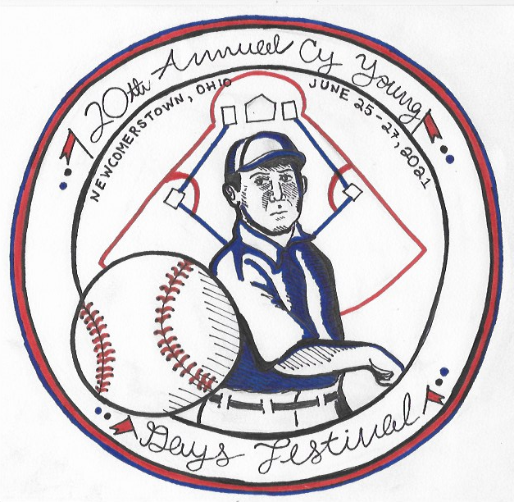

Cy Young Days Festival Cornhole Tournament
6:00PM June 25, 2021
Registration Form

Player #1 __________________________________________________________
Address ______________________________________Phone#______________
Player #2___________________________________________________________
Address ______________________________________Phone#_______________
$25.00 registration fee per two-person team. Registration will be complete when fee is paid.
Tournament shall be total points format, single game and double elimination.
Tournament shall utilize ACA rules.
Contacts: Ed Gibson 740-498-5261 Dave Boyer 330-328-0587
Return forms and registration fee to Dale Gress Real Estate 137 W. Main St. Newcomerstown 43832

