REGULAR MEETING
FEBRUARY 17, 2022
The Regular Meeting of the Town Board of the Town of Hampton, County of Washington and the State of New York was held at the Town Hall, 2629 State Route 22A, Hampton, New York, also via Zoom and live streaming on the You Tube Channel for “Town of Hampton New York” on the 17th day of February 2022.

Due to the Corona Virus, occupancy inside the Town Hall is limited at this time. Supervisor O’Brien did provide a link to join the meeting via Zoom.

PRESENT: David K. O’Brien------------Supervisor
Donald Sady-----------------Councilman
Tamme Taran----------------Councilwoman - absent
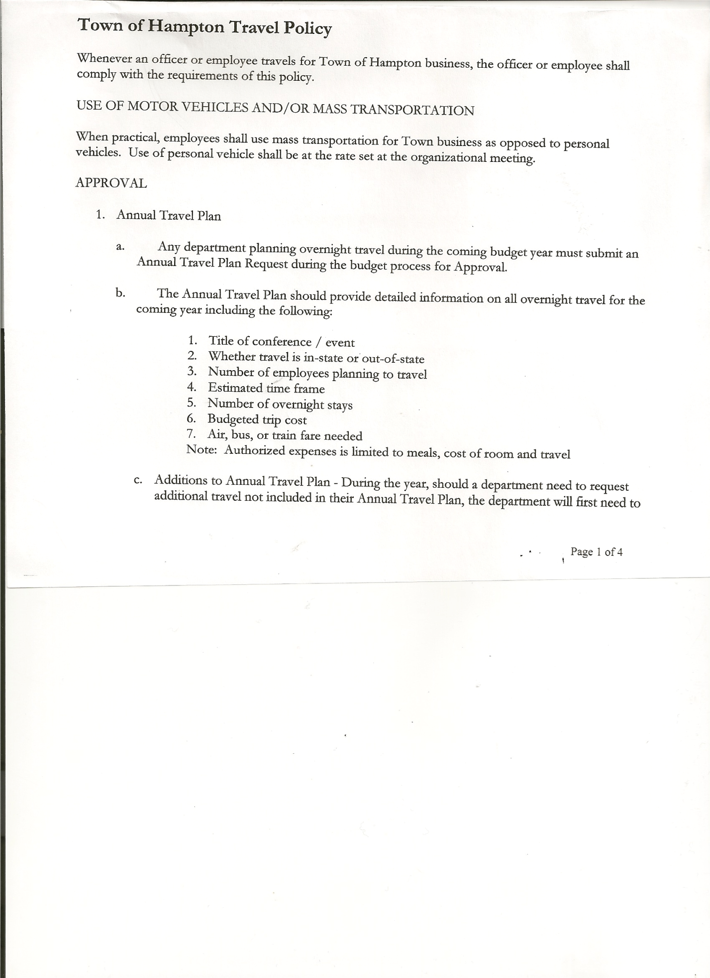
Michael Pietryka------------Councilman
Travis Dean------------------Councilman -absent
Rebecca Jones---------------Town Clerk
Camilla Shaw----------------Tax Collector/Deputy Town Clerk
Tyler McClure---------------Highway Superintendent

Planning Board Member (s):… Bonnie Hawley, Chair and Matthew Pratt
Others present at the Town Hall: Richard Cole, President, Hampton Volunteer Fire Co.
and Artie Pratt

The Regular Meeting was called to order by Supervisor O’Brien at 7:42pm, followed by the Pledge of Allegiance. Location of Fire Exits were given. Quorum of board members present.

RESOLUTION NO. 16-2022
APPROVAL OF THE MINUTES
On a motion of Councilman Pietryka, seconded by Councilman Sady, the following resolution was ADOPTED: AYES 3 O’Brien, Sady, Pietryka,
NAYS 0
ABSENT 2 Taran, Dean
RESOLVED, that the Regular Town Board Meeting Minutes for January 20th, 2022 are approved.

Larry Carman, Dog Control Officer…no report

Camilla Shaw, Tax Collector…. .112 parcels left to pay. Submitted her January 2022 report to the Board for review. Also Submitted Bank Statement to the Board for review and signatures.

Bonnie Hawley, Chair gave Planning Board Report……copy of the minutes of their meeting held February 9, 2022 are attached. Next meeting is scheduled March 9th, 2022.
Regarding the recommendation for Planning Board positions as mentioned in Bonnie’s report, the following Resolution was introduced:
RESOLUTION NO. 17-2022
APPROVAL OF PLANNING BOARD MEMBERS
On a motion of Councilman Sady, seconded by Councilman Pietryka, the following resolution was ADOPTED: AYES 3 O’Brien, Sady, Pietryka,
NAYS 0
ABSENT 2 Taran, Dean
RESOLVED, to appoint Richard Cole as a Full Member and Stuart Griffin as an Alternate Member of the Hampton Planning Board.

TOWN BOARD MEETING
FEBRUARY 17, 2022 PAGE 2

Tyler McClure, Highway Superintendent submitted his report, copy of which, is attached.
Highway Employee Jimmy Brown is improving, out of hospital and doing rehab.

SUPERVISOR’S REPORT/ COUNTY UPDATES/ COMMUNICATIONS

RESOLUTION NO. 18 -2022
APPROVAL OF SUPERVISOR’S MONTHLY REPORT
On a motion of Councilman Sady, seconded by Councilman Pietryka, the following resolution was ADOPTED: AYES 3 O’Brien, Sady, Pietryka
NAYS 0
ABSENT 2 Taran, Dean
RESOLVED that, the Supervisor’s Monthly report be accepted as submitted for JANUARY
12/31/21 01/31/22
ACCOUNT BALANCE RECEIPTS DISBURSEMENTS BALANCE
General Fund $ 51,458.11 $ 38,881.00 $ 12,248.38 $ 78,090.73
Highway Fund $130,472.90 $ 326,897.80 $ 23,514.40 $ 433,856.30
Equipment Reserve $ 79,923.46 $ 2.04 $ 0.00 $ 79,925.50
Fire #1 $ 0.00 $ 44,163.00 $ 0.00 $ 44,163.00
Fire #2 $ 0.00 $ 10,404.00 $ 0.00 $ 10,404.00
Cemetery $ 1,755.17 $ 0.04 $ 0.00 $ 1,755.21
Totals $263,609.64 $ 420,347.88 $ 35,762.78 $ 648,194.74
All Board Members present signed Supervisor’s Report.

OLD BUSINESS
Internet and Phones for the Town Hall have been upgraded.

NEW BUSINESS
Fire Company has purchased a backup generator. Councilman Pietryka presented it as a possible COVID Fund project as the fire house can serve as an Emergency Shelter. Supervisor O’Brien thought there was a small amount of funds left, but it might be needed for a water upgrade at the Town Garage. Next year’s funds may be used for an upgrade of fuel storage. Town Board members present agreed to help reimburse Fire Company for the generator if there is COVID monies left over.

PUBLIC COMMENTS/COUNCIL COMMENTS
Richard Cole wanted to advise people of the SCAM text message that is out there…it wants people to verify their delivery address.

Two vouchers on the January 20th, 2022 Warrant were voided after the meeting.
Voucher #1 for $1094.86, Nan Stolzenburg. Contract has not been signed yet.
Voucher #16 for $50.00, Twin Bridges Waste & Recycling. Town has previously requested the garbage cans be picked up. Town uses CV Waste Removal now.
RESOLUTION NO. 19 -2022
VOIDED VOUCHERS-JANUARY WARRANT
On a motion of Councilman Sady, seconded by Councilman Pietryka, the following resolution was ADOPTED: AYES 3 O’Brien, Sady, Pietryka
NAYS 0
ABSENT 2 Taran, Dean
RESOLVED, to reduce the total amount of January’s Total Warrant from $10,328.42 to $9,183.56.

TOWN BOARD MEETING
FEBRUARY 17, 2022 PAGE 3

RESOLUTION NO. 20 -2022
AUDIT OF CLAIMS
On a motion of Councilman Pietryka, seconded by Councilman Sady the following resolution was ADOPTED: AYES 3 O’Brien, Sady, Pietryka
NAYS 0
ABSENT 2 Taran, Dean
RESOLVED that the bills have been reviewed by the Town Board and are authorized for payment in the following amounts.
General Fund No. 19 through No. 33 $ 13,305.24
Highway Fund No. 17 through No. 25 $ 7,831.51
Total both funds $ 21,136.75

The Town Clerk’s report for January 2022 was submitted to the Board. The Town Clerk had Board Members review and sign bank reconciliation statements for the Town Clerk Account and Special Clerk Account dated January 31, 2022.

RESOLUTION NO. 21-2022
MEETING ADJOURNED
On a motion of Councilman Pietryka , seconded by Councilman Sady, the following resolution was ADOPTED: AYES 3 O’Brien, Sady, Pietryka
NAYS 0
ABSENT 2 Taran, Dean
RESOLVED that the meeting adjourned at 8:27pm.

Respectfully submitted,

Rebecca S. Jones, RMC
Town Clerk

