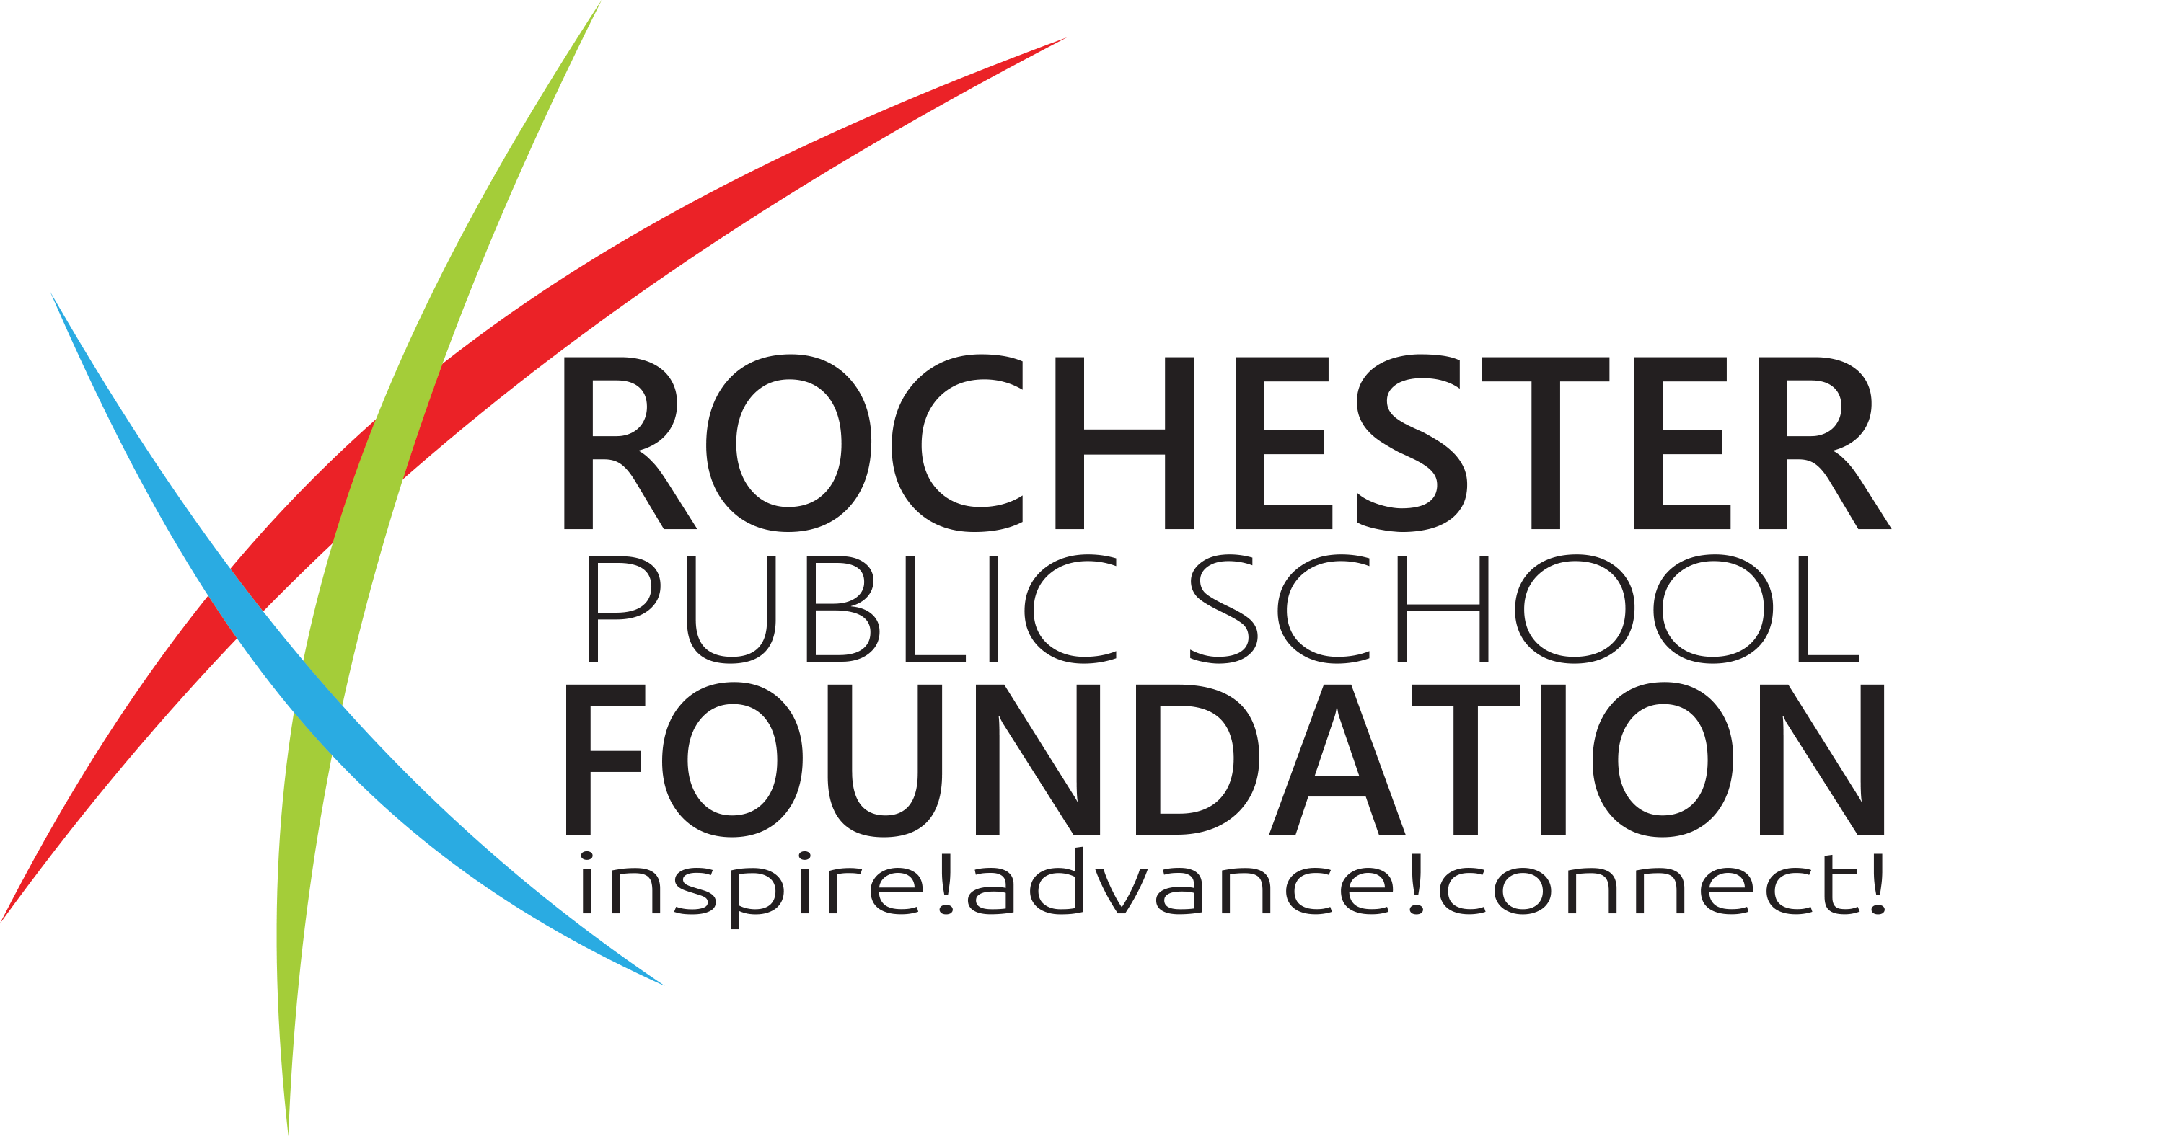

RPSF Grant Application

Please save completed application in PDF format
and submit to RPSFGrantCommittee@gmail.com
no later than November 10, 2019.
I am requesting funds for use during: (choose one)
☐ 2nd half of 19-20 school year ☐ 1st half of 20-21 school year ☐ Entire school year 20-21
Please note: Grant funds will be available approximately 3 weeks prior to the term selected. The Accounting department and/or your building secretary will assist you with requisitions and/or coding of expenses. Unused funds will be unavailable after the term selected.

Names of Project Director(s) with email and phone number for each person (at least one person MUST be school district staff): Click or tap here to enter text.
Project Site(s)/School(s): Click or tap here to enter text.

Summarize the target audience that would benefit from the grant: Click or tap here to enter text.
Number of Students: Click or tap here to enter text. Number of Staff: Click or tap here to enter text.
Age Group: Click or tap here to enter text. Grade Level(s): Click or tap here to enter text.
Describe any special needs of your student population, if applicable (e.g. FRPL, Title I, LEP, etc.):
Click or tap here to enter text.

Total Amount Requested (max $2500): Click or tap here to enter text.
Are there other sources of funding being used? Click or tap here to enter text.
If yes, what’s the source and amount? Click or tap here to enter text.

Project Duration:Click or tap here to enter text.
Beginning date:Click or tap here to enter text. Ending date: Click or tap here to enter text.

Project Title: Click or tap here to enter text.

Project Description
- Describe the proposed project, including the purpose of the project and who it would benefit.
- Describe how the project would enrich and enhance the students’ academic learning and/or social emotional growth.
- Identify the project’s desired long-term impact/results.
Click or tap here to enter text.

Project Goals and Objectives
- List the goals and objectives of the project. Include ways in which these goals would be “SMART” (Specific, Measurable, Attainable, Realistic, and Time-bound) whenever possible.
- Describe how the project strengthens the school/home/community partnership, if applicable.
- Describe how the goals and objectives of the project align with the mission of the Rochester Public School Foundation (“to advance and inspire educational opportunities for all students”).
Click or tap here to enter text.

Project Activities
- Detail the activities that will take place and the specific ways the activities will achieve the goals.
Click or tap here to enter text.

Project Timeline/Schedule
- Outline the timeline/schedule for the project's completion, including specific dates and milestones.
Click or tap here to enter text.

Project Budget
- Develop a clear and detailed budget for the project.
- Indicate expenses to be covered by Rochester Public School Foundation grant funds and expenses to be covered by other funding sources. List these items in the budget together with vendors and amounts for each item.
- Grant funds may not be used for purchase of food unless request is integral to the completion of the grant. For example, snacks for after-school programs or meals for family events would not qualify, but groceries for a cooking class could potentially qualify. If funds are requested for food items, please provide rationale.
- Please note that grant funds are limited. Project proposals should include only items that are integral to the completion of the grant. Applicants are encouraged to avoid inserting additional items that will artificially increase the request to the maximum award amount.
Click or tap here to enter text.

Project Evaluation Plan
- Describe the method/criteria to be used to measure the outcomes of the project, including information on what types of data will be collected and how.
- Indicate who will be responsible for or involved in the evaluation of the project.
- Describe how you will determine whether the project has been successful. Provide numerical/quantifiable results whenever possible. (For instance, number of students participating, a specific point increase in test scores, a percentage of participants indicating satisfaction at the end of the project, etc.)
Click or tap here to enter text.

Reporting Results
Grant recipients must submit a one-page summary of project outcomes and lessons learned, along with digital pictures, to RPSF within one year of receiving grant funds. In addition, grant recipients are required to share the results, outcomes, and lessons learned from their grants with their grade-level/department team or another relevant stakeholder group.
- Describe how you will report the results of your project to the Rochester Public School Foundation and to other key stakeholders.
- Detail a timeline and process for recording progress throughout the project and for reporting results to appropriate stakeholders upon completion.
- If applicable, describe ways in which your project could engage community members and/or create positive public relations/media exposure for Rochester Public Schools and/or the Rochester Public School Foundation.
Click or tap here to enter text.

Innovation
- Explain ways in which the project focuses on innovative, creative, and/or unique learning experiences that complement or extend an existing academic program, or how your project will create new opportunities that may not otherwise occur given limited school district resources.
- Explain whether this project would have the potential to be replicated/implemented with other sites or groups, provided the project’s objectives are realized.
- As RPSF grants are intended to be one-time funding sources, if this project would require additional funding to continue after the initial funding period, describe any potential sources for ongoing funding in the future.
Click or tap here to enter text.

Project Support
Building/Department Administrator Name: Click or tap here to enter text.
Date Reviewed: Click or tap here to enter text.
Comments from Building Administrator indicating support for proposed project (REQUIRED): Click or tap here to enter text.

If your project proposal involves the purchase of technology equipment, have you discussed your proposal with the district’s Technology Department and received approval? Click or tap here to enter text.
If not, please explain: Click or tap here to enter text.

Have you ever been awarded a grant from RPSF for a similar purpose in the past? Click or tap here to enter text.

Funding Source Categorization
Please check the box(es) of any categories for which your grant proposal might qualify. This will not affect your proposal’s chances of funding – it simply assists us with categorizing our funding sources.

☐ The Jacqueline B. Goodyear Fund for Fine Arts: To enrich the fine arts exposure and experience of RPS students and/or to promote student interest and achievement in the fine arts (defined as painting, drawing, architecture, sculpture, poetry, music, dancing, and dramatic art).
☐ The Michael Ladin Memorial Fund: To support socio-economically disadvantaged students.
☐ The Joel E. Luhman Memorial Fund: To support creative writing or outdoor photography.
☐ The Joseph Stanich Memorial Fund: To support classroom opportunities or professional development.
☐ The Athletics & Fine Arts Fund: To increase access/reduce barriers to participation in athletics and fine arts for students in need.
☐ The STEM Fund: To support learning in the STEM academic areas (Science, Technology, Engineering, and Mathematics).
☐ The Chance Fund: To provide financial assistance for activities to students who would otherwise not have the opportunity to participate.
☐ None of the above. (This does not disqualify your application.

Project Summary
- Provide a very brief (3-5 sentence) summary of your project that could be used to highlight your project in RPS or RPSF media releases, etc.
- Example from a past grant award: “This project would launch the in-school Latte Da Coffee Shop using the Alternative Peer Groups model, making it the first program in the state to establish and use the APG model to help youth struggling with addiction. The coffee shop would help peers connect with each other, overcome shame and hopelessness, improve mental health, and develop community partnerships. Students would design, develop and create business plans, interviewing skills and art to create a functional coffee shop that becomes self-sustaining over time.”
Click or tap here to enter text.

Thank you for submitting a grant proposal! Please save your completed application in PDF format and submit to RPSFGrantCommittee@gmail.com no later than November 10, 2019. You should receive an acknowledgment of receipt within a few days. If you do not, please contact us to verify that we received it. Grant award decisions are expected to be emailed to you on or around December 15, 2019.

