Eco Orca’s DECEMBER 2024 Community Helper’s and Christmas
SUNDAY |  |  | MONDAY | TUESDAY | WEDNESDAY | THURSDAY | FRIDAY | SATURDAY
 |  | 1 | 2 | 3 | 4 | 5 | 6 | 7
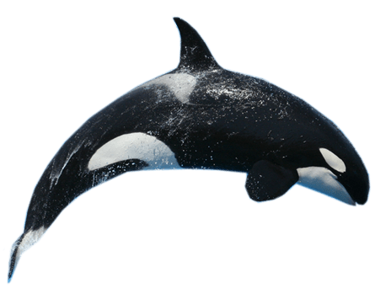 |  |  | Colwood Fire Hall Museum $3 | Sarah Beckett Park | Humpback Park | Mill Hill  Trails | Parliament Buildings | 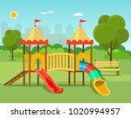
 | 8 |  | 9 | 10 | 11 | 12 | 13 | 14
 |  |  | Goldie Park Trails | Cloverdale Park | Esquimalt Lagoon | Miniature World $5 | Bay Centre Christmas Tree’s
 | 15 |  | 16 | 17 | 18 | 19 | 20 | 21
 |  |  | Gingerbread House Tour $2 | Island View Beach | Beckwith  Park | Whiffin Spit Ornament Hanging | Christmas Party  12:30-2pm
 | 22 |  | 23 | 24 | 25 | 26 | 27 | 28
 |  |  | Closed | Closed | Closed  Christmas Day | Closed  Boxing Day | Closed | 
 | 29 |  | 30 | 31 | 1 | 2 | 3 | 4
 |  |  | Closed | Closed | Closed  New Years Day | Closed | Closed

