VICTORY WORKS
2017-2018
CERTIFICATIONS OFFERED:
First Aid/CPR Forklift 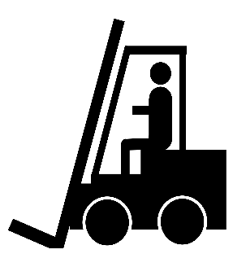

NEW EXCITING FIELD STUDIES: NEW EXCITING GUEST SPEAKERS:
Workforce Investment Center Where Should I Live?
Different Types of Housing Health Care Power of Attorney
Animal Shelter Living Will
Hospital What is Disabilities & Special Needs?
VR Training Center What is Vocational Rehabilitation?
Richland County Library What Career am I interested in?
Shopping on a Budget How Do I Ride the City Bus?
Bank
Embassy Suites
S.C. State Fair
Krispy Kreme

