2017
April
TRUE LIES
The Stuart Rod & Reel Club Newsletter
The Stuart Rod and Reel Club is dedicated to improving local fishing through by increasing angler knowledge, encouraging conservation and maximizing the fun involved in light tackle fishing in the Stuart Florida area. We hold monthly meetings on the second Thursday of each month, year round. Please join us or contact any board member for more information on how you can become a member of the Stuart Rod and Reel Club.
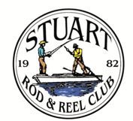

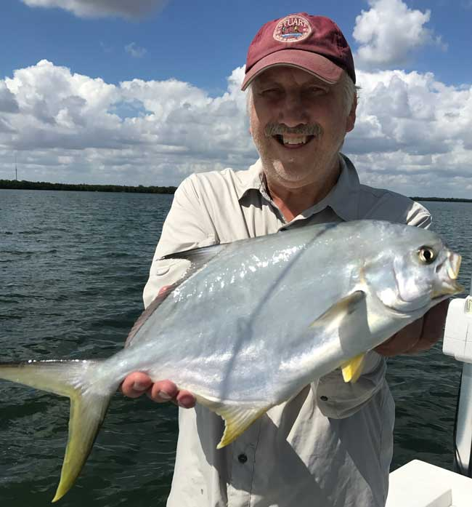
Richard Matteson with a beautiful pompano caught in the river
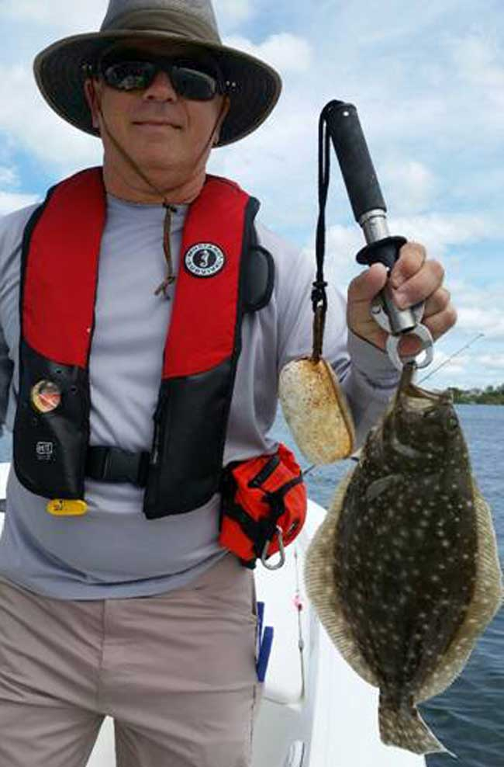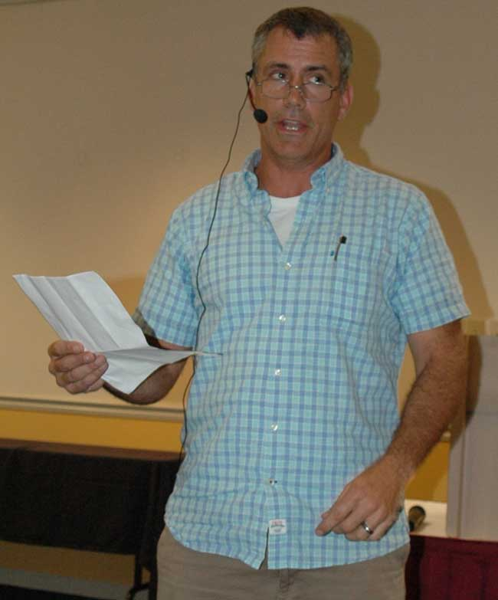
Jeff Weakley, Executive Editor of Florida Sportsman Magazine gave a very interesting talk at our March general membership meeting. Jeff discussed the most popular fish in our area; Snook, Trout and Redfish. Jeff has extensive experience throughout Florida and he now makes Jensen Beach his home.
Jeff helped us understand where and when to look for fish and how to both land them and release them safely.
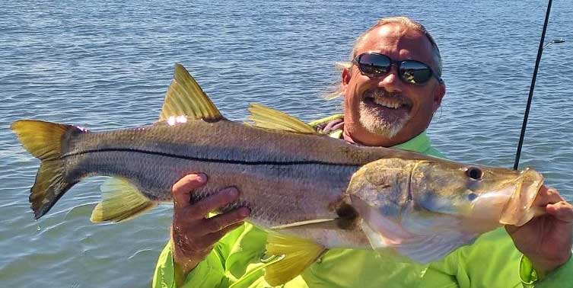
This beautiful snook brought a big smile to Jay Honan as he fished from his kayak.
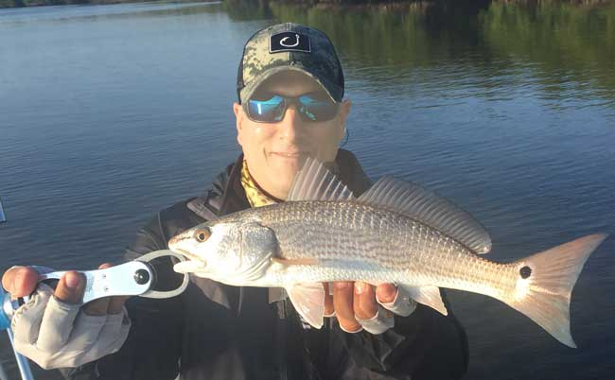
Above: Jorge Perez with a nice flounder and Juan Giachino with a fine Round Island redfish
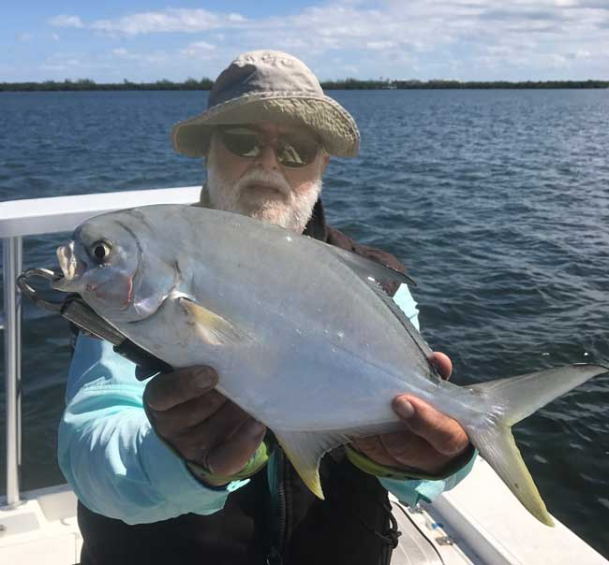
Jim Bohrer with a magnificent pompano caught on the Indian River Lagoon

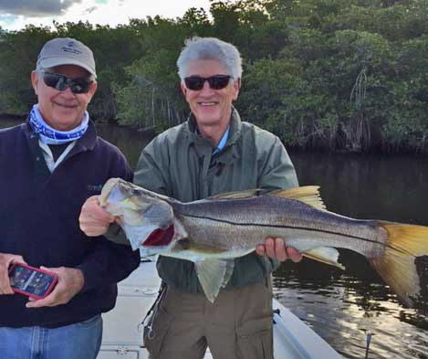
Jim Harter took out some friends who had never fly fished in our area. On this trip, one friend landed a 33 inch snook on a fly. It helps to have a great guide to show you where and why to cast to a particular spot.

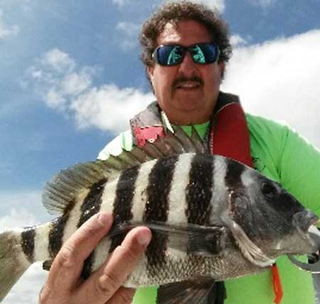
Keith Palant with a keeper sheepshead. Sheepshead smaller than this are too much work to clean, but this one will yield some beautiful meat. As they mostly eat crustaceans, they are delicious.

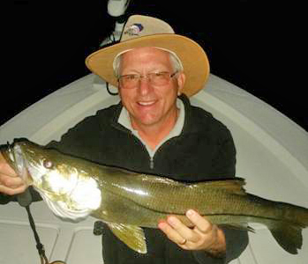
SPEAKER FOR THE APRIL GENERAL MEMBERSHIP MEETING-APRIL 13th

Captain James Cronk (an SRRC member) is giving our presentation in April. James is an expert local fishing guide and has fished as a guide both in Florida and Alaska. If you have read our March newsletter, you know that James can put you on big snook in our area.
Keith Palant took out a friend from Michigan and this is one of the snook that they caught at night.

STEINHATCHEE FLORIDA FISHING REPORT-By Jim Bohrer
Dave McClure said "instead of talking about it, let's just go" didn't have to bend my arm.
Called the Sea Hag Marina and booked a room, Dave said that his brother-in-law Bob was going to be in town and wanted to invite him to go. The three of us headed up the Turnpike to Steinhatchee.
It was a Thursday morning and we left early so that even after the five-hour trip we would have the afternoon to fish. Registered at the Sea Hag, launched the boat, and stored the trailer.
The wind was blowing hard from the east, not good when fishing the shallow water shoreline of the west coast of Florida. Even if the fish were there I couldn't have gotten to them. Dave and Bob were scratching their collective heads and stared at me saying "but you said".............I reaffirmed my knowledge the red fish were here but I did not possess the skills to find them under these conditions.
Fearing those exact conditions, and relying on the one skill that had not eluded me, prior to coming to this fishing "Mecca" I called my friend and fishing guide Capt. Grant Wilson. At least if we struck out the second day there would be someone else to blame!
7:30 AM we met Grant at the Sea Hag Dock, exchanged pleasantries and headed to the river mouth. At channel marker 7, we turned left and headed south (the opposite direction we had gone the previous day). Grant is a competitive redfisherman and guide. He has a 20 ft. Skeeter boat with a 250 HP Yamaha. It was still windy but the four of us made the 14-mile trip in relative comfort. We stopped at place just south of Pepperfish key. We fished ourselves closer to shore as the tide came in but without a redfish.
Grant was reassuring without reminding us that he spends every day here watching these fish. I believe that you hire a fishing guide for how well he or she connects their vision to the brain sensors that communicate with the angler, that's what Grant brings to the fishing experience.
REDEMPTION!!!! My inability to find fish the day before had left me with my tail between my legs, but I did know who to call. Like a light switch, Grant started seeing activity in the water. School after school of redfish, and Grant kept us in them the rest of the day. A big part of our time was spent doubling-up and even tripling-up.
If you are fortunate enough to get a good fishing guide, you increase your chances of catching and get an education!
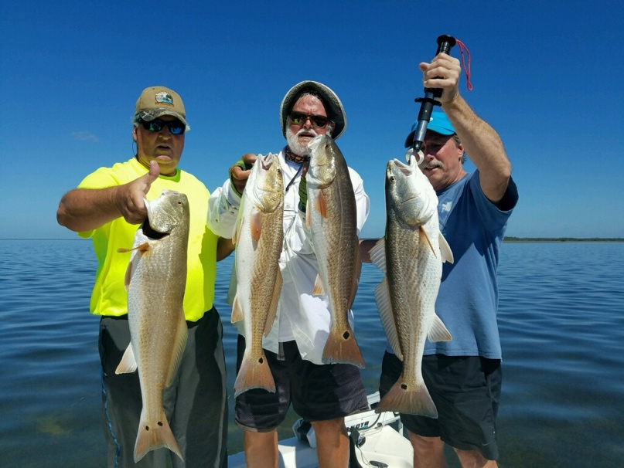
When you have a magic redfish day in Steinhatchee, it is as good as it gets. Using gold spoons, this team caught many redfish.
Left to Right; Dave McClure, Jim Bohrer and Dave’s brother-in-law.

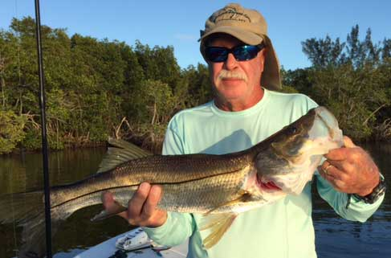
Jim Harter with a pretty snook, caught in the South Fork.

 |  |  | Club Officers
President | Jim Bohrer |  | halieutics@gmail.com | 301-648-2052
Vice President | Jim Bowdish |  | jlsb@crarybuchanan.com | 772-475-5068
Treasurer | Pete Noll |  | mpnoll@aol.com | 772-223-2136
Secretary and Newsletter Editor | Fred Bartlett |  | fredbart@aol.com | 913-909-9326
 |  |  | Board of Governors
Director |  | Roy Buckley | rlbuckley007@aol.com | 772-871-7008
House Committee |  | Jerry Hoge | jhoge@hogeengineering.com | 772-485-7267
Angling Committee |  | Frank Miller | frmiami2@gmail.com | 305-469-4654
Membership Comm. |  | Eric Rosenberg | erosen1031@aol.com | 772-210-5563
Meeting Speakers |  | Jim Bohrer | halieutics@gmail.com | 301-648-2052
Raffle Chairman |  | Jim Harter | pjharter@comcast.net | 772-223-0648
Conservation Coordinator |  | Jim Harter | pjharter@comcast.net | 772-223-0648
Events Coordinator |  | Bob Ruggeri | bob.ruggeri@yahoo.com | 772-285-4264
E-mail all newsletter copy and photos to Jim Bohrer at halieutics@gmail.com or to Fred Bartlett at fredbart@aol.com. Closing date for photos and copy is the 25th of the month preceding publication.

Kids Fishing Day at Florida Oceanographic Society
Every year we help with a day at FOS to help kids learn to fish in saltwater and how to conserve our natural resources. This event is led by FOS education director Dr. Zack Judd PhD who is a friend of our club and an excellent fisherman.

Jim Bohrer caught and brought a mess of trout for the fish cleaning station. As you may know, Jim does not generally kill trout, but he made an exception to help the kids. One young man even put a blood smear trail on his forehead, a tradition among deer hunters.

While we were not allowed to take facial photos of the kids for obvious reasons, this is always a fun event. A few general photos are shown below. The kids were very well behaved this year. At the end of the event, each kid is given a rod, reel, line and a tackle selection, courtesy of the “Fish Florida” organization. As the Florida sailfish license plates are a direct donation to this group, they have the funds needed to help sponsor many great events.
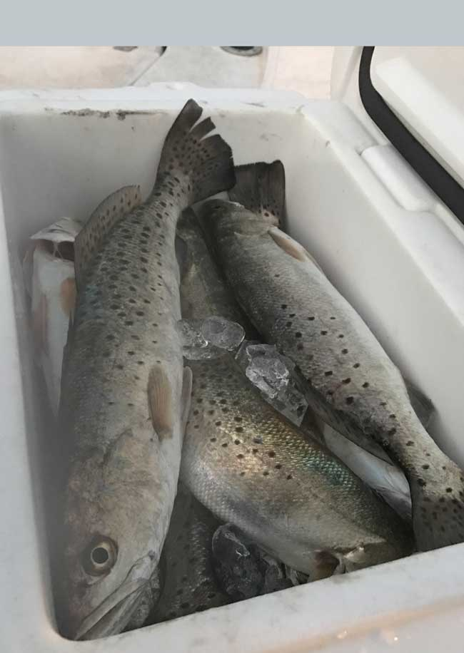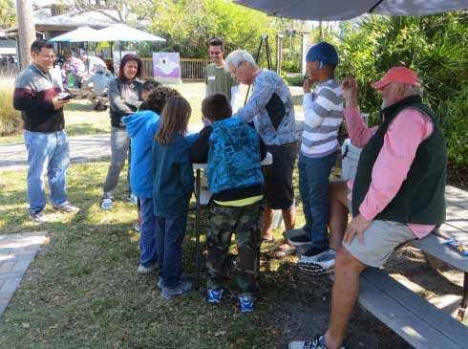
Jim Bohrer supervises the fish cleaning station. Kids were fascinated to see the parts that make up a fish.

Jim Bohrer supplied a mess of trout for the fish cleaning novices.

Thanks to all the members of the Stuart Rod & Reel Club and of the Stuart Flyrodders Club for coming out to volunteer. If you get the opportunity to help next year, it would be much appreciated.
Left to Right: Jayden Rosenberg, Eric Rosenberg, Frank Pyrzbylski and Pete Noll. Many other members helped as well.
Other stations included lure selection, knot tying, conservation, casting lessons, cast net throwing and fish identification. The FOS staff and the volunteers were great!
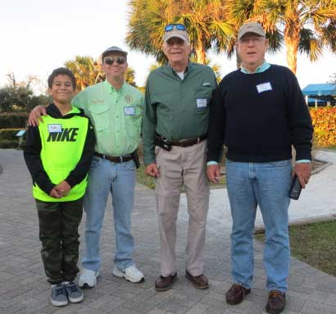
All Stuart Rod and Reel Club Outings are based purely on the Honor System. All scheduled Club Outings will be “Daylight Outings”. You can fish any of the dates listed above. Event will begin at the first safe light in the morning with lines out of the water by 1PM. Scores must be turned into the Angling Director or other board member by email, phone or verbally by 2 PM local time on the day after the event.  Natural Bait (alive or dead) is allowed except for March, May and July. Bait restriction is in effect for September.  Guests and spouses are invited to attend the food services on Saturday at Sandsprit Park. For food at restaurants, guest and spouses will be charged for their meal and beverage costs. | Family members under the age of 18 must be accompanied by a parent or legal guardian to participate in an outing. While guests are always welcome to join members during our outings, you must be a paid member of the Stuart Rod and Reel Club to be eligible to win an outing. Outing scores shall be published in the Club’s Newsletter following the Outing. Outings cancelled due to weather shall be rescheduled for the following weekend. Outing result disputes shall be settled by the Angling Director.  OUTING SCHEDULES AND RULES MAY CHANGE DURING THE YEAR.  FISHING BOUNDARIES  Boundaries will extend from the south shore of the Jupiter Inlet to the North Vero Beach Bridge.

Date | Outing/Event | Details | Host/Food Service | Rules
April  14, 15, 16 | New Member/Old Member | Any Species: Old Member fishes with any with New Member | Sandsprit Park 1:00 PM Stuart, April 15th. | New Member/Old Member
May  12, 13, 14 | Top Water Lures Only | Most Points Total - Snook =2pts.  Trout =1pts. and Redfish 3pts.  Max. 3 per species. | Sandsprit Park 1:00 PM Stuart, May 13th. | Total Points. No bait or jigs allowed.
June 9, 10, 11 | Most Species Caught-Must be legal size fish | Any species of fish caught. | Sandsprit Park 1:00 PM  June 10th | TBA
July  14,15,16 | Local Tarpon Outing | Most Tarpon: 3 Points for angler touching the leader, 1 point for a jumped fish. One point per jumped fish only. No natural bait allowed. | Shrimper’s Restaurant, Port Salerno 1:00PM, July 15th. | Three points for caught fish, one point for each jumped fish.
August  11, 12, 13 | Local Trout and Redfish Outing | Largest Trout & Redfish, total inch length | Sandsprit Park 1:00 PM Stuart, August 12th. | Longest total trout and redfish combined.
September  15, 16, 17 | Longest Snook | Longest Snook –Bait Restriction: Any snook caught on bait is worth ½ a fish caught on an artificial lure. 24” snook minimum length | Sandsprit Park 1:00  PM Stuart, Sept 16th. | Longest snook, minimum 24”
October  13, 14, 15 | Pine Island | Total Length in Inches: 1 Trout, 1 Redfish, 1 Snook (24” minimum on snook) | Pine Island Away  No Local Luncheon | Longest total length
November  10,11,12 | Local Redfish | Longest Overall Redfish | Sandsprit Park 1:00 PM, Nov 11th. | Longest total length
December 9 | Christmas Party | No Outing | Dolphin Bar & Fish House Jensen Beach | No Outing.

2017 TOURNAMENT OUTING SCHEDULE
Support our Advertising Sponsors
We are very fortunate to have many local businesses that advertise on our web site and provide additional sponsorship support to the Club. These businesses provide a wide range of products and services for the entire community. Whether you are looking for lodging, restaurants, fishing supplies, boat repair and restoration, guide services, legal services, or roof repair our sponsors deserve your consideration. You can learn more about these businesses by visiting our website at www.stuartrodandreel.com. Click on the advertiser’s tab and you will find a brief description of our sponsors with contact information and links to their websites. Make our advertising sponsors your priority when shopping. Please let them know that you learned about them through the Stuart Rod and Reel Club and that you appreciate their support.

Bait & Tackle  - Crowder Rods  - D.O.A. Lures  - Fish Heads of Stuart  - Snook Nook  - Treasure Coast Rod and Reel  - White's Tackle  - T & A Jigs, Inc. | Area Lodging  - Marriott - Hutchison Island Resort
Area Dining  - Big Apple Pizza  - Crawdaddy’s  - Dixie Grill  - Manatee Island Bar & Grill  - Manero’s Restaurant  - Polka European Deli  - Rancho Chico  - Shrimper’s | Guide & Charter Services  - Cajun Fishing Adventures Louisiana  - Catch 22 Charters Florida  - The Fish Intimidator Louisiana
Marine Products & Services  - C&H Trailer  - Manatee Marina  - Marine Customs Unlimited  - Marine Parts Outlet  - Master Repair  - Metco Marine Electronics  - Outboards Only  - Sailfish Marina  - Stuart Propeller  - Treasure Coast Battery & Alternator | General Business  - Capps Roofing  - Inn of the Dog  - Plaza 95 Marathon, Dairy Queen and Highway Café  Professional  - Crary Buchanan Attorneys

MEMBER’S INFORMATION
MONTHLY MEMBERSHIP MEETINGS WITH SPEAKERS: The monthly membership meeting is the second Thursday of the month. Our home port is The Quality Inn/Flanigan’s Bar & Grill located at 950 SE Federal Hwy. (US 1) Stuart, FL. We have the privilege of listening to many fishing industry and conservation leaders in the Southeastern Florida region. These experts include tackle manufacturers, tournament winning Captains and guides, television and print journalists, and academic researchers. We have a guest speaker from this pool at each monthly meeting. Speakers will address topics of interests such as how to fish for the upcoming outing’s targeted species and our diverse estuary system. This is a great way to gain additional local knowledge of this fishery. Dinner begins at 6PM with Meeting at 7 PM.

MONTHLY OUTINGS: The Club sponsors a fishing outing each month. All outings are based on an Honor System. You don’t have to keep your catch or take a picture of it either. Outings are scheduled for the weekend following the general membership meeting. Outings are usually three day events where anglers select to fish Friday, Saturday or Sunday. Most outings are scheduled from first safe light till 1PM. The targeted fish and scoring change from month to month with interesting twists such as more points for one species than another. The intent is to have fun! The winner of each monthly outing receives a Club logo embroidered fishing shirt. As part of the outing we have several lunches at restaurants along with club and family cook-outs. Additionally, the Board is encouraging members to partake of the lunch regardless of the day fished. These are no-cost events. With two away outings and the remainder based at Sandsprit Park, there is opportunity to participate without travelling around the state. Frank Miller as the Angling Committee Chairman will also consider your ideas about other outings in other parts of the state. This year’s outing schedule was developed to increase participation, emphasizing the fun of fishing. You are able to view the schedule in every edition of True Lies.

NEWSLETTER: We publish a newsletter, True Lies, each month. It is circulated by e-mail. We are constantly looking for your fishing reports, pictures, recipes, and any other Club related information for inclusion. Submitting information is easy. You can send an e-mail to Jim Bohrer (halieutics@gmail.com).

WEB SITE: The Club’s web site (www.stuartrodandreel.com) is a wealth of information. You can find the latest weather and tides, fishing tips and information on our advertisers/sponsors.

RAFFLE: An activity at our membership meetings that generates a great amount of interest is the “Raffle”. Tickets are $1 each or 6 for $5. Raffle prizes vary monthly but usually include a fishing rod, reel or combination. Other prizes have been tackle bags, boxes, pliers, lures and boating accessories. Your purchase of raffle tickets gives you a good chance of winning and helps support the activities of your club.

MEMBER DISCOUNTS: Your Club membership can help you to save some money. White’s Tackle offers a 10% store discount on all purchases. Be sure to mention that you are a current member of the Stuart Rod and Reel Club and that you appreciate the support that they give the club.

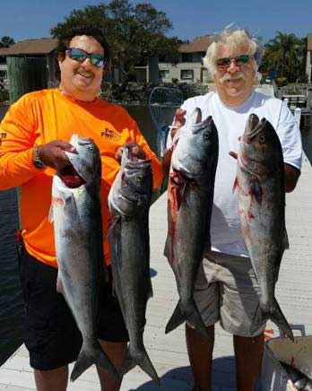
Sometimes you just need to go out and get bloody. When the mackerel are gone, it is time to look for the predator of the day. Keith Palant and his friend John got into some super aggressive bluefish. These mean choppers will test your line and your flesh. The men kept five to make into fish dip. Watch those fingers when you get into bluefish! They tried with inshore tackle, but then had to break out the heavier ocean rods. Some of these fish were seventeen pounds and Keith states that these fish outfight a big Jack Crevalle!

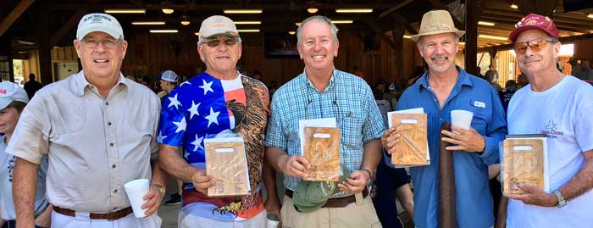
Just to show you that it is not all fishing: Pete Noll sponsored a team of SRRC members for the Young Guns fundraiser at Quail Creek. Pete’s team has won three consecutive Gold level annual championships at this event. Pictured (L to R) are Pete Noll, Jerry Hoge, Fred Bartlett, Philip Quick and Dusty Smith. Young Guns is a sporting clays shooting young person’s teaching team with volunteer coaches. The kids have won the national championship in the youth class four years running. The championship is usually held annually in Illinois and it attracts competitors from all over the USA. Congratulations!
WINNER OF THE MARCH ANGLING TOURNAMENT
It was a three-way tie between Richard Matteson, Jay Honan and Jim Bohrer. Angling Director Frank Miller conducted a “name out of the hat” drawing and Jim Bohrer is the winner of the March event! 28 members came to the luncheon event at Manatee Island Grill in St. Pierce.
Eric Rosenberg won the fish of the month event with 5 pompano. He won the SRRC hat for this month.
2017 Annual Dues
Dues for 2017 are now past due. Fully paid memberships begin the first day of January, and end on the thirty first day of December of each calendar year. An individual membership is one adult 18 years of age or older. Family memberships consist of the member, their spouse or significant other and their children under the age of 18.

Individual membership for a full year is $80
(January thru December)

Family membership for a full year is $95
(January thru December)

Send your checks payable to:
Stuart Rod and Reel Club, Inc.
c/o Pete Noll, Treasurer
1888 S. W. Mooring Dr.
Palm City, FL 34990
Membership entitles a single person (or family as applicable) to participate in all outings and to enjoy a meal at every local outing. Members also receive an included meal (with soft drinks) at Shrimper’s and Manatee Island Grill on the appropriate dates. We hold monthly meetings with interesting speakers and share information on where and when to fish in our area.

2017 SRRC Fish
of the Month Contests
The Fish of the Month Contest will run from the day after the monthly membership meeting and end at 12 Noon the day of the following meeting. All fish need to be legal size except for Snook that must be 18 inch minimum. Natural bait (live or dead), artificial lures and flies are allowed. The member catching the most fish will be the monthly winner. The monthly winner will receive a monogrammed club hat.
Date | Species
Jan 13 thru  Feb 09 | Snapper, Bluefish
Feb. 10 thru Mar. 09 | Most Pompano
Mar. 10 thru April 13 | Most Snook
April 14 thru May 21 | Largest Trout
May 12 thru June 18 | Most Snook
June 19 thru July 13 | Most Redfish
July 14 thru Aug 10 | Most Trout
Aug. 11 thru Sept 14 | Most Tarpon Caught and Released
Sept. 15 thru Oct 12 | Largest Snapper
Oct. 13 thru Nov 9 | Largest Redfish
Nov 10 thru Dec 13 | Most Black Drum

The Winner of the Year Overall will be the person catching the most total species during the calendar year. The overall prize is a $50 gift certificate to White’s Tackle in Stuart.

